_________________________________________________________________
VENDOR APPLICATION FORM
Please print, scan and email this completed form to kinscotfest@bmts.com
Type of Vendor: ❑ Food ❑ Other Business
Description of Vendor Services & Products:
Please detail what products (menu items) will be offered at the festival. Please note, the Festival reserves its right to select any Vendor on an as needed basis.
Company Name:
Contact Name(s):
Mobile / Contact Telephone Number:
Email Address:
Web Address:
Street Address:
City:
Province:
Postal Code:

VENDOR INFORMATION TO BE SUBMITTED WITH APPLICATION:
- List of festival experience
- References, if available
- Photo of set-up at a previous festival
- Dimensional layout that includes tent space, trailer overall length including hitches as well as all BBQs, tables, barricades, major appliances etc. BBQs and cooking equipment must be 10 feet from any structure. Note: All equipment must meet local fire regulations.
- Deposit cheque of $150.00, currently dated and payable to Kincardine Scottish Festival
- Priced menu or list of items to be offered for sale. All Vendors are to disclose items for sale and menu options.

DOCUMENTATION TO BE PROVIDED BY VENDOR:
- Proof of business ownership (Provincial Business Name Registration or Signed Franchise Agreement)
- Provincial vehicle registration (Vehicle Ownership), name and address are to match the applicants
- Proof of Health Inspection Certification.
- A product list of all food items sold
- Copy of applicants driver license
- Copy of signed certificate of insurance (Applicants must provide proof of $1,000,000 insurance Personal Liability & Property Damage (PL/PD) insurance)
- All vendors are to comply with all public health guidelines as detailed via this link:
  - https://www.publichealthgreybruce.on.ca/Your-Environment/Food-Safety/Special-Event-Application/Food-Vendor-Applicaton
(The Kincardine Scottish Festival reserves the right to request adjustments to menus and products to reduce/prevent duplication.)

VENDOR FEE:
Please contact the Event Manager for Location Size, Availability & Pricing. Vendor Permits start at $300 and a non-refundable deposit of 50% of fee must be received no later than May 1st in advance of scheduled Festival date.
Anticipated Fee for 2023
❑ 10 x 10 area – $300.00 + HST
❑ 10 X 20 area - $350 + HST
❑ Mobile Truck or Trailer (10 X 30 approx. area - $400 ** COMPLETE SETUP INCLUDING HITCHES MUST FIT WITHIN THE REQUESTED SPACE).
2023 – VENDOR TAKE NOTE – Due to construction and the closure of Queen St, site set up must be completed by Friday at 4pm by all Vendors. Please note, there will be no re-entry privileges this year due to restricted access as a result of a new site layout due to the Queen Street Closure.
SITE MAP
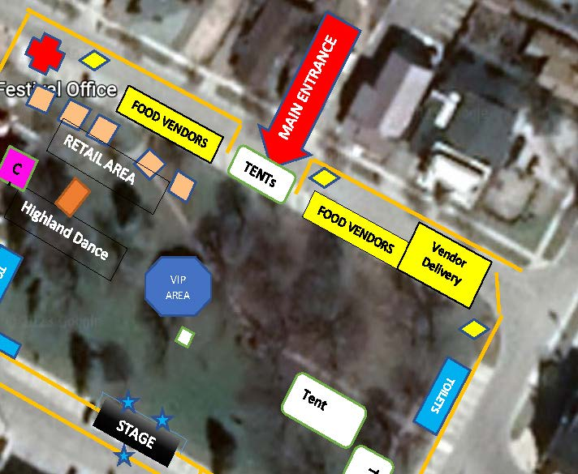 | Vendors will have to park in the adjacent public car park (behind Royal Bank). There will be a designated Vendor Delivery area at the top of Durham Market North should Vendors require deliveries over the course of the weekend. See current proposed set up.  KSF reserves its right to change site layout at any time.

Kincardine Scottish Festival Vendor Code of Conduct
The Kincardine Scottish Festival has established principles to ensure that, at all times, working conditions in its operation and the operations of others are conducted safely and workers are treated with dignity and respect, and that all internal (Kincardine Scottish Festival Representatives) and external (Vendors & Subcontractors) business operations are conducted in a lawful, ethical, and environmentally-conscious way.

All Vendors are expected to acknowledge and agree to act in alignment with this Code of Conduct by:
- Ensuring they and their staff are familiar with The WSIB’s Code of Business Ethics and Behaviour, act consistently with it, and do not contribute to its breach by a WSIB or Vendor employee or related party;
- Ensuring their business operations comply with the laws, statutes, and regulations of each jurisdiction in which they operate;
- Committing to the ethical and responsible treatment of all individuals within their own network, including with respect to workplace health and safety, employment standards, labour regulation, compensation non-discrimination, and human rights;
- Conducting business in an environmentally-responsible way;
- Ensuring that their sourcing of goods and services in no way directly or indirectly results in non-compliance with this Code of Conduct, and that their own Vendors and Sub-Contractors conduct business in compliance with all applicable laws and consistently with this Code of Conduct.
- Understand and acknowledge that harassment and discrimination are prohibited by law. Under Ontario’s Human Rights Code, every person has a right to equal treatment without discrimination and the right to be free from harassment in the workplace and during Festival operations. Any reported acts by a member of the public and or a volunteer or Festival representative may result in the immediate termination and suspension of Vendor(s) operation without refund or compensation.

______________________________________________________________________________
OFFICE USE
Vendor Application Approval
Document Checklist | Received | Not Received
Proof of Business Ownership | ☐ | ☐
Proof of Vehicle Registration | ☐ | ☐
Proof of Health Inspection Cert. | ☐ | ☐
Product List/Menu Items Sold | ☐ | ☐
Proof of (PL/PD) insurance | ☐ | ☐
Deposit Received | ☐ | ☐
Full Payment Received | ☐ | ☐

Date:
Reviewed by:
Approved by:

