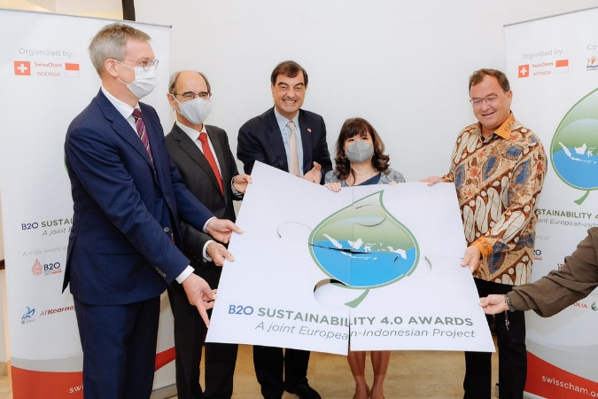
Our mission to make healthcare more accessible in Indonesia underpins PT Anugerah Pharmindo Lestari (APL)’s, part of Zuellig Pharma business. As a leading healthcare services company in Indonesia, we look beyond immediate needs to the long-term future of our employees, clients, and customers. We are driven by a strong commitment to support, enhance and strengthen the communities in which we operate.
APL is honored to take part in the B20 presidency by leading The B20 Sustainability 4.0 Award, a recognition to companies who contributes to the environment well-being and sustained living, and humbly received 2022 CNBC Award for Outstanding Company in Sustainability Community Initiative.
It is our firm belief that beyond advancing the health of patients, contributing to the environment and society must be integral to our business. We have achieved major contribution under the following pillars:
Improving Health Outcomes
We are focused on Improving Health Outcomes for the Indonesian community through the following topics:
- Access to Healthcare
- Affordability
- Community Engagement
- Preventative Care
- Enabling Healthcare Professionals
- 12 employees disease awareness as an education programme
- HPV vaccination programme for 142 employees
- Sport club for employees
- 520 blood bags collected
- 14,000+ pharmacists across Indonesia got free education from eZEducation
- Medical services for locals in Tabanan village

Nurturing Talent
Our APL employees and suppliers work tirelessly every day to bring medicines to those who need it most. We want to focus on creating the right environment to attract, develop and engage a diverse workforce for the sustainable future of our business. We grow our team by addressing:
- Talent Recruitment, Development & Retention
- Workplace Health & Safety
- Employee Engagement
- Employee Wellbeing
- Diversity & Inclusion
- 24 well-being programme sessions
- 100% training sessions accomplishment by APL employees
- Partnership with Universities in Indonesia to nurture the young talent

Setting the highest standards of integrity
The foundation of APL’s business has always been built upon us operating at the utmost levels of integrity. Our clients trust us to protect their products, reputation, and data. We do this by ensuring the integrity of the supply chain by putting robust systems in place to address:
- Product Quality & Security
- Counterfeit Products
- Parallel Trade
- Bribery & Corruption
- Public Policy
- Responsible Sales & Marketing
- Responsible Sourcing
- Data Privacy & Security

- Created awareness about sustainability among suppliers and improving responsible sourcing by conducting education session on supplier day
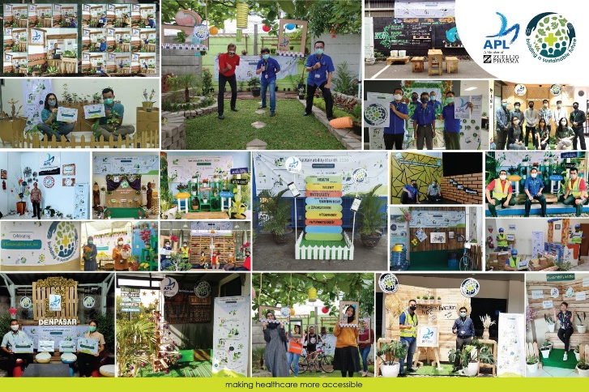
- Achieved Good Pharmaceutical Distribution Practice, Good Distribution Practice of Medical Device, ISO 27001:2013 and 9001:2015 certification for our facilities and work process
Respecting the Environment
Climate change is a reality that not only affects health outcomes, but also directly impacts our mission of making healthcare accessible to the communities we serve. APL believes that we have an ethical responsibility to protect the environment and comply with environmental laws and regulations. We will take an active role in Respecting the Environment by tackling:
- Climate Resilience
- Climate Change Mitigation & Energy Efficiency
- Responsible Waste Management
- Environmental Compliance
- 2,094 tons Co2 reduced from offset activities
- 2,864 trees have been planted
- Implemented Energy Management Systems and solar panels installation at our distribution center to optimize energy consumption
- Invested in carbon neutralization projects through the purchase of Renewable Energy Certificates (RECs), certified by I-REC Standard or the TIGR registry.
If you’d like to hear more about our programs, we invite you to visit our Sustainability report for more information.
We hope you will reach out to us to partner on sustainability and look forward to working together for a healthier future.

