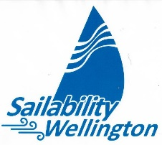
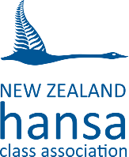

Hansa 303 North Island Regatta
4-5th March 2023
With Coaching and Ability Trophy Races on Friday 3rd March

You are invited to come to Sailability Wellington’s Seaview base for the Hansa 303 North Islands Championship. This regatta will include the Ability Trophy for sailors with an intellectual disability aided by a ‘companion crew’.

These notes are to help you decide if you wish to be involved and in what capacity. Please carefully read the Notice of Race and Entry Form. The Sailability Wellington Team will do all that we can to help you enjoy this event, learn new skills and compete for good prizes. Please feel free to phone me on 027 2494275 for more information.

We are delighted to have John Sanderson joining us from Sydney to lead coaching on the Friday as well as chairing a forum on Friday evening. John is a World Sailing accredited coach who is heavily involved in Sailability in New South Wales. We have been sponsored by IHC Foundation to enable his involvement. His coaching sessions are open to Sailors, Sailability Coaches, ‘Companion Crew’ and all Sailability Volunteers. There is no charge for this. Hansa 303s will be made available at no charge by Sailability Wellington.

Sailors and support crew visiting Wellington may charter a Hansa 303 for the series for a payment of $30. You are, of course, welcome to bring your own yacht and/or a support craft. Please phone me to let me know if you intend to bring a support boat.

The Sailability Wellington Crew will provide lunches for a small cost. As we are attempting to get as much sailing in as possible, this will be a good option. Please order these at registration time. Bottled water will be supplied for free.

Kia Manuia.
Don Manning QSM - Regatta Director 027 2494 275 ceo@sailabilitywgtn.nz
