Notice of Race
New Zealand Hansa 303 Class – North Island Championships
Singles & Doubles Plus Ability Trophy 3rd – 5th March 2023
Sponsored by
And supported by

The Organising Authority is the Lowry Bay Yacht Club Inc. (LBYC)
100 Port Road Seaview, Lower Hutt, 5011
NB: The notation ‘[DP]’ in a rule in the Notice of Race means that the penalty for a breach of that rule may, at the discretion of the protest committee, be less than disqualification.
1 RULES
1.1 The regatta will be governed by the rules as defined in The Racing Rules of Sailing.
1.2 The Yachting New Zealand Safety Regulations Part 1 shall apply.
1.3 Racing rules are changed as follows:
- RRS A5.1 and A5.2 will be changed to state that a boat starting later than 4 minutes after her starting signal will be scored Did Not Start.
- RRS A5.1 and A5.2 will be changed to state that boats still racing but failing to finish within 10 minutes after the first boats sails the course and finishes will be scored Did Not Finish. Note however that the Supplementary sailing Instructions may also propose the use of the Whiskey Flag for finishing on the course.
- RRS 61.1(a) will be changed to state that “A competitor intending to protest is required to inform the race committee at the finish line of their intention to protest immediately after finishing.”
- RRS26 will be modified to use a 3 minute countdown start sequence, as provided for in RSS26.
These changes will appear in the Supplementary Sailing Instructions. The Supplementary Sailing Instructions may also change other racing rules.
1.4 The Hansa 303 Class Rules will apply. Refer to Hansa Class Association regarding Class Rules.
1.5 Appendix T, Arbitration will apply.
2 SAILING INSTRUCTIONS
2.1 The sailing instructions will consist of the instructions in RRS Appendix S, Standard Sailing Instructions, and Supplementary Sailing Instructions (SSI’s) that will be posted on the official notice board located at the event headquarters at Seaview and online by 1 March 2023 at:
https://www.sailability-wellington.org.nz .
Paper copies of the Sailing Instructions will not be issued to competitors.

3 COMMUNICATIONS
3.1 The official notice board will be located in the Sailability Wellington container at the Seaview Marina
3.2 The online official notice board is located at https://www.sailability-wellington.org.nz
3.3 [DP] Except in an emergency, a boat that is racing shall not make voice or data transmissions and shall not receive voice or data communication that is not available to all boats. This restriction also applies to mobile telephones.

4 ELIGIBILITY AND ENTRY
4.1 The regatta is open to all Hansa 303 Class boats that comply with the Class Rules
4.2 Eligible boats may enter by;
(a) Completing the on-line booking form, and email it back to Info@sailability-wellington.org.nz
(b) Then payment needs to be made as per the entry form.
4.3 Entries will be accepted up until 1700 on Friday 24 February 2023.
4.4 Late entries, accompanied with a late entry fee may be accepted at the discretion of the Organising Authority up until 1200 on Thursday 2 March 2023.
4.5 To be eligible to compete in this event each competitor shall be a financial member of a club recognised by the competitor’s national authority. Proof of club membership may be requested.

5 FEES
5.1 Required fees, including GST, for each sailor are as follows:-
- Racing Entry Fee $30 per sailor. All ‘Companion Sailors’ in the Ability Trophy event are exempt from paying an entry fee.
- Charter Fee to use a Sailability Wellington 303 is $30 for the regatta.
- Coaching Clinic attendance, (refer 9.2) is free to all participants including sailors, Companion Crew and Volunteers from all Sailability Groups in New Zealand.
Racing and Charter fees are to be paid prior to the Friday Coaching Clinic or Prior to racing. Fees need to be paid into the Sailability Wellington Trust Account ANZ 06-0545-0279558-00, and accompanied by your name.

6 COVID-19
6.1 The event will not go ahead if there is any lockdown or other gathering restrictions are in force for the Wellington region. Refunds will be organised for those who have paid in advance in the event of a COVID related cancellation.
6.2 DO NOT attend if you are feeling unwell or have been in close contact with someone confirmed with COVID-19 in the past 14 days
6.3 Practice good hygiene and ensure your sailors practice good hygiene, use soap to wash your hands thoroughly and there will be hand sanitiser around the club for your use as well
6.4 Alert race officials if you become unwell during or soon after the event so we can implement our Covid-19 response plan.
6.5 If it becomes necessary to cancel the event, payments made to Sailability Wellington Trust by competitors in relation to the event will be refunded.
6.6 Competitors and families who are unwell or have possible symptoms, or who have come into contact with a known case of Covid-19 are encouraged not to travel to the event, and Sailability Wellington Trust will offer a full refund of the entry fees that have been paid.

7 CLASSIFICATIONS
7.1 There are no classification requirements in accordance with RRS 79 for entry to the Hansa 303 Singles or 303 Doubles. For entries for the Ability Cup, the skipper must have a recognised level of an Intellectual Disability and must always helm the boat during the races.
8 ADVERTISING AND IDENTIFICATION

8.1 [DP] Boats may be required to display advertising chosen and supplied by the organizing authority in accordance with World Sailing Regulation 20, Advertising Code.

9 SCHEDULE
9.1 Registration will be open on Thursday 2nd March and Friday 3rd March 2023 from 1100 until 1700
9.2 Coaching on the water is planned on Friday 3 March 2023 from 0900 until 1200
9.3 Briefing will be held on Friday 3 March 2023 at 1300 at the Seaview Marina Sailability Wellington container
9.4 Racing will commence on Friday 3 March 2023 with the first signal at 1400. Racing on that afternoon will be only for the Ability Trophy and 2 races will be scheduled.
9.5 The target time for each race is 20-25 minutes.
9.6 The Schedule will be to try and complete 6 races for each Class over the regatta.
9.7 The Racing Schedule will continue on Saturday 4 March 2023 and Sunday 5 March 2023.
9.8 On these 2 days it is intended to run 3 back-to-back races for the Hansa 303 Singles followed by a break, and then the Hansa 303 Doubles, followed by 2 back-to-back races for the Ability Trophy.
9.8 On Sunday 5 March 2023, no warning signal will be made after 1530.

10. EQUIPMENT INSPECTION
10.1 Boats will not be inspected at this regatta.
10.2 Boats are expected to comply with class rules

11. VENUE
11.1 The venue for the event will be the Lowry Bay Yacht Club, 100 Port Road Seaview, Lower Hutt (LBYC) and the adjacent Seaview Marina.
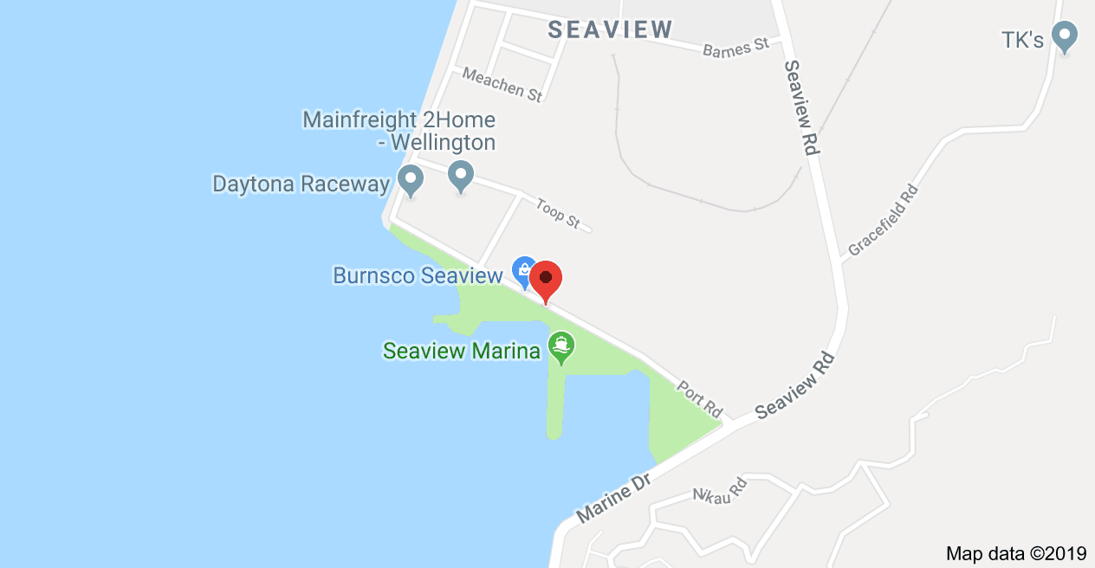

11.2 The racing area is in Wellington Harbour adjacent to Seaview Marina. Please see the diagram below.

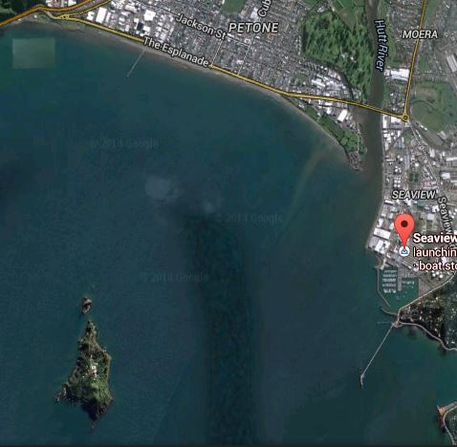
Racing
Arena

12 COURSES
12.1 The courses to be sailed shall be triangle or triangle, windward/leeward or windward/leeward courses using laid marks.

13 PENALTY SYSTEM
13.1 RRS 44.1 is changed so that the Two-Turns Penalty is replaced by the OneTurn Penalty.
13.2 Appendix P, Special Procedures for Rule 42, may apply as amended by the Supplementary Sailing Instructions.

14 SCORING
14.1 One (1) race is required to be completed to constitute a series.
14.2 (a) When fewer than 4 races have been completed, a boat’s overall score will be the total of her race scores.
(b) When from 4 to 6 or more races have been completed, a boat’s overall score will be the total of her race scores excluding her worst score.

15 SUPPORT PERSON VESSELS
15.1 [DP] All support boats must register with the Organising Authority at registration and nominate the boat(s) they support.
15.2 [DP] All support and coach boats must have VHF communications and be available to assist the race committee if required.
15.3 [DP] All support and coach boats shall have an engine safety cut out switch (kill cord) attached to the driver at all times while the engine is running unless prior written exemption has been provided by the Organising Authority.

16 HAUL-OUT RESTRICTIONS
16.1 All boats must launch and retrieve from the Seaview Marina
Note: There will be no official security overnight at the Marina

17 RIGHTS TO USE NAME AND LIKENESS
17.1 By participating in this event, competitors automatically grant to the Organising Authority and the event sponsors the right, in perpetuity, to make, use, and show, at their discretion, any photography, audio and video recordings, and other reproductions of them made at the venue or on the water from the time of their arrival at the venue, until their final departure, without compensation.
17.2 All those who take part in this event as competitors as well as support crew or spectators agree to be overflown by a drone during the duration of the event, this includes your person and your property (boats).

18 RISK STATEMENT AND DISCLAIMER OF LIABILITY
18.1 RRS 3 states: ‘The responsibility for a boat’s decision to participate in a race or to continue to race is hers alone.’ By participating in this event each competitor agrees and acknowledges that sailing is a potentially dangerous activity with inherent risks. These risks include strong winds and rough seas, sudden changes in weather, failure of equipment, boat handling errors, poor seamanship by other boats, loss of balance on an unstable platform and fatigue resulting in increased risk of injury. Inherent in the sport of sailing is the risk of permanent, catastrophic injury or death by drowning, trauma, hypothermia, or other causes.
18.2 Competitors participate in the regatta entirely at their own risk. See RRS 3, Decision to Race. The organising authority will not accept any liability for material damage or personal injury, or death sustained in conjunction with or prior to, during, or after the regatta.

19 INSURANCE
19.1 It is strongly recommended that each participating boat shall be insured with valid marine third-party liability insurance with a minimum cover of $1,000,000 per incident or the equivalent.
20 PRIZES
20.1 Prizes will be given as follows:
1st, 2nd, and 3rd place in each Class
20.2 Other prizes may be awarded at the discretion of the Class Association, Sailability Wellington Trust or the Organising Authority.
20.3 The prize-giving for the Regatta will take place at the conclusion of the Regatta on Sunday 5 February 2023, as soon as possible after racing has concluded.
20.5 North Island Championship winners for the Hansa 303 Singles and Doubles will be recognised in accordance with Yachting New Zealand Regulation 4.5.4

21 FURTHER INFORMATION
21.1 For further information please contact the Regatta Director:
Don Manning – CEO Sailability Wellington Trust at: Phone: 0272 494 275
ceo@sailabilitywgtn.nz

