Customizable Email Templates

Announcement Template—Monthly Discussion

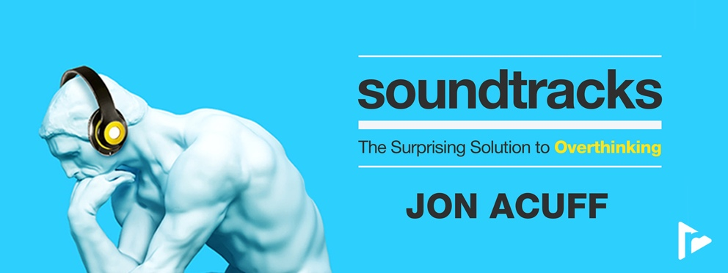

Team,

This month we’ll spend time as a team going through the Soundtracks series with author, speaker, and business leadership expert Jon Acuff on RightNow Media @ Work. I chose this series to help improve our decision-making abilities and not get trapped in the paralyzing fear of “what ifs” and self-doubt.

Over the next month, please find time to watch this six-session series on your own. In addition to watching the series, note your answers the below questions. We may not discuss every question, but I would like each person to be prepared to give your input if asked.
- [REVIEW QUESTION BANK AND INCLUDE 5-6 QUESTIONS HERE]

Please complete everything prior to [DATE], which is when we will discuss this series in our team meeting. If you haven’t registered your free RightNow Media @ Work account yet, here’s the link to do so: [INSERT CUSTOM LINK—LOG IN TO YOUR ACCOUNT, CLICK ‘CONTACTS’ IN TOP RIGHT, THEN CLICK ‘COPY INVITE LINK’ BUTTON. CONTACT YOUR CONSULTANT FOR ADDITIONAL HELP OR QUESTIONS.]

Let me know if you have any questions. I look forward to discussing this series together.

Announcement Template—Weekly Discussion

Team,

Over the next six weeks, we’ll spend time as a team going through the Soundtracks series with author, speaker, and business leadership expert Jon Acuff on RightNow Media @ Work. I chose this series to help improve our decision-making abilities and not get trapped in the paralyzing fear of “what ifs” and self-doubt.

Each week you’ll watch one session from the series and make note of your answers to the questions for that session (provided via email). We’ll then get together each week to discuss that session and the team’s responses. For our first discussion on [DATE], consider these questions as you’re watching session 1:
- [REVIEW QUESTION BANK FOR SESSION 1 AND INCLUDE TWO QUESTIONS HERE.]

If you haven’t registered your free RightNow Media @ Work account yet, here’s the link to do so: [INSERT CUSTOM LINK—LOG IN TO YOUR ACCOUNT, CLICK ‘CONTACTS’ IN TOP RIGHT, THEN CLICK ‘COPY INVITE LINK’ BUTTON. CONTACT YOUR CONSULTANT FOR ADDITIONAL HELP OR QUESTIONS.]

Let me know if you have any questions. I look forward to discussing this series together.

Reminder Template
Tip: You can reply all to your previous announcement email so your team has easy access to the questions you sent over in the original email.

Team,

Just a reminder that we’ll be discussing Soundtracks with Jon Acuff at our team meeting [next week / tomorrow].

- Make sure you’ve signed up for your free RightNow Media @ Work account: [INSERT CUSTOM LINK]
- Watch the series here (available on desktop, mobile, or TV streaming devices).
- Answer the questions I previously sent over in preparation for our discussion.

Let me know if you have any questions. I look forward to discussing this series together.

Weekly Question Email Template
Team,

For next week’s discussion, watch session [X] of the Soundtracks series with Jon Acuff on RightNow Media @ Work. Consider these questions as you’re watching:

- [REVIEW QUESTION BANK FOR THIS SPECIFIC SESSION AND INCLUDE TWO QUESTIONS HERE.]

Let me know if you have any questions. I look forward to discussing this series together.

Question Bank
From session 1:
- During Jon’s activity at the beginning of this session, what three songs came to mind, and why?
- How have you seen your positive thoughts impact your overall well-being? In what ways have you also seen your negative thoughts impact you?
- What are three “I can’t” statements that you have said to yourself? What are your three “I can” statements?
- In what ways have negative thoughts, or broken soundtracks, held you back from something you wanted to accomplish?

From session 2:
- What are three cultural soundtracks playing at your company right now, positive or negative?
- What do you expect from yourself when you do something for the first time? What kinds of thoughts do you have when things don’t go as expected?
- What kinds of situations tend to make you overthink?

From session 3:
- Who are three to five people in your life that you want to win with, and why? What is one new soundtrack you could write down for each person on your list? In what ways can this new soundtrack help you win with each person?
- How can changing your soundtrack help you make better, faster, and easier decisions at work?
- How has a negative soundtrack about a coworker dictated your attitude and work life?
- In what ways could your progress at work improve by fixing the broken soundtracks you have about specific people?

From session 4:
- Thinking of Jon’s first activity, what made your best boss your favorite? What are some reasons your worst boss became your worst boss?
- When do you tend to think in absolute statements?

From session 5:
- What could it look like for you to act on the things you want to be true in your life this year?
- What symbols typically grab your attention or drive you to action? Why do you think these symbols pique your interest?
- What could it look like for you to pick a symbol this week? Where could you put your symbol to ensure you see it every day?

From session 6 / overall series:
- What are three of your switches and why? How has switch thinking made an impact on your ability to overcome certain habits or attitudes?
- How have you tried to “turn off” your negative thoughts? Was it successful or unsuccessful?
- What are healthy ways you could turn your dial down when a negative thought gets too loud?
- What resonated with you most from this series?
- What is one thing you learned from this series that you plan to apply to your work life?

Tip: Additional questions can be found in the free series study guide on RightNow Media @ Work here.

