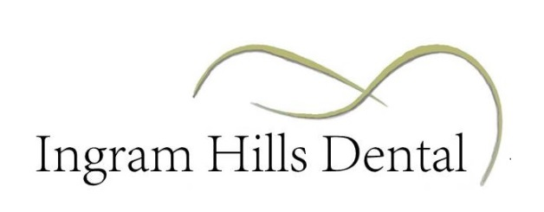

Payment is due at the time services are rendered. For your convenience we accept cash, credit cards, personal check or money order.

Insurance benefits are determined by your employer and not your dentist. Any deductible or estimated co-payment amount will be due at the time of treatment. Insurance is not a guarantee of payment; insurance companies will not pay for all your costs. Your insurance policy is a contract between you and your insurer. Your insurance and payment are still your responsibility. As a courtesy we will be glad to file your claim for you if you bring 1) your dental insurance card and 2) all required employer information. You will be expected to pay for services rendered if the office is unable to verify your insurance information before treatment or if the insurance company denies or downgrades payments after services are rendered. If payment for services already rendered has not been paid in full within 45 days, either by you or your insurance company, the remaining balance for treatment is considered due and collectible from you. We reserve the right to turn accounts over 90 days over to a collection agency.

We reserve the right to charge and collect fees for broken appointments – appointments that are cancelled or broken without 24 hours’ notice. Appointments are reserved exclusively for you.

Returned Check Fee of $30 will be added to your account balance and is collectible if your personal check is returned for insufficient funds by your bank.

Cash and Senior courtesies cannot be applied to insurance copayments and are not applicable to credit card payments. Courtesies cannot be combined and are not to exceed 5%.

I have read and understand this financial policy.

_____________________________________________ ____________________
Signature Date

______________________________________________
Printed Name

