Children report to fair stage at 12:30 to check-in.
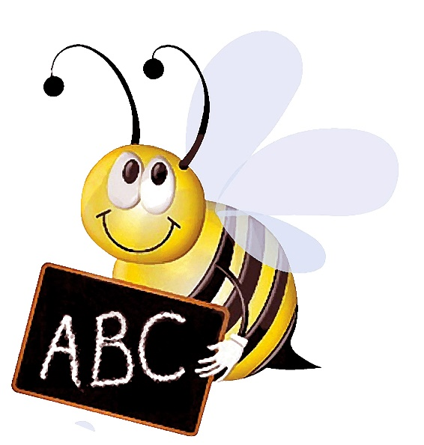
Tangipahoa Parish Free Fair Spelling Bee
Grades 3, 5 & 7
Once again, the Tangipahoa Parish Free Fair is hosting the annual Spelling Bee.
Please enter your top spellers in this year’s event.
We look forward to seeing everyone at the Fair this year.
Spelling Bee will be on Friday, September 30, 2022 at 1:00 PM.
www.tangifair.org
info@tangifair.org

