****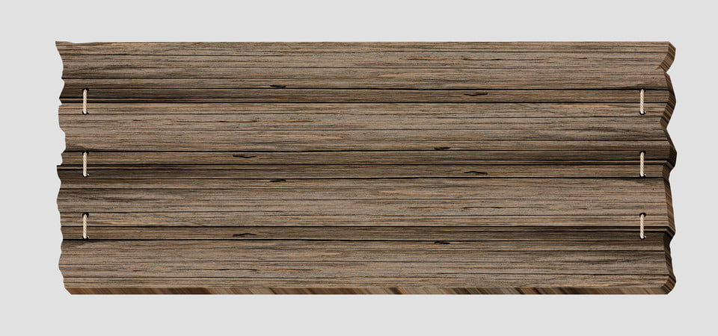

**SUNDAY MONDAY TUESDAY WEDNESDAY THURSDAY FRIDAY SATURDAY SATURDAY**

|  |  |  |  |  |  |  |
| --- | --- | --- | --- | --- | --- | --- |
| **31** |  |  |  |  | **1**  **PRETEND BEACH PARTY DAY** | **2** |
| **3** | **4 NO CAMP**  **HOLIDAY** | **5**  **Water Play with**  **Coach Jen** | **6 TRIP TO** | **7** | **8 Wear your**  **favorite team**  **Jersey** | **9** |
| **10**  Station | **11**  **Sports Day with**  **Coach Jen** | **12**  **INHOUSE EVENT** | **13**  **Water Play with**  **Coach Jen**  **Ice Cream Truck**  **$3.00** | **14**  **Sand Art Project** |  **| **16** |
| **17** | **18**  **Sports Day with**  **Coach Jen** |  **| **20**  **Water Play with**  **Coach Jen**  **Ice Cream Truck**  **$3.00** | **21 TRIP TO** | **22 Project**  **CANVAS PAINTING** | **23** |
| **24** | **25**  **Sports Day with**  **Coach Jen** | **26**  **EVENTS** | **27**  **Water Play with**  **Coach Jen**  **Ice Cream Truck**  **$3.00**  **SUBJECT** | **28**  **TO CHANGE** | **29 TRIP TO** | **30** |