****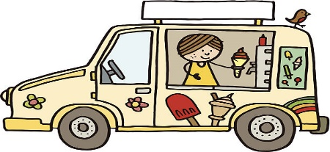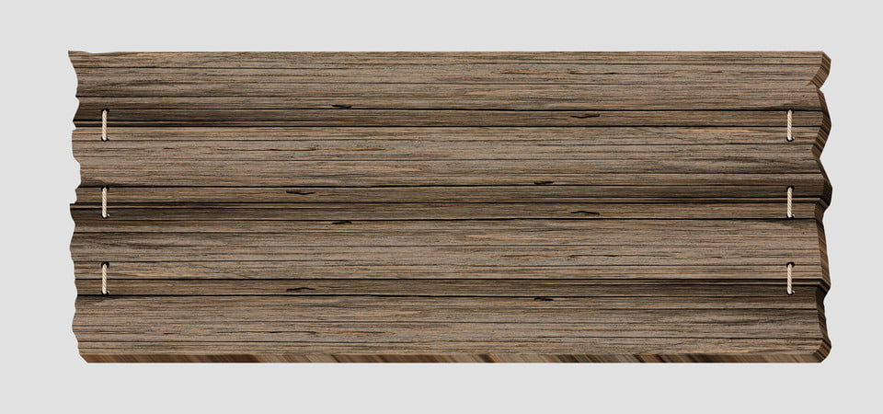

|  |  |  |  |  |  |  |
| --- | --- | --- | --- | --- | --- | --- |
|  |  |  | **1** | **2** | **3** | **4** |
| **5** | **6** | **7** | **8** | **9** | **10** | **11** |
| **12** | **13** | **14** | **15** | **16** | **17** | **18** |
| **19**  **IN** | **20**  **Sports Day with**  **Coach Jen** | **21**  **Board Games** | **22**  **Water Play with**  **Coach Jen**  **Ice Cream Truck**  **$3.00** |  **| **24**  **TRIP TO** | **25** |
| **26** | **27**  **Sports Day with**  **Coach Jen** | **28**    **EVENTS** | **29**  **Water Play with**  **Coach Jen**  **Ice Cream Truck**  **$3.00**  **SUBJECT** | **30**  **TRIP TO**  **TO CHANGE** | **1**  **PRETEND BEACH PARTY DAY** |  |

**SUNDAY MONDAY TUESDAY WEDNESDAY THURSDAY FRIDAY SATURDAY SATURDAY**