April
2022
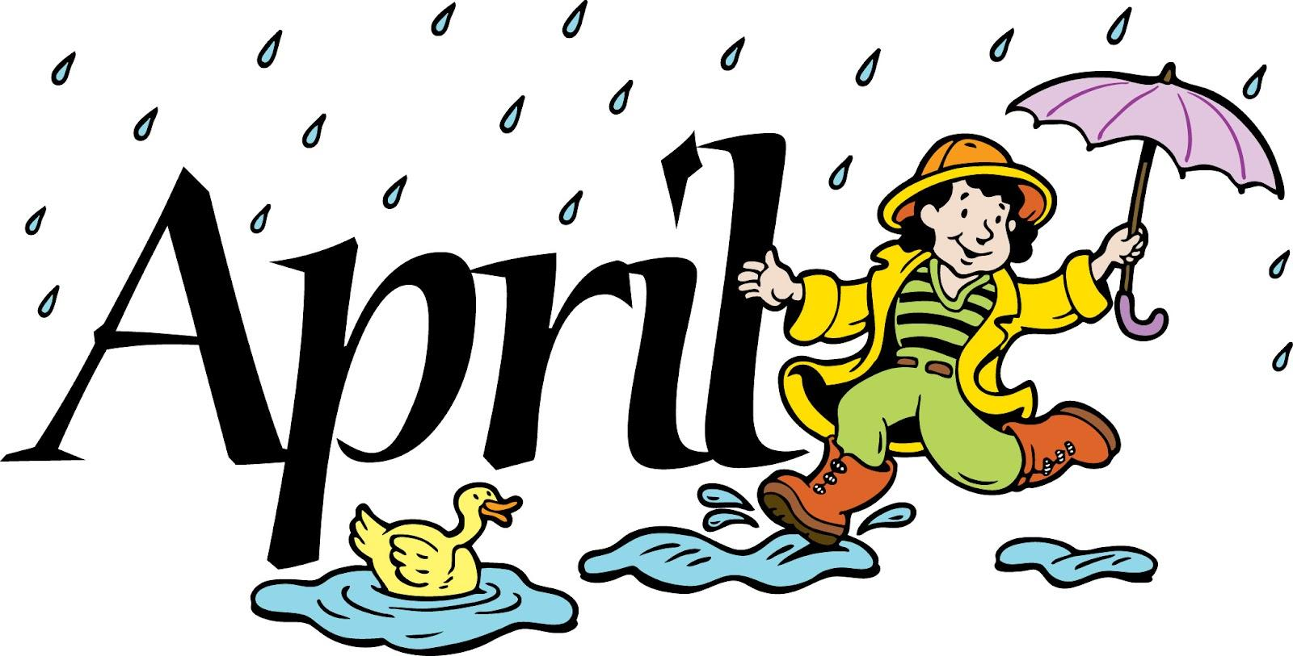
Happy Days Preschool

Sunday | Monday | Tuesday | Wednesday | Thursday | Friday | Saturday
 |  |  |  |  | 1 | 2
 |  |  |  |  | April Fools Day :)
3 | 4 | 5 | 6 | 7 | 8 | 9
Find a  Rainbow  Day | The Week of the Young Child 🡪  Picture Day | WOYC | WOYC | WOYC | WOYC | National  Unicorn Day!
10 | 11 | 12 | 13 | 14 | 15 | 16
 | 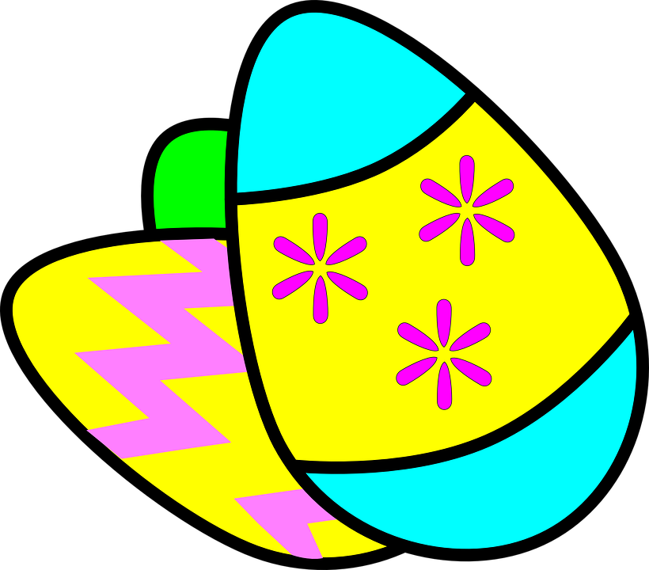  Decorating Easter Eggs | Hop like a Bunny | Easter Egg Hunt | National  Laughter  Day! | Good Friday  CLOSED
17 | 18 | 19 | 20 | 21 | 22 | 23
Happy Easter! | Have animal crackers for National Animal Crackers day! | April Showers Bring May Flowers | Class project for Earth Day | Have a picnic for National Picnic Day | Earth Day | 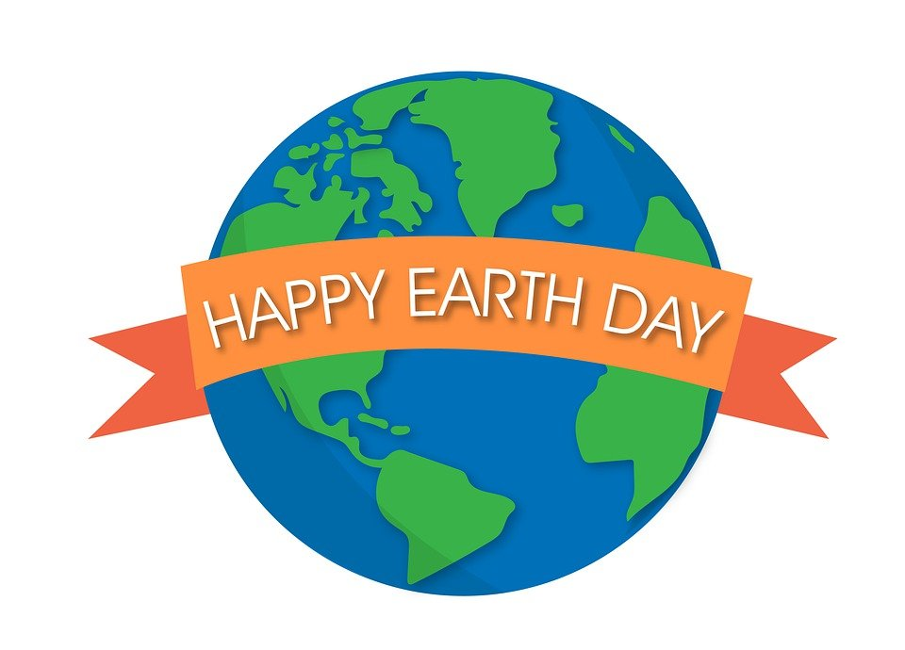
24 | 25 | 26 | 27 | 28 | 29 | 30
 | Celebrate  National  Princess  Day! | Discuss Healthy  Foods | Wear your favorite color day! | Dress up as a superhero for National Superhero Day! | Pajama Day!

