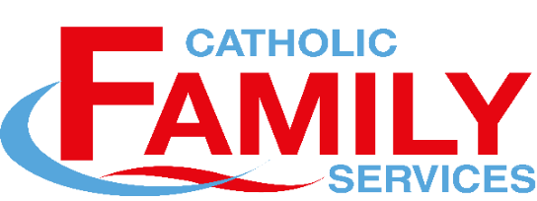
Life Improvement Programs
Winter, 2023
Unless otherwise indicated, all classes will take place at CFS – 1008 1st Avenue West

Check our website for updates (cfspa.ca)

AFTER THE STORM – A support group for women living with the aftermath of domestic violence
Full program is delivered over the week-end
Date: Sat. March 4 and Sun. March 5, 2023 *Transportation Available
Time: 9:00 a.m to 12:00 noon *Childcare Available
Registration: $25 Funded by: Civil Forfeiture

CALMING THE STORM- Anger Management for Adults
Date: Wednesdays, March 15 to April 19, 2023 *Transportation Available
Time: 6:30 p.m. to 8:00 p.m. This class may be taken in person or by zoom Registration: $25 Funded by Community Initiatives Fund

HEALING HEARTS: Grief Support Group for Adults – a support group for men and women who are dealing with loss and grief
Date: Tuesday March 7 and March 14, 2023 *Transportation Available
Time: 1:00 p.m. to 4:00 p.m.
Registration: $25

***NEW*** HOLD ME TIGHT – Relationship enrichment, enhancement and education for couples
Date and time::
Sat. March 4: 9 am to 12 noon
Sun. March 5: 1pm to 4 p.m.
Sat. March 11: 9:am to 4 p.m. (lunch will be provided)
You must attend all sessions to complete the program
Registration: $25 per couple Funded by: Community Initiatives Fund

***Grief program for teens:
HOW LONG DOES THE SAD LAST – a program for children 13 – 17 who are dealing with loss and grief
Date: Sat. and Sun, April 29 – 30, 2023 *Transportation Available
Time: 9:00 a.m. to 12 noon
Registration: FREE Funded by: Northern Lights Development Corporation

. . . . Page 2

Page 2 . . .

PARENTING FROM THE HEART – Parenting Class for parents, guardians or those who work with children
Full program is delivered over the week-end. This is a combination of the parenting portion of Taming the Tiger and Riding the Wave.
Date: Sat. March 4 and Sun. March 5, 2023
Time: 9:00 a.m to 12:00 noon *Transportation Available
Registration: Free Funded by: Ministry of Justice - Victims Services

RIDING THE WAVE - A Program for Children Ages 6-12 Exposed to Violence and Trauma & their parents
Date: Sat. and Sun, Feb. 11 and 12 *Childcare available
Time: 9 am to 12 noon *Transportation Available
Registration: FREE Funded by: Ministry of Justice - Victims Services

TAMING THE TIGER - Anger Management for Children Ages 6 to 12 and their Parents
Program delivered over a week-end
Date: Sat and Sun, Feb. 25 and 26, 2023 * Transportation Available
Time: 9:00 am to 12 noon *Childcare Available
Registration: FREE Funded by: Ministry of Justice – Victims Service

To register or for more information,
Call/Text Rose 306 961-8410 or email programs.cfspa@sasktel.net

If start dates for programs have not yet been determined, you can be put on a wait list to ensure you have a spot in the program. Please check our website cfspa.ca to see all the programs we offer.

PARTICIPANTS IN OUR PROGRAMS ARE ELIGIBLE TO BOOK APPOINTMENTS WITH OUR MENTAL HEALTH COUNSELLORS AT NO FEE

Updated: Feb. 8, 2023

