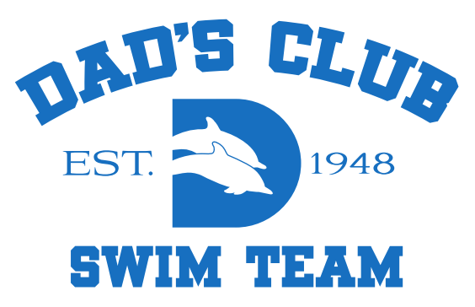

I, , legal guardian of , a minor athlete, give express written permission, and grant an exception to the Minor Athlete Abuse Prevention Policy for , to travel with Coach ___________, and Chaperon ____________ to travel to ___________________ on _____(Date)___________.
I acknowledge that cannot share a hotel room, sleeping arrangement or other overnight lodging location with the coach at any time. I further acknowledge that this written permission is valid only for the dates and location specified herein.

Legal Guardian Signature:
Date:

