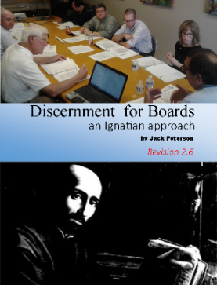
DISCERNMENT TRIAGE WORKSHEET
Not all issues need to be discerned with the same intensity. The following worksheet is used to triage what level may be required for each of the 6 components for group discernment, found in:
Discernment for Boards: an Ignatian approach
By Jack Peterson (jackpeterson@managingformission.com)
Lulu Press, 2015, 109 pages

To order, go to the following link: http://www.managingformission.com/publications/4574830335

Group Discerning:
Date this form completed:
Issue for discernment:

- Triage
  - Who is bringing the question forward and why?
Sometimes it is not clear who is raising the question and what their reasons are. Identifying that clearly will help us understand their needs and standing, which can shape the discernment needed.
  - Who should make the decision?
Often this will seem obvious, but not always. Whoever the appropriate decision-making person or body is must ultimately decide on the process it needs to use.
  - How important is this issue for the school?
The more important the issue, the more likely it will require deeper discernment.

  - What is the mission impact of this question?
The more this issue impacts mission, the deeper the discernment. Try to envision the mission and how it is impacted in concrete terms.
  - How complex is this issue?
The more complex the issue, the more likely it will require deeper discernment.
  - What persons or groups will be significantly impacted and how?
Generally, the more people impacted, the deeper the discernment must be. It is also important to visualize these people so that the impact of the decision has a human face.
  - What process should we use to define the Discernment Process itself?
Is this triage adequate for defining the discernment about to be undertaken, or do we need to take a step back to consider the triage process we should use? Don’t overcomplicate the process, but don’t undershoot it either.
- Gathering information
  - How important is data to making this decision?
  - Is the data needed already available?
  - If not, what will it take to get it?
  - Who can the board ask or delegate to gather the data?
  - Recommended process for gathering the appropriate background information:
- Individual prayer and reflection
- Is this a question for which some people are likely to have strong feelings?
- Are personal interests likely to impact how people discern this question?
- How much divergence of opinion or perspective is there on this issue?
- What persons or groups need to be involved in this discernment in some way?
- Group Discussion
- Who will need to discern this question?
- How big is the group?
- What group discussion methods will be considered?
- Making the decision
- Who needs to make the decision?
- How much consensus will be needed?
- How many things need to be decided?
- Implementing the decision
- Will we need to know when the decision would be put into effect?
- Does it need to be clear who will be responsible for it?
- Is it important to be able to measure if the intended outcomes were achieved?
- Could this decision involve significant resources, and how willing are we to provide them?
- Does the need to be adjusted if it is not leading to the intended results?
- Will this decision require periodic evaluation?

More information on group discernment and other issues for faith-based schools, including books, free videos and downloads, is available at www.managingformission.com.

