March __, 2023

By Email

Vanessa A. Countryman
Secretary
U.S. Securities and Exchange Commission
100 F Street, N.E.
Washington, D.C. 205499–1090
rule-comments@sec.gov

Re: Rule Proposal No. 34-96495; File No. S7-31-22 Order Competition Rule

“Internalization is one of the greatest threats to price discovery in financial markets.” - Kenneth Griffin
Ms. Countryman:

We The Investors (“WTI”) appreciates the opportunity to comment on the U.S. Securities and
Exchange Commission’s (the “SEC” or “Commission”) Order Competition Rule Proposal (the “OCR Proposal”).

We The Investors is organized around five key principles as laid out in our Investors’ Bill of Rights. These include Transparency; Simplicity and Fairness; Choice and Control; Best Execution; and Better Settlement and Clearing. This comment letter will focus on three of those principles: Transparency; Simplicity and Fairness; and Best Execution.
Markets function best when there is open, transparent and fair competition for order flow. In all rulemaking efforts, regulators should ask themselves how the rule in question furthers these goals. It is clear beyond a reasonable doubt that our current market structure is anything but open, transparent and fair.
Our 2022 presentations to SEC Commissioners and staff provided a robust set of data to demonstrate this. The Commission has gone even further than we did, leveraging data unavailable to academics and market participants as well as producing excellent analysis to validate this conclusion.
The Commission has authoritatively substantiated our concerns, and those of Citadel CEO Ken Griffin, who expressed his own unease over market structure in a strongly worded 2004 comment letter to the SEC. Speaking specifically about U.S. equity markets and the proposed Regulation NMS, Griffin explained that “[i]n the long run, unfettered internalization will result in substantially poor executions for all retail and institutional investors.”
We could not agree more.
The fundamental flaws in our market structure are plain to see. Today, therefore, one important question remains–what can be done to remedy the situation? The OCR Proposal is one idea. WTI believes that it represents an improvement over our current market structure, and we fully support it. However, we do not believe that the OCR Proposal is the optimal regulatory response to the problems in our markets.
We support open competition for order flow, and also believe that innovation and competition are healthy forces for finding optimal economic outcomes. The ideal place for such competition to occur is at the NBBO. That is where the broadest and most diverse set of participants can come together. If exchanges want to offer qualified auction facilities, they should be permitted to do so, but there should be more room for innovation than what the Commission has advanced in the OCR Proposal.
This comment letter will set out to answer three main questions:
- What are the primary problems in our current market structure?
- Why is a Trade-At rule our preferred solution to these problems?
- If the Commission does not adopt a Trade-At rule and proceeds with the OCR Proposal as constructed, what are the most important changes that should be made to reduce unintended consequences and allow for the most competitive and innovative trading environment?
In addition, we have seen firms who profit from the status quo criticize these proposals, so we will set out to respond to their primary criticisms:
- Will the OCR end zero-commission trading?
- Is there reason to think that spreads will widen with an OCR?
- Will we lose the benefits of cross-subsidization, thereby making less liquid stocks harder to trade? Is this a bad thing? Should the prices of those stocks reflect their actual supply and demand?

Problems in Today’s Markets
It would seem, on the surface, that U.S. markets are the envy of the world. Certainly, this is a platitude often expressed by the middlemen who profit from our current market structure.

The truth, however, is somewhat murkier. In many situations, U.S. markets are held up as an example to be avoided by other countries. This is especially true regarding the level of off-exchange trading and intermediation in U.S. markets. U.S. markets are certainly the biggest in the world, but does that mean they are the best?

We’ll address this question. But we would also argue that we should not let the state of global markets restrict our benchmark. It isn’t enough to strive for the best markets, relatively speaking. We must strive for the best possible markets according to our own metrics–transparency, efficiency, fairness, and simplicity.

Are U.S. Markets Enviable?
While it makes for a nice sound bite, the truth is that U.S. markets are neither the envy of the world, nor are they even as liquid, efficient and resilient today as they have been in the past. We have seen a consistent deterioration in market quality in the post-Reg NMS world, demonstrated by the following charts from Wellington Management:
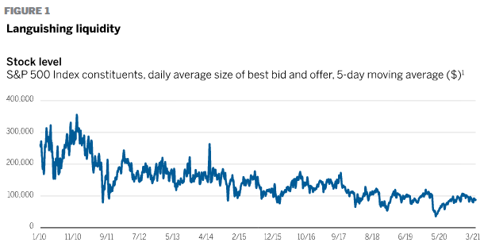
Since 2010, the 5-day moving average of the daily average size of the best bid and offer for S&P 500 Index constituents has consistently dropped. This average is now at a third of the level it was at in 2010.
Markets are also more fragile. Today, when volatility increases, there is less index liquidity available than there was immediately after the 2008-2009 financial crisis:
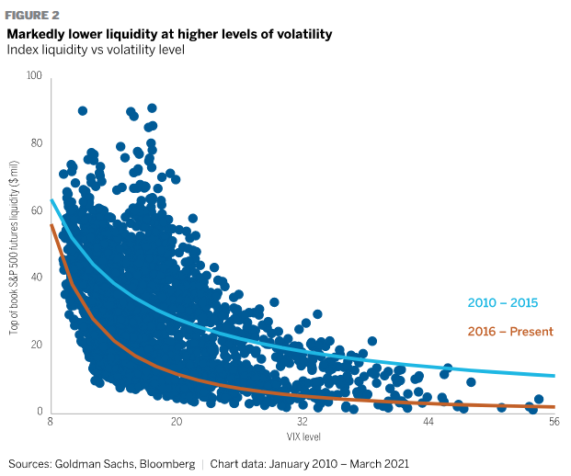
There has been a steady increase in rolling 24-month volatility of one-month realized S&P 500 volatility since Reg NMS:
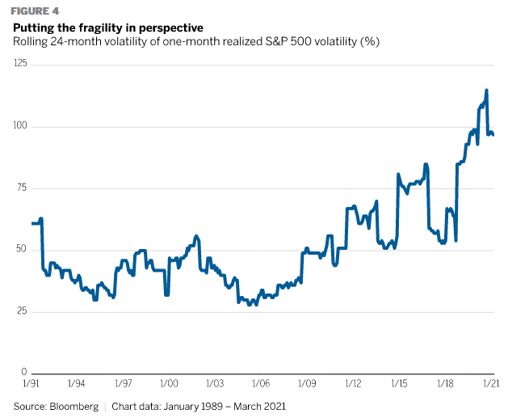
To reiterate, markets are at once more fragile and less liquid today than they were just a decade ago. Markets are therefore less able to absorb larger orders. As we will also see from some newer research below, markets are more prone to extreme price moves in securities with higher levels of internalization.
While complicated, this next chart, based on research from XTX, illustrates the point quite conclusively. It shows the results of simulating “instantaneous execution of [a] test order of a ‘representative’ order size vs. aggregate book of relevant venues… Each point on the chart represents average execution costs in a single stock (where order size is a function of this stock size as defined above), and bold lines are a semiparametric regression of these costs onto free float itself.”
U.S. markets may be larger than others, but “after controlling for the company size, instantaneously available lit liquidity in U.S. equities market is inferior to Tokyo Stock Exchange and Europe, and even to Korea for small stocks.”
This chart demonstrates that the Tokyo Stock Exchange is “the most liquid market in the world for a stock of a given size.”
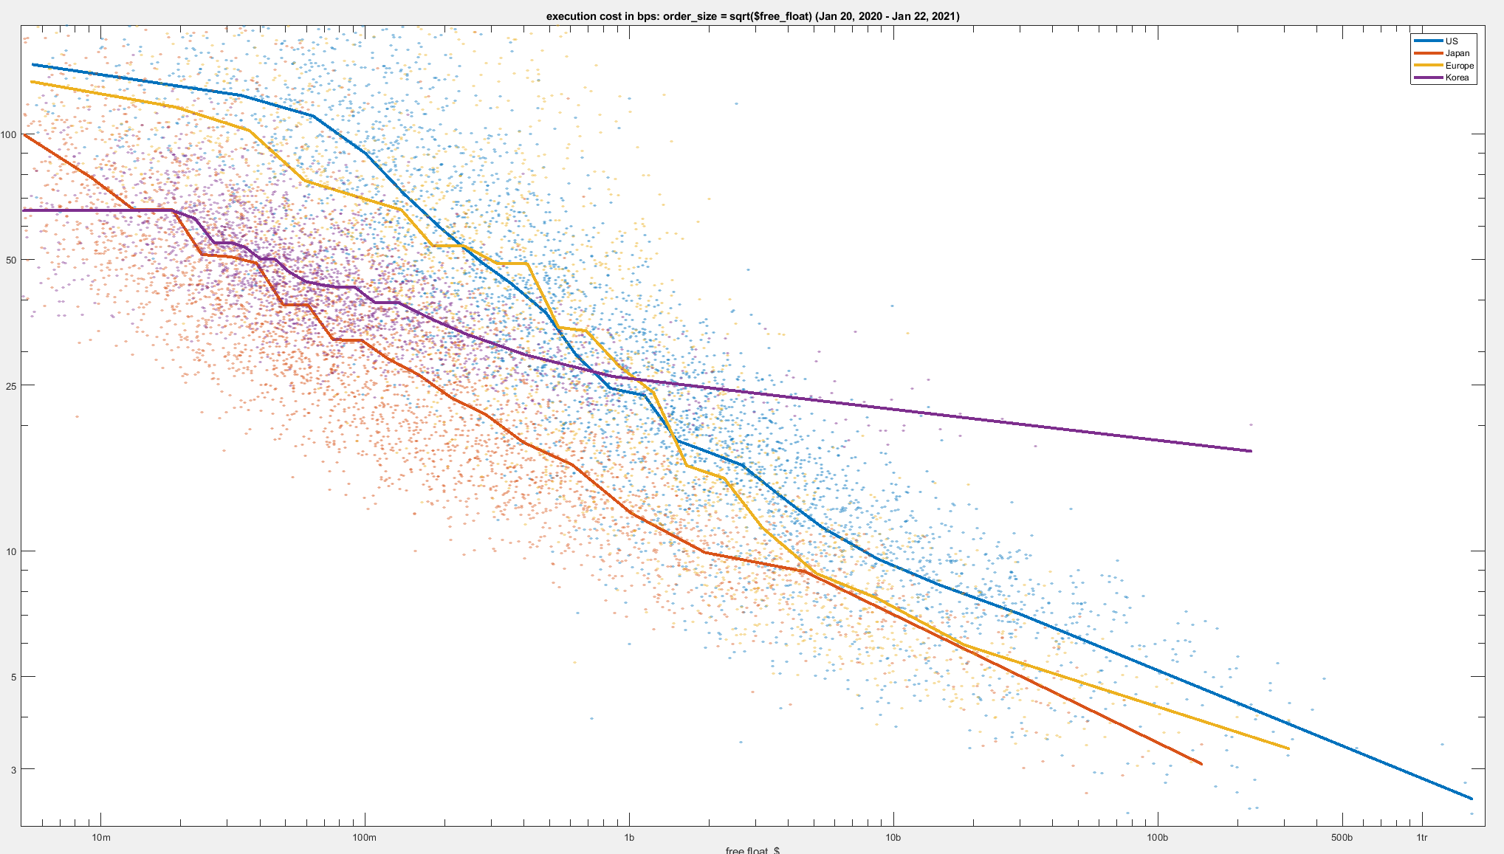
In addition, we can see a direct relationship between high internalization rates and increased execution costs to institutional investors. Babelfish found that “impact costs for stocks with a high retail market share were three times as expensive as stocks with low retail involvement. We also found that as retail market share increases, costs increase.”
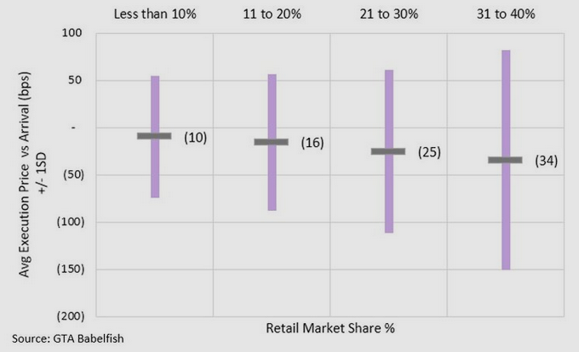
This further demonstrates that markets are becoming increasingly fragile. And as more trading volume is siphoned out of the lit system, and into the uncompetitive off-exchange realm, market efficiency is suffering, liquidity is dropping, and transaction costs are increasing. As Citadel CEO Ken Griffin explained presciently in 2004 when he foresaw all of these problems: “As more and more brokers engage in the practice of internalization, bid-ask spreads in the public markets will continue to be wider than they otherwise would, quoted liquidity will continue to fall and the role and value of the public markets will be greatly diminished. Furthermore, as bid-ask spreads widen in response to internalization, aggressive broker-dealers will be able to internalize an ever increasing portion of their order flow, sending only the most challenging of orders into the marketplace for execution - and only further worsening the situation corroding the value of the market.” We wholeheartedly agree that these practices have corroded the value of public markets, and that the investing public is paying the price.
Despite these findings, many commenters will proclaim without evidence or data that:
- “We share a commitment to ensuring that the U.S. equities market remains the most liquid, efficient, and competitive in the world”
- “The U.S. equity markets are incredibly efficient and resilient and investors, especially retail investors, have the greatest ease of access, lowest cost of trading and best execution in history.”
- “[T]he U.S. equity markets are the most robust, transparent and fair in the world, and that the retail investor experience has never been better.”
These are nothing more than empty refrains, which are used to delay or prevent reform. Unfortunately, simply issuing these proclamations does not make them true. WTI believes that the SEC must make the necessary changes to give meaning to these claims.

Markets Are a Concentrated Mess
If anything, the analysis in the OCR Proposal understates the problems in today’s markets. The supporters of the status quo will argue that the off-exchange trading space is competitive amongst the handful of wholesalers.
They intentionally conflate their own competitive preferences for actual competition.
WTI did an early analysis of the Herfindahl-Hirschman Index (HHI) in our WTI SEC Presentation. We found that the off-exchange OTC market met the DOJ definition of a “highly concentrated market” throughout 2019 - 2022. Edwin Hu and Dermot Murphy performed a more comprehensive analysis in their June 2022 paper. They had several important findings:
- Most importantly, they found “more internalization is associated with worse price improvement” and “reducing internalization could potentially lead to decreased spreads, increased depth, and better price improvement in stocks with highly concentrated internalizer markets.”
- Overall, spreads are wider in the presence of internalizers, even when there is robust internalizer competition, and wider still when there is insufficient competition.
- Interestingly, they also found that the highest internalized stocks were subjected to more extreme price movements. They calculated that “the size of extreme price movements is about 53.6 basis points larger in the highest internalization quintiles compared to the lowest quintiles. This last result suggests that the increase in adverse selection on public exchanges, which is induced by the diversion of retail order flow, also increases stock price fragility.”

This last point is one that critics have been making about the practice of internalization for many years. Increases in the toxicity of order flow going to lit stock exchanges reduce incentives for on-exchange market makers to post limit orders. Other exchange-based incentives reward speed and induce a latency race-to-zero. This combination leads many market makers to exit lit markets, reducing market maker diversity and increasing market fragility.

We do not seek to demonize market makers nor do we seek to glorify them. We simply believe that market structure should incentivize diverse trading strategies and on-exchange liquidity. The more that markets incentivize competition and diversity, the better for all participants.

Do We Dare Risk All The “Price Improvement” and “Size Improvement”?
Undoubtedly, the retail brokers and wholesalers who oppose the OCR Proposal will warn the Commission of a critical loss in both price improvement and size improvement. Brokers and wholesalers want the Commission to believe that the only possible way to provide price improvement to the orders of individual investors is through exclusive flash order facilities, where they have the discretion to either internalize the trade or route it externally.
The underlying premise of such claims is silly. In essence, wholesalers are claiming to perform magic. They are not performing magic.
As discussed above, there is absolutely no reason to think that open competition for retail order flow will not result in the same, or better, outcomes for individual investors. In fact, it is possible that auction participation could be even more aggressive for institutional investors than for high-speed intermediaries. This is because institutional investors are uniquely willing to provide liquidity on-exchange with negative realized spreads.
For example, Virtu claims that not only is their price improvement worth billions of dollars per year to individual investors, but that “Real PI Provided by Virtu Is Over 3x Greater Than What Is Measured by Rule 605.”
Does this claim hold up to any scrutiny? Quite simply, no. This argument ignores so much of what we now know, due in part to the SEC’s CAT analysis. Most importantly, the claim ignores both midpoint liquidity (as we discuss in greater detail below) and the fact that spreads in the U.S. are roughly 25% - 30% wider than they would be in the absence of internalization.
Further, Virtu claims that “Competition among wholesalers drove a 750% increase in net PI per share since 2013.”
Is this true? As with most claims from high-speed rent seekers who are desperate to continue operating exclusive flash order facilities, the answer is quite obviously no. The claim simply ignores “what happened to the spreads actually paid to wholesalers over the same period. Indeed, this is a topic Virtu conveniently avoids. Both the size of PI and those spreads are driven by 2 factors: 1) because both are measured in cents per share, and stock splits are not as common now, average share price in 2020 is much higher than in 2013; 2) Dramatic change in the composition of stocks that retail participants are trading (towards stocks with wider spreads), driven by perverse incentives throughout the system.”
Virtu’s price improvement claims and “data” fall apart under the most superficial scrutiny. As evidenced by the analysis contained in the OCR proposal, wholesaler data is at best inflated and, at worst, manipulated.
To the point, retail brokers continuously claim that nearly all of their clients’ orders receive “price improvement.”
However, according to analysis in the OCR Proposal, “current wholesaler trading in NMS stocks indicates that 18.64% of the price improved shares of wholesaler principal transactions received price improvement of less than 0.1 cent.” While brokers can claim inflated price improvement statistics, a significant portion of that price improvement is immaterial, while much of the rest simply ignores on-exchange liquidity. This finding in footnote 350 of the Commission’s analysis is a critical point:
Commission analysis of CAT data in infra Table 20 found that, on average, 51% of the shares of individual investor marketable orders internalized by wholesalers are executed at prices less favorable than the NBBO midpoint. Out of these individual investors shares that were executed at prices less favorable than the midpoint, on average, 75% of these shares could have hypothetically executed at a better price against the non-displayed liquidity resting at the NBBO midpoint on exchanges and NMS Stock ATSs.
It’s important to note that the Commission’s overall analysis has little notion of reflexivity. Re-introducing the orders from individual investors back on to lit exchanges means that adverse selection will drop materially, resulting in tighter spreads and liquidity that is more robust and diverse. As overall market quality improves, all participants will benefit.
Therefore, the benefits cited in the Commission’s analysis are even more impressive. These are the benefits in the existing market, not the market that will be more conducive to posting displayed orders on exchanges.
Finally, let’s take a closer look at the eroding credibility of those critics who argue that the Commission is making too many changes:
- FIA PTG
  - June 2017: “For the past few years, FIA PTG has been making the case for a holistic review of equity market structure.”
- Citadel
  - July 2004 (Ken Griffin): “Citadel fully supports the Commission's decision to consider updating its rules and regulations to address the important market structure issues raised by the many exciting developments in the U.S. equity markets.”
  - December 2012 (Joe Mecane): “We have suggested that a holistic review of market structure, as the SEC had intended back in 2010 with the Concept Release on Equity Market Structure, is probably the best way to try and address all the issues that are being raised on this panel because it is difficult to address any of these issues in isolation.”
  - July 21, 2014: “Citadel wholeheartedly supports the data driven and comprehensive review of U.S. equity market structure recently advocated by several members of the Commission.”
  - March 6, 2023: “We are deeply concerned that the Commission has simultaneously issued multiple far-reaching proposals that would dramatically overhaul current market structure”
- SIFMA
  - August 2013: “SIFMA supports a holistic review of U.S. equity market structure”
  - March 2, 2023: From an article detailing SIFMA’s opposition to the new SEC rule proposals: “On December 14, 2022, the SEC issued four proposals to completely rewrite the regulations governing the structure of our equity markets, including how orders are priced, executed and displayed to the public.”
It seems that these firms are in favor of holistic, comprehensive reforms provided those reforms enrich them or their members, and are opposed to any fixes that might pose a risk to their, or their members’, profitability.

The Case for Trade-At
WTI supports a simple Trade-At rule modeled on the Canadian rule, as discussed in the alternatives section of the OCR Proposal. The Canadian rule can be summarized in two sentences:
- Small, non-block orders can only be executed off-exchange if they receive material price improvement; and
- Material price improvement is defined as a full tick if the spread is more than a tick wide, or at the midpoint if the spread is a tick wide.
Trade-At has several compelling advantages over the current OCR Proposal:
- Simplicity: Trade-At is not a prescriptive rule. It allows exchanges to compete for order flow based on execution quality and innovation. They are welcome to build auction facilities for individual investor orders, and the Commission could even allow for certain benefits (e.g., smaller trade increments) if these facilities fulfill certain requirements.
- Open Competition: Trade-At recognizes that the best competition for order flow happens at the NBBO, and provides the best incentive for lit liquidity and trading. The benefits of competing at and strengthening the NBBO accrue to all market participants.
Why is Trade-At our preferred solution? In seeking to reduce internalization and off-exchange trading to promote more efficient price discovery and lit liquidity diversity, we must be mindful of unintended consequences. A Trade-At rule is the least likely approach to be gamed. This is because simpler rules are more difficult to game than complex rules.
Moreover, in seeking to reduce internalization and off-exchange trading to promote more efficient price discovery and lit liquidity diversity, we must be mindful of unintended consequences. A Trade-At rule would minimize unintended consequences and has been tried successfully in the U.S. in the past.
The rule would also facilitate market dynamics that nearly all participants agree are important. Specifically, there is broad consensus that open competition for order flow provides the best outcomes for all participants.
A Trade-At rule would also address the problems identified earlier:
- Markets are less liquid and more fragile due to fragmentation. The U.S. markets have devolved into a needlessly complex and elaborate apparatus with enough levers and buttons to confuse Rube Goldberg. Worse yet, the result is a system in which any order that would be desirable to trade against is segmented and isolated off-exchange. The only trading that does take place on-exchange is against toxic orders with high adverse selection.
- Market participants are increasingly concentrated. As the Hu-Murphy paper and our own analysis have shown, the off-exchange market for OTC trading is “highly concentrated.” U.S. markets are stuck in a concentration feedback loop both on- and off-exchange. Increasing amounts of off-exchange trading have driven increases in adverse selection on-exchange. The firms that can best navigate that increase are those with scale, speed and access to better information, such as data on off-exchange order flow characteristics. The firms that operate exclusive flash order facilities have a distinct informational advantage over firms operating on-exchange, resulting in an increase of information asymmetries, reduction of profitable on-exchange trading opportunities, and reduction in the diversity of on-exchange market makers and market making strategies. What has been the result of this concentration feedback loop? According to IEX, from 2013 - 2021, “the number of exchange members declined 44% on Nasdaq, 26% on NYSE, and 69% on NYSE Arca. The number of specialists or designated market makers on the floor of the NYSE has declined from 25 in 2000 to only 3 today.” This is the exact opposite outcome that policymakers want. It is also precisely what has led to the drop in liquidity and increase in market fragility.
- “Price improvement” and “size improvement” are only provided through exclusive flash order facilities. We believe that price and size improvement should be determined by the market, not bestowed upon “fortunate” investors at the behest of oligopolists. If wholesalers are truly providing competitive execution quality and price improvement, there is every reason to believe they would still do so in the face of open competition. First, a Trade-At rule will narrow spreads more than any other option the Commission is considering by ensuring that the majority of pricing competition takes place at the NBBO. This will reduce transaction costs materially, and mitigate the need for price improvement. Second, a Trade-At rule will allow exchanges to design facilities that can provide price and size improvement. Moreover, fair access requirements ensure that the maximum number and type of participants can compete in such facilities.
As discussed previously, the Hu-Murphy Paper provides the best benchmark and analysis to justify a Trade-At rule, although it is by no means the only paper to do so. The results of their research, however, point directly to the efficacy of a Trade-At rule in the real world of U.S. equities, and put to rest many of the concerns and criticisms of those defending the status quo.
The findings from the Hu-Murphy Paper are summed up in this table from the paper:
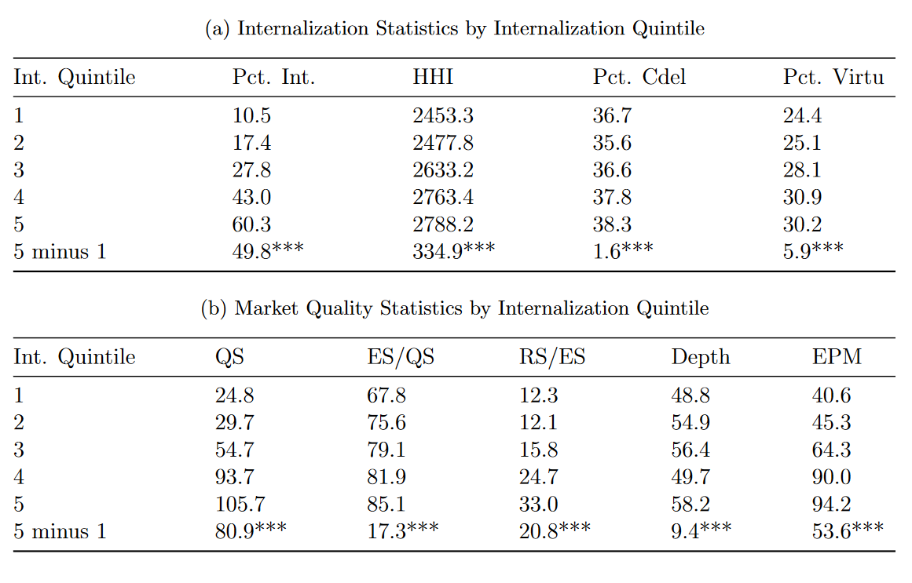
There are several important conclusions to draw from this table. Most importantly, higher rates of internalization are associated with:
- Higher concentration of wholesalers and less competition
- Significantly higher quoted spreads
- Higher effective over quoted spreads
- Higher realized over effective spreads
- Significantly higher extreme price movements.
This last point is important, as mentioned above. Higher rates of internalization are associated with more extreme price movements (i.e. these stocks are more fragile than others).
Both the mandated auction mechanism in the OCR Proposal and a Trade-At rule would dramatically reduce internalization and off-exchange trading. Hu and Murphy demonstrate that when a Trade-At rule was tried in the real world - even under suboptimal conditions - the results were extremely beneficial to market quality.
Many market participants remain concerned about pushing order flow on to exchanges. They rightly point out the problems with our current exchange structure, especially the immunity that exchanges enjoy through their self-regulatory status and the monopolistic power they exert over data and connectivity.
We agree with these concerns. However, we consider it beneficial for the Commission to address these issues in lieu of preserving a non-competitive and inefficient status quo. Despite all of these issues and the privileged regulatory position that wholesalers enjoy today, exchanges still provide surprisingly good environments for trading once you control for order flow characteristics of what ultimately makes it to the exchange. Improving the adverse selection profile of orders going to exchange can only help.
There is a striking difference between the level of competitiveness on-exchange vs off-exchange. The OCR Proposal and the Hu-Murphy Paper show this in several ways, but perhaps one of the best ways of demonstrating this is by examining the ratio of spread earned to the level of adverse selection. This technique, developed by BestEx Research, provides a more accurate picture of the competition level both on- and off-exchange. BestEx Research shows that, in fact, on-exchange trading is 2.3 times more competitive than trading among off-exchange wholesalers.
This lays waste to the wholesalers’ argument that they are providing more price improvement and more competitive trading prices relative to the on-exchange experience. Wholesalers are only able to provide price improvement because they have “first dibs” on any order they receive. They are the exclusive operator of a flash order facility in which they have a free option on every order.
Given the level of competitiveness on-exchange, even under the present extreme circumstances in which the only orders that are sent to exchanges are the orders no other counterparty wants to interact with, there is no reason to think that individual investors will see inferior outcomes on-exchange. In fact, there is good reason to believe that both individual and institutional investors will see far better outcomes than under our current anti-competitive system.
The Commission’s economic analysis in the OCR Proposal makes a compelling case that individual investors are being harmed due to the factors described above, and the harm is significant – between $1.12 billion and $2.35 billion per year. It is noteworthy that this estimate is exactly in-line with the estimates of BestEx Research, who used “different data sources, different methodologies, and different time periods.” This alignment provides robust support to the SEC’s methodology and results.
The SEC’s methodology, however, fails to account for the benefits to institutional investors under an open market regime where the order flow from individual investors is no longer isolated to the exclusive flash order facilities operated by wholesalers. BestEx Research estimates these benefits at $1.86 billion, for a total benefit to individual and institutional investors of $3.56 billion.
Is $3.56 billion the right estimate for the annual benefits of reducing internalization? We do not believe it is even close. The Hu-Murphy Paper found that when internalization was reduced dramatically in TSP3, the average quoted spreads for symbols in which there was little off-exchange competition (High HHI) were “about 20 basis points lower than the average quoted spreads for High HHI TSP2 stocks.”
This meant an approximate spread reduction of 30%, which Hu-Murphy calculated would result in a cost savings of “about $7 billion” for this one class of stock. Taking this benefit, together with the Commission’s competitive shortfall estimate and BestEx Research’s institutional investor estimate, gives us more than $10 billion annually. This is to say nothing of the potential benefits that could result from adoption of an appropriate tick size reduction for securities that are limited in their ability to quote at sub-penny prices. Indeed, this is the Commission’s goal with the NMS Proposal. While we do believe this is a good idea, we are concerned about reducing tick sizes as dramatically as proposed. If tick sizes are reduced an appropriate amount, such stocks would no longer be tick-constrained.
These results are dramatic. They also undermine any contention from supporters of the status quo that the reduction of internalization and increase of on-exchange trading would have any detrimental effects whatsoever. The SEC tried it in the real world. It worked.
This is strong evidence to support WTI’s assessment–the competitive shortfall savings in the OCR Proposal significantly and materially understates the likely benefit to individual investors, as it is only a measure of the competitive shortfall and benefits in the current market. A market in which overall adverse selection is materially lowered on-exchange will result in a significant tightening of quoted spreads, which will provide benefits above and beyond the current competitive shortfall. The reduction in adverse selection on-exchange will increase the profits to on-exchange market makers, which will result in increased on-exchange competition, tighter spreads and deeper, more liquid markets. The total annual estimate of $10 billion in benefits cited above does not account for this positive feedback loop.
Opponents of Trade-At (and likely of the OCR Proposal) will point to studies on Canadian and Australian Trade-At rules that did not produce improvements in market quality.
On this particular point, there are several reasons why it is problematic to draw conclusions from regimes in other countries and compare them to U.S. markets:
- The Canadian Trade-At rule was approved in 2012, after Canadian markets had been operating under a minimum price improvement rule since 1998. U.S. markets have no such rule.
- U.S. markets are far deeper and more liquid, with a broader range of participants.
- Canadian markets are inextricably linked to U.S. markets, and unilateral changes can face difficulties because brokers have the option to route orders south of the border.
- Canadian and Australian markets were still facing tick size constraints, which significantly reduced the benefits from these rules; the U.S. is making concurrent tick size changes that would address this problem.
Despite these issues, the evidence for costs and benefits of Trade-At rules in other countries is mixed, as the OCR Proposal notes in its treatment of the Trade-At alternative. It is difficult to draw any conclusions on the impact of a Trade-At rule in the U.S. based on outcomes in the Canadian or Australian markets.
Fortunately, we need not rely on the results of Trade-At rules in other countries. The Tick Size Pilot actually included a real-world test of Trade-At in U.S. equity markets. And this real-world test was a successful demonstration of the benefits of a Trade-At rule, again despite being tested under the suboptimal conditions of the Tick Size Pilot.
Finally, there have been some notable supporters of a Trade-At rule:
- Virtu Financial
  - “We appreciate the aim of the Pilot’s “Trade-At” requirement, applicable to securities in Pilot Group 3, of facilitating and enhancing the price discovery mechanism on National Stock Exchanges.”
  - Virtu was a founding working group member of the Healthy Markets Association in 2015, whose second highest priority was to establish a Trade-At rule.
  - Virtu publicly endorsed the so-called “Grand Bargain” explained below.
- Citadel
  - “Internalization is one of the greatest threats to price discovery in financial markets.”
  - “Internalization without meaningful price improvement reduces competition, limits price discovery, leads to market fragmentation and should be banned.”
  - Broker-dealers should be permitted to internalize an order “only if the broker-dealer is already quoting on an immediately accessible electronic market at the NBBO for a size no less than the size of the order the broker-dealer is seeking to internalize.”
- New York Stock Exchange and Others
  - In 2015, the NYSE and Credit Suisse announced a “Grand Bargain”, “that would, among other things, ban maker-taker pricing schemes at trading venues because in their view they add to market complexity and the appearance of conflicts of interests, reduce the access fee cap for trading centers from $0.003 per share to $0.0005 per share, and contemporaneously adopt an industry-wide “Trade-At” rule.” This of course makes their recent opposition to the OCR Proposal even more perplexing. Perhaps they should blink twice if Citadel is holding their order flow hostage.

Improving the Auction Proposal
If the Commission chooses not to adopt a Trade-At rule, there are important changes that could be made to the OCR Proposal to reduce unintended consequences and create a competitive, transparent environment. Broadly, WTI believes that the OCR Proposal is overly prescriptive, and that the final rule should allow for greater innovation among qualified auction facilities.
For example, we believe that a batch auction structure is far more compelling and likely beneficial than the proposed call auction structure. We do not claim to know, however, which should be used when, and which option will provide the best outcomes under various security and liquidity circumstances. Therefore we believe the OCR Proposal should be amended to allow for both types of auctions.
We further believe that the time period of 100ms - 300ms is too long, and too likely to result in unintended consequences as it becomes very likely that continuous order book changes can happen during this time period. 100ms is likely the longest time necessary to ensure robust participation from both on-exchange traders and institutional investor order-routing algorithms.
We also agree with the concerns expressed by both Proof Trading and BestEx Research regarding information leakage in these auction facilities, and further agree that “one way the SEC proposal could be tweaked to reduce information leakage for institutional investors would be to omit side from the order attributes that are mandated to be exposed in auction messages.”
Finally, we do not believe that any form of PFOF should be allowed in markets and urge the Commission to ban PFOF in all forms, as discussed in our previous comment letter. Allowing rebates for qualified auctions is antithetical to the notion that retail brokers must route orders based on execution quality, rather than fee structure. Furthermore, if the Commission continues to allow such a fundamentally flawed and conflicted practice to persist, it would be especially dangerous to allow brokers who route orders to qualified auctions to have such volume counted towards other volume-based fee tiers on exchanges.

Combatting the Fear, Uncertainty and Doubt
The high-speed rent seekers and their supporters are left with little honest recourse in the face of the OCR Proposal’s excellent economic analysis. As such, they have resorted to ad hominem attacks and the spreading of Fear, Uncertainty and Doubt (FUD). Their perspective is neither informed by data, nor is it in the best interests of markets. Supporters of the status quo are simply attempting to preserve the current system of high-speed rent seeking and their exclusive position operating flash order facilities. As such, let us examine the most common FUD that they spread and put such claims to rest.

Will the OCR Proposal end zero-commission trading?
Of course not. Regardless of whether the existence of zero-commission trading is a good thing or not, the end of unfettered internalization, and even the elimination of PFOF and exchange rebates, will not end zero-commission trading. While undoubtedly we will see a shake-up of broker business models, and some may start charging commissions again, this will not mean the end of zero-commission trading.
How can we be so certain? There are two primary reasons:
- As the SEC’s analysis shows, many brokers offer zero-commission trading without accepting PFOF .
- Zero-commission trading exists in other countries, including those with Trade-At rules or where PFOF is banned .
Anyone who suggests that the OCR Proposal will end zero commission trading should immediately be discredited and all of their subsequent arguments should be seen as lacking legitimacy.

Will spreads widen under the OCR Proposal?
Not only will spreads not widen under the OCR Proposal, but it is clear from the research cited above that spreads will tighten. WTI believes that spreads are likely to tighten far more under a Trade-At rule than with mandated auctions, but still believe there will be material and significant positive spillover effects of retail auctions. When a greater diversity of market participants have access to low adverse selection order flow, and as competition consequently becomes fiercer and more open, those benefits will be reflected in the NBBO. Even though their study did not specifically encounter the envisioned market structure of mandated retail auctions, the Hu-Murphy Paper did find positive NBBO spillover effects when internalization was competitive (Low HHI). There is every reason to believe that such an effect would also pertain to competitive auctions.
WTI believes that these positive effects are less readily predicted under the mandated auction model because there is no equivalent international or domestic point of comparison. However, given the U.S. experience with the Tick Size Pilot discussed above, the benefits under a Trade-At rule are likely to be substantial.
WTI again urges the Commission to ban all forms of PFOF. As we discuss in our previous comment letter, these practices lead directly to wider spreads. Nearly every international regulator who has banned the practice agrees.

How important is cross-subsidization? Is it even a good thing?
Another argument consistently proffered by high-speed rent seekers trying to preserve their exclusive flash order facilities is that the practice allows them to cross-subsidize lower-liquidity thinly traded stocks with the profits they earn from providing inferior execution quality on higher-liquidity actively traded stocks.
Is this a beneficial outcome for markets? If you believe it preferable that stock prices accurately reflect supply/demand dynamics, it makes little sense to support this outcome.
Increasing liquidity and improving market quality for smaller capitalization or lower liquidity companies is an important goal, and one that has been sacrificed in the interests of the one-size-fits-all market structure approach of the past.
Most market participants can agree on at least one point: One-size-fits-all market structure does not work, and has not worked historically. However, we would prefer the Commission actually solve this problem, rather than relying on the rent-seeking middlemen who hold our markets hostage.

Conclusion
It is unfortunate that in the face of potential revenue loss, supporters of the status quo have resorted to ad hominem attacks, scaremongering and FUD. Industry firms fear change, especially when such change could threaten revenue and annual bonuses. However, for too long the Commission has promulgated regulation that picks winners and losers, instead of creating a fair, level, transparent playing field where open competition for order flow can determine winners and losers in markets.
Large parts of the industry have supported the reduction of excessive off-exchange trading for many years, including many current opponents of change who, in the face of regulatory stagnation and inaction, determined that they could not beat the rent seekers, and therefore resolved to join them. For example, Ken Griffin, the CEO of Citadel explained in 2004 that he believed “that the potential long-term impact of internalization is so corrosive to our national market system that the Commission should take every possible step to curtail this business practice. Indeed, the dramatic fall in processing costs in recent years almost completely eviscerates the arguments in favor of internalization.”
We applaud the Commission for seeing through these motives, and pushing to increase competition, reduce intermediation and improve market quality. We support the Commission’s efforts, although we believe that a simple Trade-At rule will be more effective at accomplishing those goals than the mandated retail auction mechanism specified in the OCR Proposal.
Sincerely,

[YOUR NAME]
[ANY OTHER INFO, SUCH AS YOUR TITLE/POSITION AND FIRM]

We The Investors, launched in March 2022, is a grassroots advocacy campaign built by, and for, individual investors. Our mission is to educate individual investors in order to empower them to represent themselves on market structure issues. We are supported by industry firms and over a hundred thousand individual investors.
The Investors’ Bill of Rights can be accessed at: https://www.urvin.finance/advocacy
We The Investors, “Sec Letter #01: payment for order flow (PFOF)” Urvin Finance, (May 27, 2022), Available at https://www.urvin.finance/advocacy/wti-sec-pres-01/
U.S. Department of Justice, “Herfindahl-Hirschman Index”, (July 31, 2018), Available at https://www.justice.gov/atr/herfindahl-hirschman-index Note: HHI is “a commonly accepted measure of market concentration” that “takes into account the relative size distribution of the firms in a market. It approaches zero when a market is occupied by a large number of firms of relatively equal size and reaches its maximum of 10,000 points when a market is controlled by a single firm.”
Hu, Edwin and Murphy, Dermot, “Competition for Retail Order Flow and Market Quality”, SSRN, (June 8, 2022). Available at https://ssrn.com/abstract=4070056 or http://dx.doi.org/10.2139/ssrn.4070056 (“Hu-Murphy Paper”)
Ibid.
Ibid. Note: When a market is classified as a “highly concentrated market” the primary result is increased scrutiny of any merger that would “increase the HHI by more than 200 points” by both the DOJ and FTC.
Ibid.
Blaugrund, M.; Clague, J. & Mecane, J., “Comment Letter–Re: Equity Market Structure Proposals (File Numbers S7-29-22, S7-30-22, S7-31-22, and S7-32-22)”,Securities and Exchange Commission (SEC), (March 6, 2023), Available at https://www.sec.gov/comments/s7-31-22/s73122-20158677-326603.pdf
SIFMA, “SIFMA Statement on SEC Equity Market Structure Proposals”, Traders Magazine, (Dec. 15, 2022), Available at https://www.tradersmagazine.com/am/sifma-statement-on-sec-equity-market-structure-proposals/
Cifu, Doug, “Statement Before SEC Investor Advisory Committee Meeting”, Securities and Exchange Commission, (June 10, 2021), Available at https://www.sec.gov/comments/265-28/26528-8901053-242178.pdf
Blaugrund, M.; Clague, J. & Mecane, J., “Comment Letter–Re: Equity Market Structure Proposals (File Numbers S7-29-22, S7-30-22, S7-31-22, and S7-32-22)”, Securities and Exchange Commission (SEC), (March 6, 2023), Available at https://www.sec.gov/comments/s7-31-22/s73122-20158677-326603.pdf
Ibid.
Langton, J., “SIFMA Calls for Review of SRO Structure”, Investment Executive, Available at https://www.investmentexecutive.com/news/industry-news/sifma-calls-for-review-of-sro-structure/
The Exchange, “Virtu Financial CEO weighs in on payment for order flow regulation”, CNBC, (June 8, 2022), Available at https://www.youtube.com/watch?v=K064hJQ7fdI Note: Wholesalers are not performing magic, as far as we know. Given Doug Cifu’s claim that “wholesalers provide infinite liquidity at the NBBO,” one is left to wonder out of which bottomless magic hat Virtu is pulling these shares. More seriously though, there is a fundamental hypocrisy to operating a service that destroys the NBBO, and then pointing out how much better Virtu is relative to the benchmark that they have ruined.
Cifu, Doug, “Measuring Real Execution Quality: Benefits to Retail Are Significantly Understated”, Virtu Financial, (June 10, 2021), Available at https://www.sec.gov/comments/265-28/26528-8901054-242178.pdf
Babelfish Analytics, “Meme Stocks: Inaccessible Trading Share, Trading Cost, and Risk”, (Feb. 5, 2021), Available at https://www.babelfishanalytics.com/news/2021/2/4/meme-stocks-inaccessible-trading-share-trading-cost-and-risk
Cifu, Doug, “Measuring Real Execution Quality: Benefits to Retail Are Significantly Understated”, Virtu Financial, (June 10, 2021), Available at https://www.sec.gov/comments/265-28/26528-8901054-242178.pdf
Gerko, Alexander, “Separating Fiction from Facts Separated from Fiction”, LinkedIn, (June 11, 2021), Available at https://www.linkedin.com/pulse/separating-fiction-from-facts-separated-alexander-gerko/?trackingId=rB1JHjQsU%2FbVNNEIrioDNw%3D%3D
Mittal, Hitesh, “Is the Order Competition Rule a Windfall for Investors?”, BestEx Research, (January 5, 2023). Available at https://4982966.fs1.hubspotusercontent-na1.net. (“BestEx Research”)
Cifu, Doug, “Comment Letter–Re: Proposed National Market System Plan To Implement a Tick Size Pilot Program on a One-Year Pilot Basis”, Virtu Financial, (Dec. 19, 2014), Available at https://virtu-www.s3.amazonaws.com/uploads/documents/2014.12.19-Virtus-Comment-Letter-Proposed-National-Market-System-Plan-To-Implement-a-Tick-Size-Pilot-Program-on-a-One-Year-Pilot-Basis.pdf
SUBCOMMITTEE ON SECURITIES, INSURANCE, AND INVESTMENT OF THE COMMITTEE ON BANKING, HOU.S.ING, AND URBAN AFFAIRS UNITED STATES SENATE, “Hearing: COMPUTERIZED TRADING VENUES: WHAT SHOULD THE RULES OF THE ROAD BE?”, (Dec. 18, 2012), Available at https://www.govinfo.gov/content/pkg/CHRG-112shrg80273/pdf/CHRG-112shrg80273.pdf
Order Competition Rule. 88 FR 128, (“OCR Proposal”) at 113, Federal Register, (Jan. 3, 2023), Available at https://www.federalregister.gov/documents/2023/01/03/2022-27617/order-competition-rule
Bishop, Allison, “Comment Letter–Re: Order Competition Rule, Release No. 34-96495; File No. S7-31-22”, Proof Trading, (Feb. 8, 2023), Available at https://www.sec.gov/comments/s7-31-22/s73122-20156866-325036.pdf
We The Investors, “Comment Letter–Re: Rule Proposal No. 34-96496; File No. S7-32-22 Regulation Best Execution and Rule Proposal No. 34-96494; File No. S7-30-22 Regulation NMS: Minimum Pricing Increments, Access Fees, and Transparency of Better Priced Orders”, Urvin Finance, (March 31, 2022)
See OCR Proposal footnote 583: “It’s also important to note that even brokers that do not accept PFOF experienced increased revenue and profits, despite adopting zero commissions. See Kenneth Corbin, Fidelity Posts 6th Straight Record Profit, Barrons (Mar. 9, 2022), available at https://www.barrons.com/advisor/articles/fidelity-earnings-2021-51646853970”
Unrau, Heidi, “Free Trading: The Best Zero Commission Brokers in Canada”, Hardbacon, (Jan 24, 2022), Available at https://hardbacon.ca/en/investing/zero-commission-trading-in-canada/ Note: There are many zero-commission brokers in Canada, where internalization without material price improvement is not permitted.
We The Investors, “Comment Letter–Re: Rule Proposal No. 34-96496; File No. S7-32-22 Regulation Best Execution and Rule Proposal No. 34-96494; File No. S7-30-22 Regulation NMS: Minimum Pricing Increments, Access Fees, and Transparency of Better Priced Orders”, Urvin Finance, (March 31, 2022)
Securities and Exchange Commission (“SEC”) Division of Trading and Markets, “Memorandum–Re: Maker-Taker Fees on Equities Exchanges”, (Oct. 20, 2015), p. 6-7, Available at https://www.sec.gov/spotlight/emsac/memo-maker-taker-fees-on-equities-exchanges.pdf
Cifu, Doug, “no arguments from me! Never asked and never needed any of that stuff. Simple transparent and fair,” [Tweet], Twitter, Available at https://twitter.com/Dougielarge/status/545911383070875649
Gerko, Alex, Citadel has some opinions on tick sizes in TSE (which happens to be the most liquid market in the world…, [Tweet], Twitter, Available at https://twitter.com/alexandergerko/status/1633503897456189440?s=46&t=rb20g8nBaKrXwcHTKQ92NQ
It is important that the Commission ensure that material price improvement is required for any off-exchange trading of small orders. The Commission has recognized this in the OCR Proposal, only allowing trades to be internalized at the midpoint. This is the same benchmark we would urge for a Trade-At rule.
Michaels, Cody, “Commission Free Trading UK 2023—Best Zero Fee Brokers”, Traders Best. (March 4, 2023), Available at https://www.tradersbest.com/uk/stocks/commission-free/ Note: There are many zero-commission brokers in the UK, where neither internalization nor PFOF is permitted., See https://www.tradersbest.com/uk/stocks/commission-free/
Gallagher, Anthony, “6 “Best” Singapore Stock Brokers”, Securities.io. (March 5, 2023), Available at https://www.securities.io/top-5-singapore-stock-brokers/ Note: There are many zero-commission brokers in Singapore, where PFOF is not permitted.
Rapaport, Emma, “$0 commissions: Australia's trading fee shakedown gathers steam”, MorningStar,(June 1, 2020), Available at https://www.morningstar.com.au/insights/stocks/202847/0-commissions-australias-trading-fee-shakedown-gathers-steam Note: There are many zero-commission brokers in Australia, where internalization without material price improvement is not permitted and PFOF is not prevalent.
Also See OCR Proposal at 302: “the majority of PFOF received by retail brokers comes from transactions in the options market.” and “the retail broker industry did not experience a drop in profits following the end of commissions. This includes non-PFOF brokers, who did not choose to make up for lost commission revenue by charging wholesalers PFOF.”
Also See OCR Proposal at 303-304: “The average PFOF payment that brokers receive on a 100 share order is 10 to 20 cents, far less than the commission fees previously charged by broker-dealers.”
Gerko, Alexander, “Which country has the most liquid equities market?”, LinkedIn, (Feb. 15, 2021), Available at https://www.linkedin.com/pulse/which-country-has-most-liquid-equities-market-alexander-gerko/ Note: It is worth highlighting one more point from that post which, while not directly pertinent to the Order Competition Rule, is nonetheless an important regulatory consideration: “fixed costs of accessing this liquidity in the U.S. (market data, colos, sophisticated SOR technology etc) is different by orders of magnitude, especially compared to Japan and Korea.”
IIROC-OCRCVM at 6.6, “Annotated Universal Market Integrity Rules”, (March 1, 2023), Available at https://www.iiroc.ca/media/1021/download?inline#%5B%7B%22num%22%3A315%2C%22gen%22%3A0%7D%2C%7B%22name%22%3A%22FitR%22%7D%2C-289%2C-5%2C901%2C796%5D
U.S. Department of Justice, “Herfindahl-Hirschman Index”, (July 31, 2018), Available at https://www.justice.gov/atr/herfindahl-hirschman-index
BestEx Research
Ibid.
The Tick Size Pilot was an indiscriminate widening of spreads, regardless of whether stocks were tick-constrained or not, which made it difficult to easily understand the results. It was generally considered a failure, but this perspective and conclusion lacks nuance. Subsequent studies provide a deeper understanding of the Tick Size Pilot. For example, a DERA study from November 2022 showed that literature examining the Tick Size Pilot was flawed due to “treating all non-tick constrained stocks the same in their empirical analysis.” When decomposing results into tick and non-tick constrained stocks, that study was able to show significant benefits from the Tick Size Pilot for certain stocks. As the Commission makes holistic changes to market structure, including tick size reform, it is reasonable to draw the conclusion from this study and others that the benefits will be complementary. See: https://www.sec.gov/files/dera_wp_ticksize-pilot-revisit.pdf
Hu-Murphy Paper at 33
Ibid. at 34
Regulation NMS: Minimum Pricing Increments, Access Fees, and Transparency of Better. Release No. 34-96494; File No. S7-30-22 (“NMS Proposal”) at 308, Federal Register, (Dec. 14, 2022), Available at https://www.sec.gov/rules/proposed/2022/34-96494.pdf
Cooper, Adam, “Comment Letter–Re: Release No. 34-49175; File No. S7-07-04 — Competitive Developments in the Options Markets”, Securities and Exchange Commission, Available at https://www.sec.gov/rules/concept/s70704/citadel04132004.pdf
The latency race to zero is a socially wasteful outcome that results from various inducements and incentives in our current market structure. These inducements and incentives push firms to invest in faster and faster technology, because our current structure rewards speed above all else. This results in less market making diversity and fewer profitable trading strategies. As a consequence, markets become more “self-similar” and more fragile.
Ramsay, John, “Comment Letter-Re: File No. S7-30-22; Release No. 34-96494; Regulation NMS: Minimum Pricing Increments, Access Fees, and Transparency of Better Priced Orders”, Securities and Exchange Commission (SEC), (March 20, 2023)
See infra, Ken Griffin Hates Internalization
See infra, Ken Griffin Hates Internalization
Griffin, Kenneth, “Comment Letter–Re: Regulation NMS - File No. S7-10-04”, Securities and Exchange Commission, Available at https://www.sec.gov/rules/proposed/s71004/s71004-436.pdf (“Ken Griffin Hates Internalization”)
See infra, Ken Griffin Hates Internalization
See infra, Ken Griffin Hates Internalization
See infra, Ken Griffin Hates Internalization
See infra, Ken Griffin Hates Internalization

