United Way Newsletter Blurbs 2021

Early childhood development is important, and what is known as the achievement gap begins as early as early childhood programs. Children who don’t meet these milestones are more likely to fall behind their peers in cognition, language, and behavior control, which will have great impact on their learning and academic achievement later in life. Your donation to the United Way Impact Fund will support the development of children in our community.

In 2020, there were 1,785 domestic violence assaults reported in Lincoln. Your contribution to the United Way Impact Fund helps give agencies the ability to assist these individuals so they can provide them with the comprehensive and positive support they need.

According to 2019 census data, 33,000 people in Lancaster County are living in poverty, 7,634 of whom are children. And according to Lincoln Vital Signs most recent data, in the city of Lincoln alone, 14.7% of children live at or below the poverty line. We know that the pandemic worsened the economic outlook for many in our community. Your donation to the United Way Impact Fund assists these families so they not only have access to food and shelter, but also programs that help them build a more stable future.

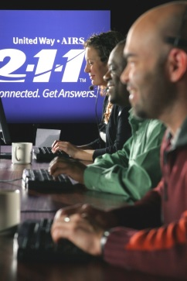
2-1-1 is a call center that provides information and referrals to individuals and families in need, 24 hours a day, seven days a week. During 2020, trained 2-1-1 staff helped 4,010 callers from Lincoln and Lancaster County. The number of callers looking for food support increased by 60 percent. By contributing to the United Way Impact Fund, you are helping provide this invaluable service.

Nearly half of Lincoln Public School students receive free or reduced lunches. By third grade, the reading level of these students tends to be 16 percentage points lower than their peers, making these students four times more likely to drop out of school without a diploma. By contributing to the United Way Impact Fund, you are supporting these children so they can focus on their education rather than where their next meal will come from.

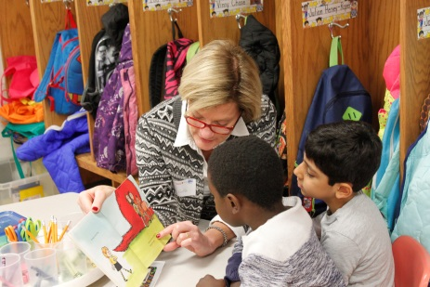
Reading for just 15 minutes a day exposes a child to over 1 million words of text in a year. In 2020, United Way distributed 6,794 books to children in Lincoln and Lancaster County, helping them build their home libraries. By donating to the United Way Impact Fund, you’re supporting programs that ensure the children in our community are given opportunities to become proficient readers.

Did you know that children who spend at least half their childhood in poverty are 90% less likely to graduate with a diploma? Your donation to the United Way Impact Fund supports programs that give children the help they need so they can receive a fulfilling education and one day, a diploma.

114,233 nights of emergency and transitional shelter were used to assist individuals with housing services and maintain stable housing in Lincoln and Lancaster County this past year. Your donation to the United Way Impact Fund helps provide accommodations to those in our community who need it most.

Did you know that of the 10 leading causes of death, seven are chronic illnesses? Half of all Americans are living with at least one chronic illness. Donating to the United Way Impact Fund gives resources to programs that support sufferers of chronic disease and help to provide assistance and education to them and their families.

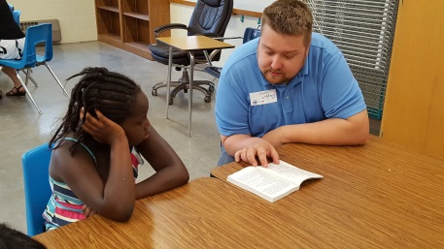
In 2020, 2,043 children improved academic performance. Additionally, 4,423 youth developed positive relationships with at least one adult. Students from low-income backgrounds are more likely to struggle academically than their peers. Your donation to the United Way Impact Fund supports an array of programs that close the achievement gap in our community.

Mental health is an important component of overall well-being. Lincoln residents say they experience 3 days of poor mental health per month, and on average, Lincoln Police Department receives a call relating to suicide every day. By donating to the United Way Impact Fund, you’re helping our partner agencies provide support to individuals who struggle with their mental health, helping them get back on the path to living a fullfilling life.

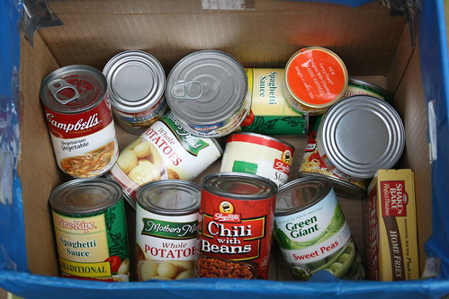
Last year, 6,069,222 pounds of food were distributed to those in need. Your contribution to the United Way Impact Fund helps agencies fight hunger amongst the impoverished individuals and families throughout our community.

For students to be successful, they need to find stability and strength at home. The Lincoln community is tackling chronic absenteeism, and you can help by supporting Stable. Strong. Successful. – a new initiative by United Way. Through Stable. Strong. Successful. families will receive the support they need to face life’s many challenges and set the young students in their family up for success along the way. Stable families. Strong homes. Successful students.

