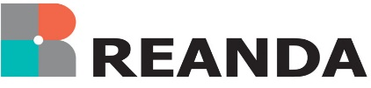
REANDA INTERNATIONAL
FIRM INFORMATION SHEET
- Contact detail
Name of contact
Position
Tel
Fax
Address
Email
Website
B. About your firm
- Firm name
- Establishment year of the firm
- Form or nature of the business entity under which it operates
- The business scope of your firm
- The name of the regulation body of which the firm or its partners are oversighted
- Number and location of offices
- Other network/association to which the firm is/was a member or has affiliation. Please give details
- Size of firm
(a) Number of partners
(b) Number of professionally qualified staff
(c) Total number of staff (excluding partners)
(d) An estimate of annual turnover attainable by the firm in 2023 and the comparative in 2022
(e) Analysis of the firm’s annual turnover ending 31 December 2022 or the latest practical day
- Audit and assurance for listed companies
- Audit and assurance for others
- Bookkeeping and accountancy
- Company secretarial
- Advisory
- Corporate finance
- Litigation
- Management consulting / insolvency
- Tax
- Valuations
- Others
- Client services provided, services specialized in
- List of principal clients so far as they may be disclosed
- The eligibility to sign audit reports for listed company
- Industry specialty
- Languages spoken within the Firm
- Others (e.g. ranking published by local regulatory body that the firm has participated in, if any)

