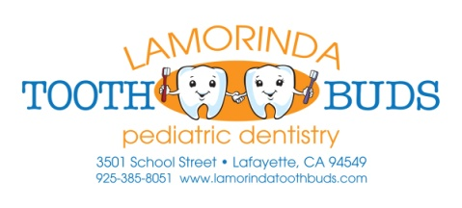

Consent for Protective Stabilization
Protective stabilization may include using a papoose board and Velcro straps or being physically restrained by a parent, guardian, and/or dental staff member, if necessary.
Protective stabilization if often necessary if the patient is not yet able to cooperate due to age or mental or physical impairment and treatment is needed to prevent or treat pain/infection. The safety of the patient, staff or guardian may be at risk without the stabilization.
Benefits:
- Patients who are unable to cooperate may need to be physically stabilized to complete dental treatment. Stabilization allows dental treatment to be done more safely and effectively.
Risks:
- Chance of injury, such as bruising or skin abrasion, choking, panic attacks and injuries to the person performing the restraining.
Alternatives:
- Not having any treatment or postponing treatment, if treatment is unable to be performed in a safe manner without the use of protective stabilization. Delaying treatment may cause further progression of dental disease, further damage to teeth, or swelling/infection may occur.
- Treatment under sedation – i.e. General Anesthesia
The use of protective stabilization for treatment has been fully explained to me. I have given the doctors and staff at Lamorinda Tooth Buds – Pediatric Dentistry a complete review of my child’s medical history. I consent to treatment of my child as explained above and all my questions have been answered.

________________________________________________ ___________________________________ Child’s Name Date
________________________________________________ ___________________________________ Parent/Guardian Name Parent/Guardian Signature

