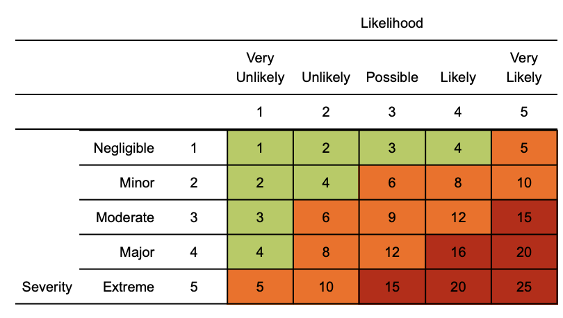
Risk matrix used in risk assessment below
RR = residual risk

Use guidance from the government and industry bodies to ensure the risk assessment is following the latest advice. You will need to amend the assessment to suit the controls at your premises. This document is uncontrolled once downloaded or printed.

Struggling to complete the risk assessment?
Try HandsHQ and complete a risk assessment in minutes

Coronavirus (COVID-19) Construction risk assessment

Contents:
General risk of contracting covid
Suspected case of covid on site
General travel - including international travel
Access / egress to site
Poor hygiene
Use of welfare facilities
Manual Handling
First aid - including mental health
Visiting client premises
Stress

Assessment date: 21st July 2021
Review date: 21st July 2021
Version: 10.0

Hazard | Risk | Control measures | RR | Persons at risk
General risk of contracting covid  This assessment accepts the following groups are at high risk: older males, those with a high BMI; those with existing health conditions; and those who are black, Asian or minority ethnicity (BAME) | 3  x  4  =  12 | Anyone who has the following will be turned away from site:  1. A high temperature, a new continuous cough, or a loss of, or change in, their normal sense of taste or smell;  2. Is within 10 days of receiving a positive Coronavirus (Covid-19) test result;  3. Has returned from a country where you are required to quarantine for 14 days;  4. Contacted by the NHS Test & Trace app to self isolate  It is up to the business to decide a phased return back to the office however, a flexible working policy should be in place as part of the company management system  Any changes to local and national government guidelines are to be followed  Ensure a single point of contact (SPOC) is nominated for reporting and investigation requirements | 2  x  1  =  8 | Individual workers
Suspected case whilst working on site | 4  x  4  =  16 | If a worker develops suspected COVID-19 symptoms the following should occur:  - Worker to return home immediately  - They must then follow the guidance on self-isolation and not return to work until their period of self-isolation has been completed  - The work area should receive deep cleaning and social distancing maintained. Please consult specific company procedures  - A single point of contact (SPOC) is to be nominated for liaising with the authorities | 4  x  1  =  4 | Individual workers
General travel including international travel | 3  x  4  =  12 | - Do not travel if you are experiencing covid symptoms, received a positive covid test or have been informed by NHS Test & Trace to self isolate.  - Travelling abroad must be undertaken in line with the government traffic light scheme.  - Where an occupational health (OH) service provider has been appointed, please seek additional advice or concerns through this service  - When using public transport, it is strongly advised to wear face covering  - Where corporate vehicles are shared (such as minibuses), limit passengers, increase ventilation and cleaning and encourage bubbles amongst staff (cohorting) | 4  x  1  =  4 | Individual workers
Access / egress to site | 4  x  3  =  12 | - Log all visitors to the site and continue to utilise the NHS test & trace scheme. Where large events are concerned, the NHS Covid Pass needs to be followed.  - Encourage all workers to maintain high levels of hand washing hygiene before entering or leaving the site  - Regularly clean common contact surfaces in reception, office, access control and delivery areas e.g. scanners, turnstiles, screens, telephone handsets, desks etc  - Increase ventilation across site where possible  - Continue to wear PPE in accordance with both site rules and your own task risk assessment. | 4  x  1  =  4 | Individual workers
Poor hygiene | 4  x  3  =  12 | - Wash your hands thoroughly and regularly. Use soap and water for at least 20 seconds. Use alcohol-based hand sanitiser if soap and water is not available and hand washing technique to be adopted as directed by NHS  - Avoid touching your face/eyes/nose/mouth with unwashed hands and cover your cough or sneeze with a tissue then throw it in the bin.  - Regularly clean the hand washing facilities and check soap and sanitiser levels  - Provide suitable and sufficient rubbish bins for hand towels with regular removal and disposal.  - Monitor levels of stock and top up accordingly  - Continue to enhance the cleaning regimes for toilet facilities, particularly door handles, locks and the toilet flush | 4  x  1  =  4 | Individual workers
Use of welfare facilities on site - exposure from large numbers of persons | 4  x  2  =  8 | - Dedicated eating areas should be identified on site to reduce food waste and contamination  - Break times are encouraged to be staggered to reduce congestion  - Hand cleaning facilities or hand sanitiser should be available  - All areas used to receive regular cleaning  - Increase ventilation in common areas where possible | 4  x  1  =  4 | Individual workers
Manual handling - dual lifting (risk of transmission) | 4  x  3  =  12 | - Always consider if the task can be performed with one person using mechanical aids  - Ensure the individual(s) are fit for work prior to commencing task, showing no covid symptoms  - Break down the load where possible so that one person can comfortably carry  - Where teams are used, cohorting fixed teams is encouraged | 4  x  1  =  4 | Individual workers
First aid - including mental health | 4  x  2  =  12 | - First aid contents to be monitored to ensure adequate supplies remain  - First aid cover arrangements to be reviewed  - First aiders to ensure they have received refresher training so that any amended practices to keep people safe from covid is followed  - Emergency plans on site and communicated so all staff understand what action to take in the event of a confirmed case of covid  - Mental health first aiders (MFHA) to be implemented as required  - Communicate any occupational health service available to the workforce including any available employee assistance programme (EAP)  - Line management to regularly communicate to their team(s)  - Effective reporting system established on site in order to rectify any raised issues or incidents in a timely manner | 4  x  1  =  4 | Individual workers
Visiting client premises | 4  x  3  =  12 | - Do not travel if you are experiencing covid symptoms or have been contacted by test & trace to isolate  - Check beforehand that the client is still happy for your visit and understand what covid arrangements the site would like you to continue to follow  - Use welfare facilities properly, maintaining good hygiene  - Try to not share items with client (pens, notepads, laptops etc)  - Staff are encouraged to have hand sanitiser available in case welfare supplies are not available | 4  x  1  =  4 | Visitors and client employees (host)
Stress | 4  x  3  =  12 | - Remote staff to receive periodic contact via online team meeting or line management calls  - Advise staff of technology apps that can assist with stress management  - Where enrolled, advise staff about occupational health advice available, including any confidential assistance programmes (EAP)  - Stress assessments available from H&S / HR specialists  - Offer flexible working arrangements where possible | 4  x  1  =  4

Training
Please ensure a manager’s brief has been completed alerting to company specific COVID process / procedures and this assessment.

Additional guidance can be found in this link:
https://www.gov.uk/guidance/working-safely-during-coronavirus-covid-19/construction-and-other-outdoor-work

Training actions include:
- Develop clear communication and training materials / resources for ensuring the workforce has Covid-19 awareness
- Assess what refresher covid training may be required with your workforce
- Consider whether any mental health first aiders or mental health awareness training is required across the workforce
- Where an employee assistance programme (EAP) is operated, ensure the workforce are aware and have access to it

Management Controls
Covid Priority Actions (as stated within the government guidance):
- Continue to complete risk assessments and incorporate the risk of covid
- Ensure there is adequate ventilation within the workplace
- Ensure there is enhanced cleaning within the workplace
- Continue to turn staff, visitors, contractors and others who are experiencing covid related symptoms
- Ensure that staff are able to check in via the NHS Test & trace scheme and the NHS covid PASS for higher risk premises and crowded venues
- Ensure that your staff are regularly communicated with and suitably trained in covid arrangements

General Management controls:
- Ensure the covid risk assessments are reviewed and communicated to the workforce
- For businesses that employ more than 50+ persons, the risk assessment results shall be published / displayed
- Ensure fixed teams are allocated where possible (cohorting)
- Ensure the mental health of the workforce is monitored
- Monitor regional changes (England, Wales, Scotland and Ireland) to remain compliant
- Monitor international travel guidance and ensure suitable safe systems of work are drawn up
- Monitor changing industry guidance applicable to your business - For reference, the new statement (dated 15/7/21) from the Construction Leadership Council (CLC) is located here - https://www.constructionleadershipcouncil.co.uk/wp-content/uploads/2021/07/CLC-Statement-15-July-2021-Site-Operating-Procedures-Lifting-of-Restrictions-Statement.pdf
- Ensure hazardous waste processes are implemented for sites to manage covid related hazardous waste such as covid tests.
- Ensure a single point of contact (SPOC) is nominated to liaise with the authorities.
- Implement a flexible working policy

