 | 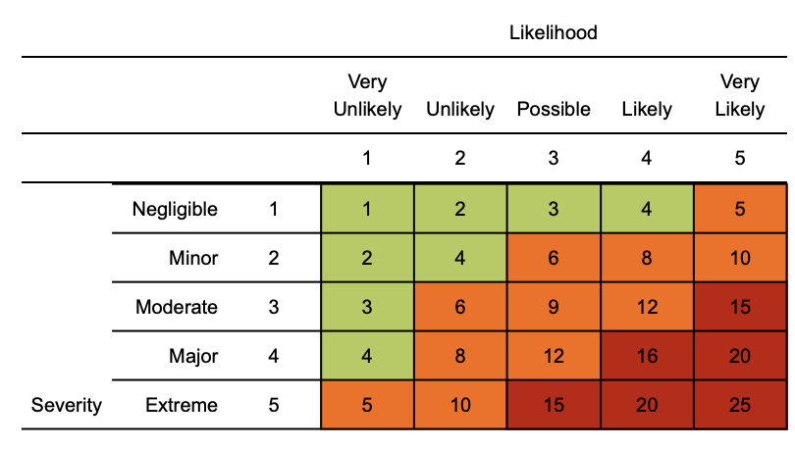  Risk matrix used in risk assessment below  RR = residual risk

Please note this is an example COVID risk assessment to help you plan hospitality premises reopening and is not an exhaustive list. Please continue to check back with developing government, local authority and industry body advice to delete, amend and add content as appropriate.

Struggling to complete the risk assessment?
Try HANDS HQ and complete a risk assessment in minutes

Coronavirus (COVID-19) Retail Risk Assessment
Contents
Non essential workers
Individuals at increased risk
Travel
Social distancing
Welfare & hygiene
Meetings
General infection control
Protecting the public
Stress including mental health
Emergencies
Inbound / outbound of goods

Assessment date: 28th May 2020
Review date: 28th June 2020
Version: 1.0

Hazard | Risk | Control measures | RR | Persons at risk
Transmission from non-essential workers | 4  x  4  =  16 | - Only essential workers to work in the shop  - Those in back of house and administrative functions should continue to work from home where possible  - It will be determined what the minimum number of people needed is on the premises to operate safely and effectively  - Those working from home should receive regular contact from line management and ensure that correct work equipment and access to appropriate work systems is available | 1  x  4  =  4 | Employees
Individual workers at a higher risk if contracting COVID 19 | 4  x  4  =  16 | - Clinically extremely vulnerable individuals shall remain shielded in accordance with their medical advice  - If clinically vulnerable (but not extremely clinically vulnerable) workers cannot work from home, they should be offered the option of the safest available on-site roles  - Assess and making reasonable adjustments to avoid disabled workers  being put at a disadvantage. Equality remains promoted throughout the business  - Additional risk assessment remain as a requirement for new or expectant mothers | 1  x  4  =  4 | Individual employees
Risk of COVID 19 transmission - Staff travelling to and from work | 4  x  4  =  16 | - Commuting to work via walking, cycling or private transport where possible  - Public transport to be used as last resort and face covering recommended when travelling but not essential  - Providing additional parking or facilities such as bike racks to help people walk, run, or cycle to work where possible  - Staggering arrival and departure times at work to reduce crowding into and out of the workplace  - Reducing congestion, for example, by having more entry points to the workplace | 1  x  4  =  4 | Employees
Social distance when using the premises including access / egress | 4  x  4  =  16 | - Maintain social distancing in the workplace wherever possible  - Where the social distancing guidelines cannot be followed in full in relation to a particular activity, businesses should  consider whether that activity needs to continue and implement additional measures  - Use ‘fixed teams or partnering’ where possible (so each person works with only a few others)  - Consideration into plexiglass at points of transaction  - Setting up 2m signage and one way systems where the premises design permits  - Regulating use of high traffic areas including corridors, lifts and staircases to maintain social distancing  - Social distancing to also be maintained with staff using break out and canteen facilities  - ‘Pinch’ points and high traffic areas to be regulated by staff | 1  x  4  =  4 | All those using retail premises
Meetings | 4  x  3  =  12 | - Using remote working tools to avoid in person meetings  - Only absolutely necessary participants should attend meetings and should maintain 2m separation throughout  - Avoiding transmission during meetings, for example avoiding sharing pens and other objects  - Providing hand sanitiser in meeting rooms  - Holding meetings outdoors or in well-ventilated rooms whenever possible  - For areas where regular meetings take place, use floor signage to help people maintain social distancing | 1  x  4  =  4 | Employees
Welfare & hygiene - handwashing, sanitation  facilities and toilets | 4  x  4  =  16 | - Wash your hands thoroughly and regularly. Use soap and water for at least 20 seconds. Use alcohol-based hand sanitiser if soap and water is not available and hand washing technique to be adopted as directed by NHS  - Providing handwashing facilities, or hand sanitiser points, especially at retail entrance and exit points where not possible  - Avoid touching your face/eyes/nose/mouth with unwashed hands and cover your cough or sneeze with a tissue then throw it in the bin  - Increase cleaning rota / schedule in your work area  - Enhance the cleaning regimes for areas with high traffic or ‘touch points in the vicinity’  - Provide suitable and sufficient rubbish bins for hand towels with regular removal and disposal  - Ensure sufficient supplies of soap, hand sanitiser and paper towels remain in place  - Requesting staff change into work uniforms on site using appropriate facilities/changing areas, where social distancing and hygiene guidelines can be met  - Washing uniforms on site rather than by individual staff members at home  - Payments should be encouraged using contactless methods where possible | 1  x  4  =  4 | All those accessing and using the retail premises
General Infection control | 4  x  4  =  16 | - Display the government COVID 19 poster to show commitment that the premises have been made COVID secure  - Encouraging customers to avoid handling products whilst browsing, if at all possible  - Encouraging customers to shop alone where possible, unless they need specific assistance  - Putting teams into shifts to restrict the number of workers interacting with each other  - Use safe outside areas for breaks  - Opening windows and doors frequently to encourage ventilation, where possible  - Wedging doors open, where appropriate, to reduce touchpoints. This does not apply to fire doors  - Where you are already using PPE in your work activity to protect against non-COVID-19 risks, you should continue to do so  - Unless you are in a situation where the risk of COVID-19 transmission is very high, your risk assessment has reflected the fact that the role of PPE in providing additional protection is extremely limited  - Continuing to keep customer restaurants and cafes closed until further notice, apart from when offering hot or cold food to be consumed off the premises  - Checking whether you need to service or adjust ventilation systems, for example, so that they do not automatically reduce ventilation levels due to lower than normal occupancy levels  - Limiting customer handling of merchandise, for example, through different display methods, new signage or rotation of high-touch stock  - Putting in place picking-up and dropping-off collection points where possible, rather than passing goods hand-to-hand.  - Setting up ‘no contact’ return procedures where customers take return goods to a designated area | 1  x  4  =  4 | All those accessing and using the retail premises
Protecting members of the public | 4  x  4  =  16 | - Working with neighbouring businesses and local authorities to consider how to spread the number of people arriving throughout the day for example by staggering opening hours; this will help reduce demand on public transport at key times and avoid overcrowding  - Limiting the number of customers in the store, overall and in any particular congestion areas, for example doorways between outside and inside spaces  - Continue to provide and monitor queue management systems  - Ensuring any changes to entries, exit and queue management take into account reasonable adjustments for those who need them, including disabled shoppers  - Using outside premises for queuing where available and safe, for example some car parks  - Providing clear guidance on social distancing and hygiene to people on arrival, for example, signage and visual aids  - Informing customers that they should be prepared to remove face coverings safely if asked to do so by police officers and staff for the purposes of identification  - Fitting rooms should be closed wherever possible given the challenges in operating them safely. Where fitting rooms are essential, they should be cleaned very frequently, typically between each use  - Procedure in place to manage clothes that have been tried on (delaying their return to the shop floor)  - Introducing visible social distancing measures  - Reminding customers who are accompanied by children that they are responsible for supervising them at all times and should follow social distancing guidelines  - Encourage payment transactions to be completely contactless. This could include requesting that customers use contactless card payments (the contactless payment limit was recently increased to £45 per transaction), mobile payments, disinfecting a chip and pin pad after every use, and offering e-receipts instead of paper to reduce potential contact  - Disinfectant and disposable cleaning wipes should be made available for customers to use alongside self-service/touch screen terminals  - Determining if schedules for essential services and contractor visits can be revised to reduce interaction and overlap between people, for example, carrying out services at night  - Asking customers to order online, on apps or over the telephone to reduce queues and stagger pick-up times | 1  x  4  =  4 | All retail premises users
Stress - including mental health | 4  x  4  =  16 | - Remote staff to receive periodic contact via online team meeting or line management calls  - Advise staff of technology apps that can assist with stress management and / or mental health  - Where enrolled, advise staff about occupational health advice available, including any confidential assistance programmes  - Stress assessments available from H&S / HR specialists  - Offer flexible working arrangements where possible  - Review any mental health first aider support for staff  - Safe social interaction helps promote better mental health  - Offering advice around regular exercise will improve mental health  - Consult with local authorities if there is additional mental health resources available | 1  x  4  =  4 | Employees
Inbound /outbound of goods - risk of COVID 19 transmission | 4  x  4  =  16 | - Revising pick-up and drop-off collection points, procedures, signage and markings  - Minimising unnecessary contact at gatehouse security, yard and warehouse. For example, non-contact deliveries where the nature of the product allows for use of electronic pre-booking  - Considering methods to reduce frequency of deliveries, for example by ordering larger quantities less often  - Where possible and safe, having single workers load or unload vehicles  - Where possible, using the same pairs of people for loads where more than one is needed  - Enabling drivers to access welfare facilities when required, consistent with other guidance  - Encouraging drivers to stay in their vehicles where this does not compromise their safety and existing safe working practice, such as preventing drive-aways | 1  x  4  =  4 | Employees, delivery drivers
Emergency incident - accident or fire within the premises | 5  x  2  =  10 | - In an emergency, for example, a fire or break-in, people do not have to stay 2m apart if it would be unsafe  - People involved in the provision of assistance to others should pay particular attention to sanitation measures immediately afterwards, including washing hands  - First aider cover to be reviewed to ensure it remains suitable and that first raiders are aware of additional COVID precautions to take if attending to a casualty | 1  x  5  =  5 | All those access and using retail premises

Training
Please ensure a manager’s brief has been completed alerting all retail staff to COVID 19 secure specific processes, policies and procedures. The following links provide additional guidance from the government:

https://assets.publishing.service.gov.uk/media/5eb9703de90e07082fa57ce0/working-safely-during-covid-19-shops-branches-v1.1-250520.pdf

Management - general controls for senior management to consider
- Display posters in staff areas and in public interface areas to show COVID Secure commitment to both staff and members of the public
- Make sure staff members’ phone numbers and emergency contact details are kept up to date
- As far as possible, where staff are split into teams or shift groups, fixing these teams or shift groups so that where contact is unavoidable, this happens between the same people
- Identifying areas where people have to directly pass things to each other and finding ways to remove direct contact such as by using drop-off points or transfer zones
- Developing communication and training materials for workers prior to returning to site, especially around new procedures for arrival at work
- Ongoing engagement with workers (including through trade unions or employee representative groups) to monitor and understand any unforeseen impacts of changes to working environments.
- Awareness and focus on the importance of mental health at times of uncertainty
- Communicating approaches and operational procedures to suppliers, customers or trade bodies to help their adoption and to share experience

