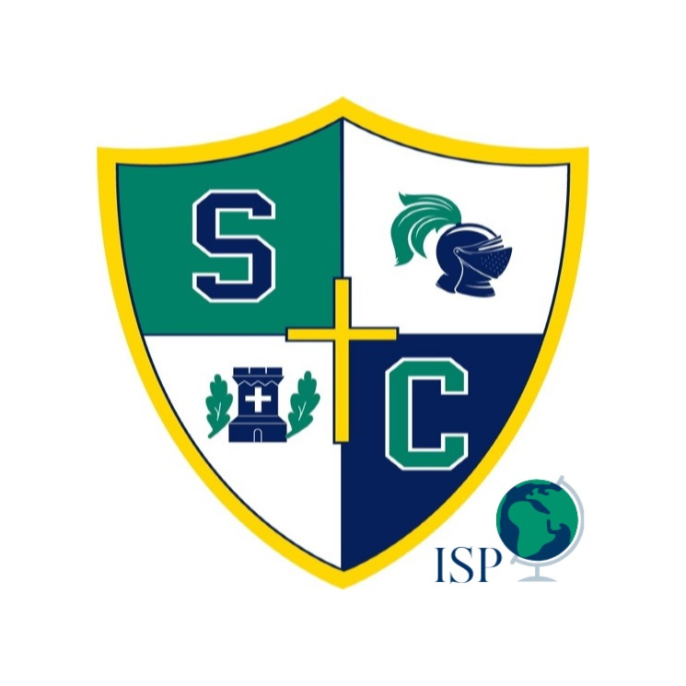
Seton Catholic
International Student
Application

Thank you for your interest in attending Seton Catholic. This application is designed for international students applying to study at Seton Catholic in grades 9-12 and asks for information required by ICE, SEVIS, Immigration Services, New York State and the Roman Catholic Diocese of Ogdensburg. Please complete all the fields below. If something is not applicable to you or your application, please put “N/A” for “Not Applicable” in the answer.

Please note that Seton Catholic’s I-20, mailing fees, and application fees are non-refundable.

Please return completed forms to the Director of International Students, Mr. Joongsik Kim at: jkim@setonknights.org. Upon receiving the application Mr. Kim will respond with a delivery confirmation of your application. If you do not receive this confirmation within 24 hours, then please re-send your application again.

After receiving confirmation of the International Application, you will receive an invoice for your non-refundable application fee of $275.00 from businessoffice@setonknights.org.

All documents and application fees must be paid before an application can be reviewed for full consideration.
I-20 fee + mailing fee will be assigned after student has been given acceptance to Seton Catholic.

Order of Application Status for Agency Students:
Step One: Application from agency
Step Two: Seton application + payment of $275.00 application fee (via wire transfer)
Step Three: If Seton Catholic approves application, then student will receive an interview
Step Four: Interview
Step Five: Decision from Seton Catholic – notification within 2-3 weeks of interview
If Accepted:
Step Six: Notification of acceptance, invoice for I-20 creation
Step Seven: Pay I-20 fee + mailing fee
I-20 Fees are non-refundable
$2500.00 paid through wire transfer
+ Mailing fee: $100
Step Eight: I-20 created, mailed to student

Order of Application Status for Private Students:
Step One: Inquiry from student
Step Two: Seton application + payment of $275.00 application fee (via wire transfer)
Step Three: If Seton Catholic approves application, then student will receive an interview
Step Four: Interview
Step Five: Decision from Seton Catholic – notification within 2-3 weeks of interview
If Accepted:
Step Six: Notification of acceptance, invoice for I-20 creation
Step Seven: Pay I-20 fee + mailing fee
I-20 Fees are non-refundable
$2500.00 paid through wire transfer
+ Mailing Fee: $100
Step Eight: I-20 Created, mailed to student

Student’s Name:

Agency:

If non-agency student, please answer “private” in the answer field.

Please place an “x” in the answer that best fits your desired academic studies at Seton Catholic

Applying For:
_______ 2022-2023 School Year (January– June)
________ 2023-2024 School Year (September – June)
________ 2024-2025 School Year (January – June)

Grade You’re Applying For:
___________ 8th Grade
___________ 9th Grade
___________ 10th Grade
___________ 11th Grade
___________ 12th Grade

I-20 Mailing Address
*Please note according to F-1 Regulations, I-20’s may only be mailed to students. COVID-19 has allowed the I-20 to be emailed, but this regulation is temporary. *

Primary Contact at Home Address:

Student Home Address:

Student Information
Name:
Given Family English Nickname

Date of Birth:
day month year

Alternate Address:

Email Address:

Country of Citizenship: Country of Birth:

Languages Spoken:
*Please list language and fluency degree (fluent, moderate, beginner)

Current School Information
School Name:
School Address:
School Phone:
Date of Attendance: From: To:
Grade Completed:
Please have your current school send your current transcript to the Director of International Students, Joongsik Kim at: jkim@setonknights.org. Please note that your application is NOT complete until this is received.

Family Information
Father:
Given Family Name

Email Address:
Mobile Phone:
Company:

Mother:
Given Family Name

Email Address:
Mobile Phone:
Company:

Siblings:
Name Age School

Test Scores Information
TOEFL:
SLEP:
iTEP:
TOEFL Jr.:
SSAT:
Additional Tests:

Teacher Recommendation Letters
Please have two teachers, staff, or faculty write letters of recommendation for your application to Seton Catholic. Please have them email those letters to the Director of International Students, Joongsik Kim at: jkim@setonknights.org. Please note that your application is NOT complete until these letters are received.

Personal Questions:

- Are there any special accommodations with regards to your academic studies that we should be aware of?

- Are there any significant family situations that we should be aware of?

- What contributions would you bring to the Seton Catholic school community?

- What is the greatest challenge your generation will face?

Personal Essay
Please write an essay introducing yourself! Be sure to include why you are interested in Seton Catholic and the Upstate New York area. Describe your academic and personal goals while at Seton and your goals once you graduate. Be as detailed as you can, this is our first impression of who you are. Attach a copy of your essay to this application.

