Online American Sign Language (ASL) Class Schedule Winter 2022:

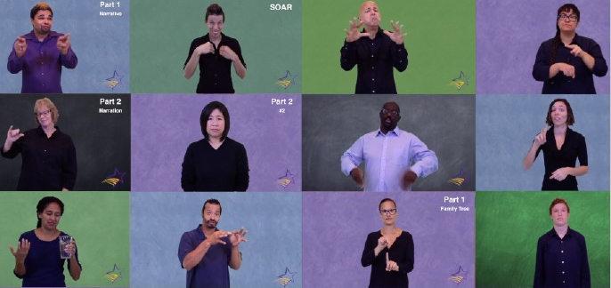
What’s New?
All classes will be held virtually over Zoom. Our curriculum has been adapted to be taught in this format. Our strict cap of 15 students per class ensures that each student still receives individual attention.

Why learn ASL at DEAF, Inc.?
Our voice-off online classes provide a fun, relaxed, and interactive learning environment. Get support and feedback from our instructors, who are Deaf and native ASL users.

DEAF, Inc. Uses the TRUE+WAY ASL Curriculum
TRUE+WAY ASL (TWA) is a technology-driven curriculum that provides online videos and interactive activities. TWA’s main objective is to promote real-world conversations related to student’s daily lives with the goal of students being able to converse with Deaf people in the community.

We will send the link to students to buy their own access code when the number of students has passed the requirement. Access codes will be $36. This price increase is due to the TWA upgrade from Second Edition to Third Edition.

Winter Schedule
Classes meet once a week for 10 weeks

Level | TWA Units | Day | Time (EST)
ASL 1 | 1-3 | Tuesdays January 11th – March 15th | 6pm – 8pm
ASL 1 | 1-3 | Wednesdays January 12th – March 16th | 1:30pm – 3:30pm
ASL 1 | 1-3 | Wednesdays January 12th – March 16th | 6pm – 8pm
ASL 1 | 1-3 | Thursdays January 13th – March 17th | 6pm – 8pm
ASL 1 | 1-3 | Saturdays January 15th – March 19th | 10am – 12pm
ASL 2 | 4-6 | Tuesdays January 11th – March 15th | 6pm – 8pm
ASL 3 | 7-9 | Wednesdays January 12th – March 16th | 6pm – 8pm
ASL 4 | 10-12 | Thursdays January 13th – March 17th | 6pm – 8pm
RSL |  | Wednesdays January 12th – March 16th | 6pm – 8pm

Tuition: $275 (does not include TWA online access code)
To secure your spot, register and pay by Monday January 3rd, 2021, by 4:00pm EST
For more information and to register visit www.deafinconline.org/asl-program
Classes require a minimum of six (6) students. Refunds only if class is cancelled.
Contact asl@deafinconline.org with questions.

