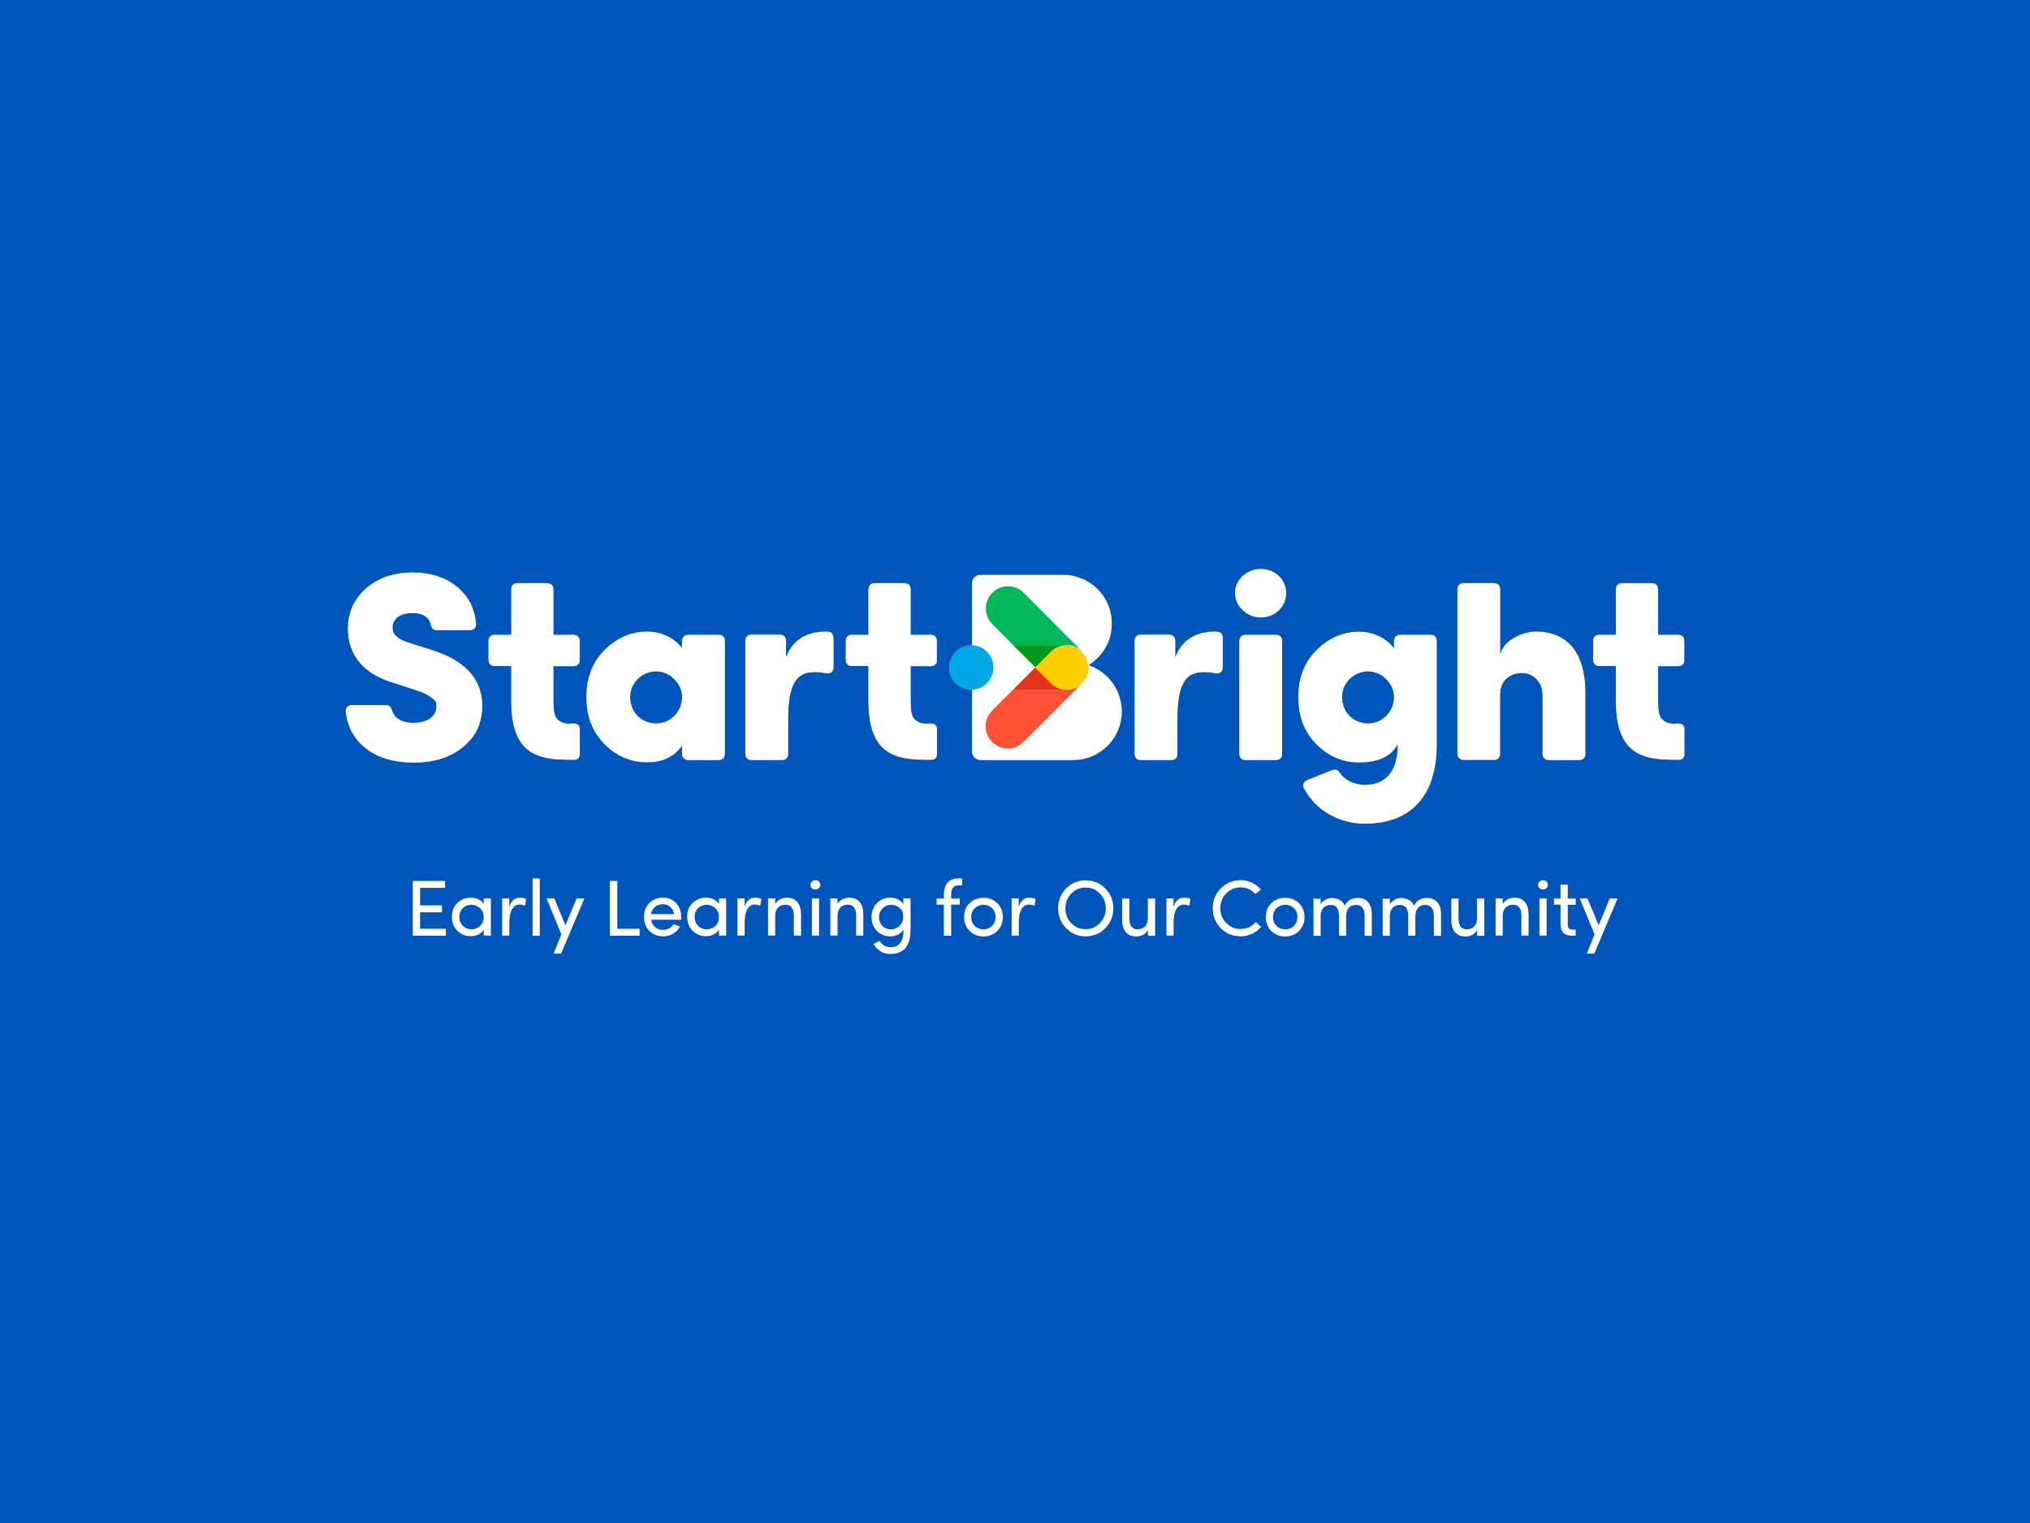
At StartBright we believe that play is the best way for children to develop and master skills. This not only prepares them for school, the transition to school and engaging positively in school but it sets the foundations for lifelong learning. Play allows children to develop their whole self, their strengths, personalities, relationships, and sense of belonging. Play helps them understand themselves, emotions, and feelings, likes and dislikes, interests, and questions. It truly is the work of the child and is nurtured and supported by you the parent, their first educator.

In this booklet we will look at different aspects to ensure your child has a positive start to school. We will look at topics such as:
- Core Development
- Balance
- Emotional Development and Wellbeing
- Emotional Regulation
- Outside Play
- Literacy and Numeracy
- Creativity

Core development
Having a strong core, is important for your child’s attention span, concentration and being able to engage in what is going on. Without a strong core your child will find it hard to engage with the learning that surrounds them in school, to pay attention to challenging tasks and to partake in learning within the classroom setting. We adopt many strategies within our day to strengthen core muscles in a playful way, as I am sure you do at home. In doing this we are physically preparing children for school and the enhancing the physical strengths we need to focus, concentrate, and learn. Below are some activities you can do to help strengthen your child’s core and get them moving. These are seen as fun and a new challenge, however we know they are developing gross motor movements, spatial awareness, spatial reasoning, body awareness, strengthening muscles and mobility to manoeuvre safely in their environment.
- Aeroplanes
- Mountain Climbers
- Crunches
- Superman
- Sitting on different height chairs
- Sitting on stools or stumps of wood
- Sitting on the floor in a cross-legged position or with feet out flat
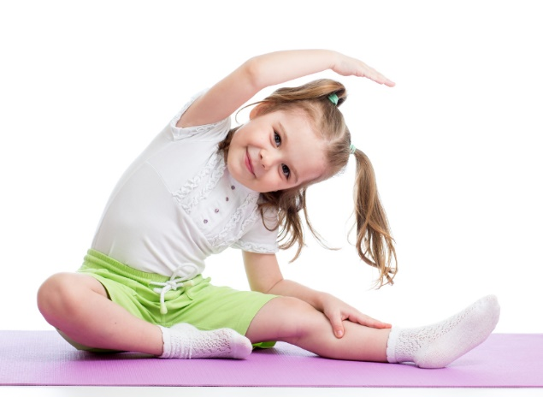
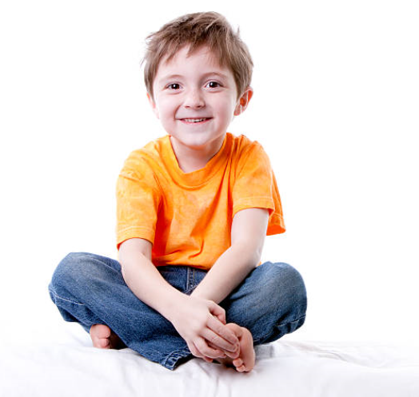
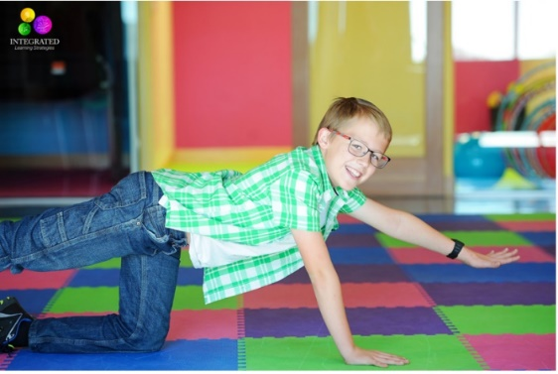
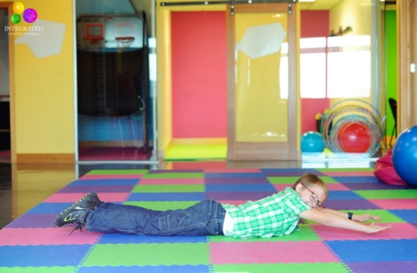
- Yoga poses
Balance
Balance is a skill children need to master in order to function in the world. It develops their coordination, ability to join in games and helps concentration and engagement in what is going on around them. It allows children to navigate through their environments safely and facilitates them in connecting to the outside world. Mastering balance on uneven surfaces, challenges children to adapt quickly to situations, to be able to problem solve and seek alternative reasoning and encourages risk assessment. These skills help us throughout life and learning them from a young age encourages resilience, confidence, and competency.
- Egg and spoon races- hand eye coordination, spatial awareness, concentration, and muscle movements
- Sack races- large body movements, developing of leg and upper body muscles, processing information and coordination
- Balancing on walls and kerbs when out for a walk- depth perception, risk assessment, coordination, and spatial reasoning
- Balancing on play equipment in the park or playground- risk assessment and resilience, determination and perseverance, coordination and large body movements and awareness.
- Walking across cushions/uneven ground- increased risk assessment, preplanning movements, higher order thinking, coordination, depth perception
- Hopscotch – this has added number recognition, cross body awareness and thinking
- Walking up and downstairs with alternating feet unsupported- sequencing, coordination, depth perception
- Riding a bike- risk assessment, combining all skills together, sequencing
- Steppers- coordination, large muscle movements upper and lower, depth perception, spatial awareness, and reasoning
- Yoga poses like tree pose or lotus- stationary balance and focus
- Playing at different heights e.g. the floor uses different muscles than a small table, kitchen table uses different muscles than kneeling at a low table.
- Hanging off branches of trees from arms or legs depending on their bravery
- Pulling themselves over exercise balls
- Wheelbarrow races
- Climbing up a slide
- Tug of war
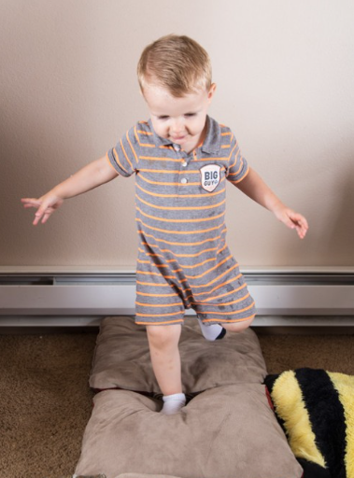
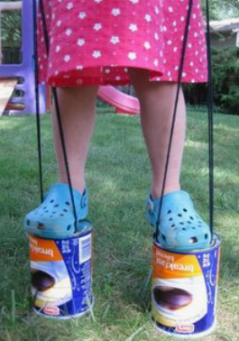
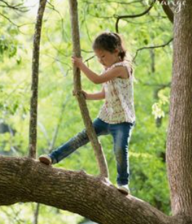
- Changing their seating, using cushions or stools to sit on rather than chairs, they need to use their core and balance to sit up correctly
Emotional Development and Wellbeing
Emotional development and wellbeing are constantly being developed upon at home. The conversations you have daily, the strategies you use to calm situations, how you yourself show your emotions and the love, support and guidance you surround your children in. Given the times we are in this may be something you focus your attention on even more. Children, although they may not voice it, take in what is going around them, feel the stresses and pressures around them as well as the calmness and positivity. Children are very resilient by nature but providing them with spaces and places to word out their concerns and ask questions, supports their growth with emotional development and positively impacts their wellbeing.
With transitioning to school, children naturally gravitate to certain experiences to play out scenarios that are on their mind. Imaginative play tends to be the driving force for them to play out scenarios that are curious to them, to ask questions and seek answers, to play out different role types, and to act out different feelings they may be feeling about transitioning. This space, time and set up allows them to freely explore many opportunities and possibilities and cement conversations, words, and routines into their minds. This supports positive wellbeing and complements emotional development simultaneously.
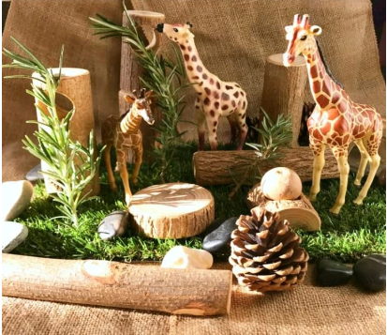
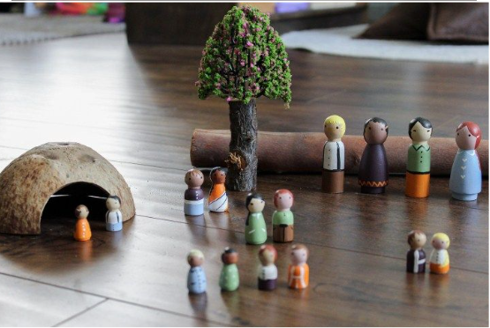

- Small world play- conversations can occur around school, work through problem solving and emotional themes, take on different roles, familiarity with roles (teacher, pupil)
- Books- gives words and vocabulary around school, can address feelings and emotions of such a transition, allows for questioning and open conversation. Familiarises them with visuals of school, resources etc.
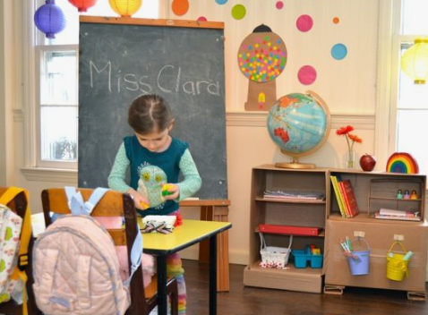
- Role play- allows them to replay the scenarios they have heard of or are curious about. They can practice routines, use the vocabulary the have learned and become more familiar of roles (both learner and teacher) Can also master how to use items like lunch boxes, school bags, pencil cases etc.

Emotional Regulation
Emotional regulation means understanding and responding to our emotions whether it be large emotions like happiness, sadness and anger or our quiet emotions like anxiety, stress, or shyness in many ways. Being able to regulate these takes practice, determination, perseverance and understanding. We as adults still thrive to master these and so children need plenty of time and space to begin to develop these skills. Everyday conversations and scenarios are key to aid this development. Talking with them about times when they are experiencing upset or anger; what does their body feel like? how can we get back to calm? Talking about addressing the different ways to express our emotions i.e. deep breaths, walking away, finding a teacher or adult.
Developing a habit of talking about how we are feeling from such a young age helps family groups open the lines of communication around emotions and feelings. This supports children to become more self-aware but also increases their capacity to read other people’s emotions. It also shows that emotions, feelings and mental health are topics that a re openly discussed.
Opportunities to have these conversations and help develop emotional regulation:
- Role play- play out scenarios to do with emotions anger, upset, happiness, fear, excitement. Opportunity to use words and techniques to regulate
- Books- gives vocabulary and shows examples of different emotions, how someone might look when displaying certain emotions and the strategies they used to regain calmness.
- Small world play- role play different approaches to emotions, practice regulation skills, vocabulary
- Board games- dealing with frustration, also great for turn taking and patience, knowing how to win and lose gracefully
- Sensory play- to provide calm, release tension and offers a space to talk about emotions, many children feel safer talking when they are doing something
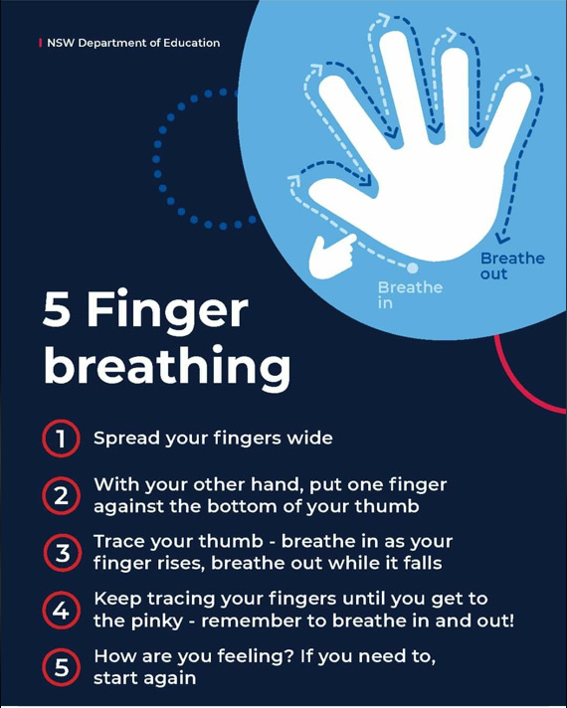
- Breathing- Research suggests across all ages the breath is a helping factor in emotional regulation, whether it’s calming yourself down to concentrate on a task because you are just so excited, or relaxing the body in times when you are feeling frustrated and angry. Many of our educators use the ‘smelling the pizza, blowing out the candle’s’ analogy. This helps the children visualise something while taking in big breaths and exhaling with some force. This focus and the deep breathing helps to relieve the body of some of the energy so we can discuss the situation or reconnect to what we were doing.

Outdoors
Not only is the outdoors good for physical health it allows children to connect with nature, something they instinctively gravitate to. Playing in the outdoors gives children freedom and space to relieve tension and regulate their body. Nature has such a positive impact on children’s wellbeing, it calms and soothes the body, and allows for free exploration and insightfulness. It also has the added benefit of risk taking, imaginative play and developing curiosity. The outdoors offers a lot of learning to children such as natural consequences, critical thinking and developing resilience and determination to accomplish tasks. It allows children to work through previous learning and reflect on things, drawing their own conclusions. This learning can be out the back garden, up in the mountains or on daily walks around the community. It is your presence in these experiences which can help children unpack the learning and provides opportunities to reflect, reimagine and understand.
Some experiences to think of:
- Digging- exerts tension, connects them to nature, physical movements, curiosity, exploration
- Planting- connectedness to nature, responsibility, patience, and care, science and discovery
- Climbing trees or mountains- physical exertion, pre-planned movements, risk taking, focus, resilience, determination, perseverance
- Going on walks- quiet time to think, space, listening for birds/nature, observing, conversations,
- Playing in the back garden- running, jumping, investigating the plants, grass, trees, soil, insects
The possibilities and learning opportunities are endless in nature. It opens up avenues for conversations and reflections about an abundance of subjects and topics, one being transitioning to school.
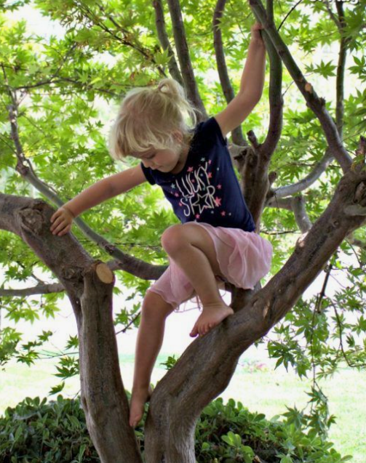

Literacy and Numeracy
As children will be moving into a more formal sense of learning when starting school is beneficial to familiarise them with what they will be seeing. As we implement our day through play, letters and numbers are always present in a playful way. Symbols in play add a different element to this understanding too. They give meaning to the world around by delivering information through pictures rather than words. Lámh (sign language) creates another avenue of literacy learning too, we implement this within the rooms so children can communicate in a variety of ways.
At home children are surrounded by letters and numbers throughout their day too. Here are some examples that you may keep in mind when going through your day to instil numeracy and literacy in a hands-on playful way.
- Have letters accessible to them when they are drawing. It is a simple way for them to familiarise themselves with their shape and look
- Adding resources like keyboards (Even a picture of one) and old telephones shows them letters and numbers are present in everyday circumstances.
- Looking out for their special letters when out and about see can they spot the first letter of their name, or and M for mammy or D for daddy etc.
- Adding in rulers to playdough for measuring purposes or tape measures in block building.
- Simple tasks like setting the table for dinner, how many people need a fork and knife, can you count them out.
- Cooking and baking, measuring and reading instructions
- Matching socks brings in identification of pairing.
- Sorting encourages children to engage in mathematical concepts, scavenger hunts, spotting all the yellow cars when out and about, looking for things that fly,
- Creating patterns and following sequences, Lego is a great tool for mastering these skills.
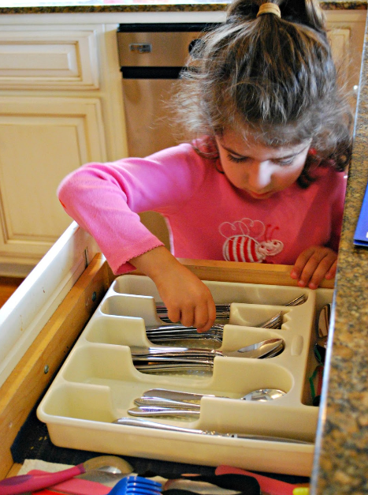
- Books are a heavy influencer of early literacy skills. Reading to children but also allowing children to read to you helps with understanding word formations, letters and their positions, direction of reading, how words are formed and that they can make meaning.

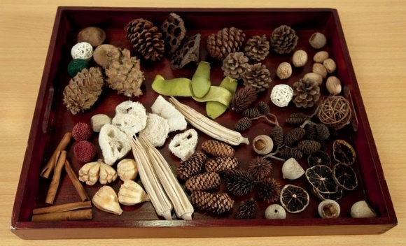
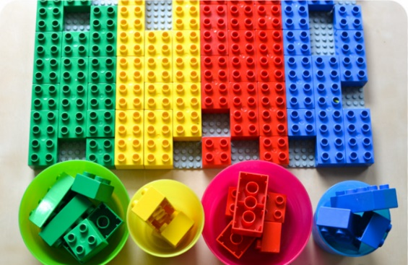
Creativity
Creativity allows children to express themselves and their views using many different mediums, drama, art, drawing, sculpting, dance, song, music and construction. It opens opportunities to seek new meaning, reasoning and hope in the world around them. Creating something takes imagination, artistic expression, critical thinking and the vision to see something with new eyes. Children are experts at this, think of all the uses they find for a stick. Providing them with the space and time to practice these skills will reinforce their sense of curiosity and exploration. This creativity often happens spontaneously at home, children express themselves through the arts at such an young age, it is often seen as a part of their personality.
Some experiences that may help this:
- Painting
- Gluing/Collage
- 3d art projects- boxes, egg cartons, recyclable materials
- Drawing
- Blocks
- Den building
- Fort making
- Dancing
- Singing
- Playdough
- Clay
- Role play
- Small world play
- Sensory experiences- sand, water, mud
The possibilities to be creative are endless, look at your children they are experts!
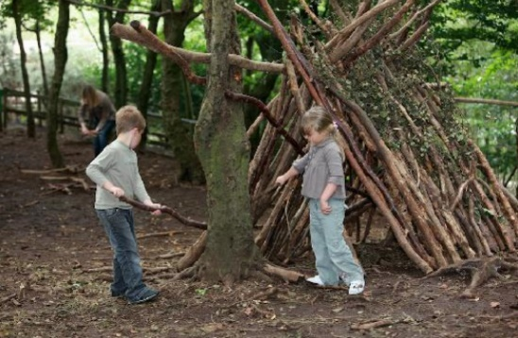

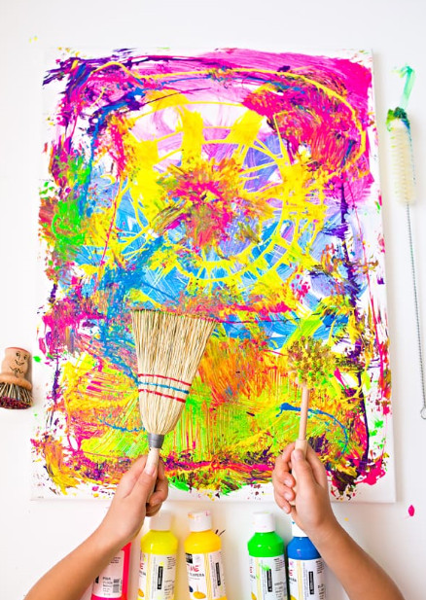
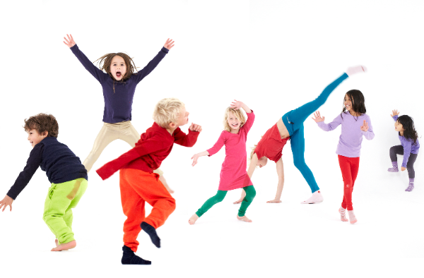
At StartBright we value play-based learning and recognise this is the best way for children to develop and learn skills vital for their future learning journey. Children are capable and competent learners. Play offers them the space and time to develop these attributes. They can seek meaning and understanding of their own interests, develop theories and hypothesis for their own questions and connect to those who surround them and to the world they live in. Learning and working through play offers opportunities to children to extend their own learning, supports confidence to question norms and facilitates their critical thinking and reasoning. It also connects children to other children and adults so they can learn to communicate, collaborate and develop social skills. They can work through emotional understanding and regulation. Play provides opportunities for children to expand their thinking and become active citizens in their community and the wider world.
This learning is fully supported by our educators who observe and document the children’s interests and wonderings. It is through this facilitation, planning and environment creation that children can continue to develop, practice and master skills needed for later life and lifelong learning. This wonderful partnership and respect for play allows children to focus on the present and simply be the innovators and creative thinkers they are.
Childhood is a special time that should be filled with fun, laughter and happiness and playing is the essence of this. As Albert Einstein once said, “Play is the highest form of research”.

Our work is supported and guided by Aistear, The Early Childhood Curriculum Framework and Siolta, The National Quality Framework for Early Childhood Education.

