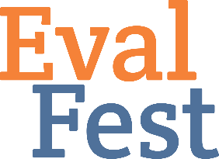
Evaluation Planning
Tip Sheet

Three months before the Festival Begin new instrument identification/development
Identify any event hosts who can help with data collection

Two months before the Festival Finalize all instruments
Interview field researchers

The month before the Festival All instruments programmed
All field researchers hired & assigned to data collection events/shifts
Make paper copies of surveys, if needed
Get Festival t-shirts or some other swag for field researchers to wear when collecting data
Buy data collection supplies: clipboards, pens, golf pencils, flashlights & red balloons (for star gazing events)
Mail all surveys and materials out to remote event hosts collecting data and/or field researchers
Confirm all data collection with event hosts; email to introduce event hosts and evaluators so they can make plans for meeting prior to beginning of event

During the Festival Field researchers trained in 30 minutes prior to first shift; if not possible, training done by phone/webinar
Field researchers arrive 30 minutes early for each event to meet event host and deal with any final logistics that need sorting out
If data collected by a field researcher alone, have him/her text/call to check in at beginning of the shift to help solve any logistical surprises AND at end of shift to report number of surveys collected
Keep a running tally of surveys collected at each event
For Expos, visit venue early to map out zones for field researchers so they do not cluster/overlap during data collection; assign field researchers to zones; if shift is more than two hours, consider having two zones per shift

Email Survey Data Collection If possible, send email survey to attendees who registered to attend events; send initial invite and a one-week reminder only
Survey event hosts and any K12 teachers or scientists on the Friday after their event; send an initial invite, a one-week reminder, and a Past Due reminder two weeks after the event; you can choose how long to keep sending Past Due reminders depending on the audience

One month after the Festival All survey data collection done
All data entry done

Two-three months after the Festival Evaluation report or debrief meeting with Festival team

