Στοιχεία Επιχείρησης
Ενοικιαζόμενες Τουριστικές Επιπλωμένες Κατοικίες)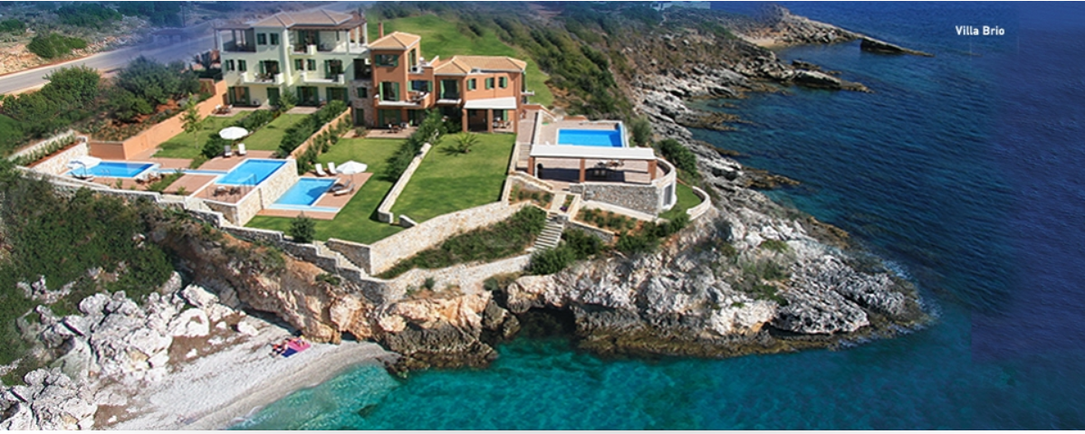
Villa Brio complex
Skala
1.6 km Skala-Poros Coast Road
Kefalonia 28086
Greece
Tel.: +30 6932531393
E-mail: info@villabrio.gr
ΜΗΤΕ 0458Κ91000327601

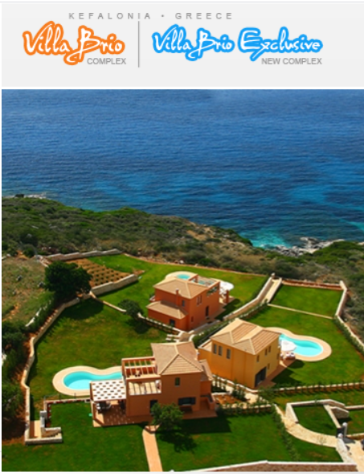

Villa Brio Exclusive complex
Skala
2.6 km Skala-Poros Coast Road
Kefalonia 28086
Greece
Tel.: +30 6932531393
E-mail: exclusive@villabrio.gr
ΜΗΤΕ 0458Κ91000420001
ΜΗΤΕ 0458Κ91000419901
ΜΗΤΕ 0458Κ91000420101

About Villa Brio complex
• Only one of its kind seafront accommodation of 4 elegant self-catering villas, in Kefalonia Island, Greece, with private beach, swimming pools and a stunning view over the Ionian Sea.
• "Brio" villas are at the edge of the famous sandy beach of Skala, just 1 mile from the village and 30 min from the island's International Airport.
• The four "Brio" villas have been smartly designed to satisfy those who opt for finesse & affordable luxury during their holiday…
• In "Brio" villas you can combine moments of tranquility in the privacy of its seafront location, along with vivid night life at the close villages of Poros and Skala...

About Villa Brio Exclusive complex
• Α new seaside complex of 3 smart detached villas with private pools & direct access to turquoise waters.
• Just on the coast from Skala to Poros, the villas enjoy superb views over the blue horizon of the Ionian Sea & the smooth coastline.
• Location offers a unique sense of “being away from it all”, yet close enough to amenities along the coast.
• Just 1 km further from Villa Brio complex.

Location
Villa Brio complex is located at the edge of the famous long sandy beach of Skala village, 40 min drive from the International Airport of Kefalonia.
It takes 20 min easy walk to the centre of the village, where you find a great variety of restaurants, bars, food shops, bakery, pharmacy, medical centre, gift shops, car/bike rentals, ATM etc.
A wonderful beach just on-site…guests enjoy direct access to crystal clear water via a private deck into the sea! On top, beside Villa Brio, there is a secluded beach, with easy stair access. Long sandy beach of Skala commences at 200 m from the villa.
Closest restaurant is found at 100 m, while super market at approx.300 m. Near the complex, in Skala beach, there are a water sports centre, scuba diving & boat hire options available; alternately, you could enjoy walking or cycling along the coast, which is smartly lit up at night. Tennis is available in nearby hotels, while mountain biking, horse riding, sea kayak and trekking within 30 minutes drive.
Finally, not to forget that in Poros, 10 km from the complex, there is a port from where you can sail around the island!
Regarding need of a car, given the above you could easily do without, unless you intend to further explore the natural beauties of the island, that are indeed worth seeing!
For your info, taxis are on call for local transfers to/from the village of Skala, showing up in our villas within just a couple of minutes and charge only 5 Euros per way.
Useful to mention as well that Villa Brio complex is approx. 1 km or just 10 min pleasant walk on the coastline to our newest Villa Brio Exclusive complex.
Στοιχεία Επικοινωνίας
Αννίτα Μιχαλοπούλου
info@villabrio.gr , www.villabrio.com

