Maker with Rame Parish Council

16th July 2022

Members of the Parish Council,

You are hereby summoned to attend Meeting of the Parish Council to be held on Monday 25th July 2022 in the Maker with Rame Community Hall, commencing at 7 p.m., for the purpose of transacting the following business.

Due to the current levels of Covid 19 in the community, the Parish Council respectfully requests that each attendee observes the current Government Guidelines at the relevant time.
Members of the Public will be limited to 30.

Please be aware that meetings may be audio recorded.

Carolyn Y. May
Clerk/ RFO to Maker with Rame Parish Council.

AGENDA

- To receive apologies and accept the reasons for non-attendance.

- To receive any declarations of interest relating to items on the agenda and accept dispensations.

- To receive the Chairman’s Report.

- Cornwall Councillor for Rame Peninsula & St Germans Kate Ewert Report.

- Public Open Forum (strictly 15 mins).

- Citizens Advice Cornwall Presentation - Lead Cllr Ferguson with Wailim Wong (15 mins)

- To approve the Draft Minutes of the meeting held on 27th June 2022 (Appendix A)

- Correspondence
  - Tide Bells and Pontoon for boats in the Bay
  - Parking issues in the Square, Cawsand
  - Ownership and condition of sea wall under Maker with Rame Institute

- Committees and Ways of working and Committee updates
- Finance and Economy: Lead Cllr Weale
  - Payments to be approved.
  - Bank reconciliations to be reviewed and approved.
  - Financial Management report to be reviewed and approved

- Planning, Traffic, and Infrastructure: Lead Cllr Weale
General update of issues, actions, and projects:
  - Planning Applications (Appendix B to follow)
  - Planning Decisions – to note (Appendix C to follow)
  - Correspondence from CC re disposal of 1 Porspoder Place, Green Park, Cawsand
  - Neighbourhood Development Plan opportunity to review (Cllr Ferguson)

- Public Services: Lead Cllr Kidd.
General update of issues, actions, and projects:
  - Defibrillators – Key contact point and date for training Thu 28th July 2022
  - Consultation process for Toilets Refurbishment project
  - Stained Glass Window for the Community Hall - update

- Recreation and Community: Lead Cllr Fox.
  - Dogs on Beaches
  - Play park inspection update

- Environment and Conservation. Lead Cllr Green.
  - Survey Monkey proposal
  - Community Orchard Welcome Sign.
  - Community Orchard Maintenance update
  - Wild gardens and spaces event - update
  - Pigshill Update
  - Clean Cornwall Initiative

- PPML Update. Lead. Lead Cllr Weale

- Community Projects Proposals. Lead Cllr Weale

- Review of Actions from past meetings – Appendix B. Lead Cllr Weale

- Matters for the 26th September 2022 Full Council Meeting agenda (No meeting in August)

Appendix A
Maker with Rame Parish Council

Chairman: Cllr John Weale
Vice Chairman: Cllr Jon Kidd
Clerk/ RFO: Carolyn Y. May

Minutes of the Parish Council meeting held at 7pm on Monday 27th June 2022
at
Maker with Rame Community Hall

Present: Cllrs. Weale (Chairman), Kidd (Vice Chairman), Condon, Ferguson, , Green, Lingard, Murray, Ireland
Apologies: Cllrs. Fox, Newcombe Sutcliffe, Cllr. Ewert (Cornwall Council), Clerk Carolyn May
Also Present: Two members of the public.

Declarations of Interest: None

  - Chairman’s Report

Cllr Weale shared the views of all in the Community that the Platinum Jubilee Weekend had been a great success and offered a massive thank you to all the volunteers involved in making it such a success – and particularly the Jubilee Committee which included Cllrs Lingard, Newcombe and Fox.

Cllr Lingard confirmed that now all invoices had been accounted for, the event cost a total of £1590.11(after the donation from the Clerk of £100 for ice-creams was taken into account.

This was well under the original budget of £10,000 and the revised budget of £6,500.

All agreed this was very good value for money.

Cllr Weale noted that we had already been approached for a Community Event at the same Half Term slot next year.

Action – Clerk to put Community Event 2023 on the agenda for the October meeting to commence planning and budgeting.

Cllr Weale lastly thanked everyone one else for their efforts on various projects and initiatives that would be covered during the course of the evening.

  - Cornwall Councillor for Rame Peninsula & St Germans Kate Ewert Report

Cllr Ewert had sent her apologies for the meeting.

Cllr Weale noted two issues that he was in discussion with her about.

Firstly, he recalled there was an opportunity to write to Cornwall Council before end of June re dogs on beaches. He took an action to investigate further and if this is the case, to ensure a response within the required timelines.

Secondly, he had asked Kate if she had received any comments from residents regarding what appears to have been a 500% increase in ground rents for the chalets at Trenninow and Wiggle – some of which are in MwR Parish. This was a joint decision by Cornwall and Plymouth Councils with the Park.

Cllr Green expressed concern that this might have been as a consequence of the Park being required to achieve a zero budget. Cllr Condon was concerned as to what else might be planned to commercialise the Park in order to bring in extra funds to make this possible.

Cllr Murray reported that there were many private landlords inc Antony Estate in the same area that had also increased their charges so this was not out of line with what was happening as a whole.

There was also a concern that the rent increases for long-standing local residents – would force them out of the area in favour of second home owners. A number of chalet owners were believed to be residents of Plymouth who came across for weekends.

Cllr Weale noted that there was a Facebook page where various concerned residents had made their points known; however MwRPC had not been approached directly by the residents in the Parish. This was a matter between Landord and Tenant - the Parish Council will not get involved unless approached by residents of these areas.

Action - On the wider issue of the Mt Edgcumbe Country Park zero budget and what the plans were to make this possible, Cllr Weale request Chris Burton to attend a future meeting to present.

  - Public Open Forum (strictly 15mins).

John Lentell was keen to raise the issue of dogs on beaches, and spoke on behalf of a number of concerned residents in Cawsand.

The decision by Cornwall Council to open up 42 beaches in the area was taken without consultation with the local residents and they were not informed of the changes either. The yellow stickers updating the signage on Cawsand beach was confusing too.

At times, there were over 20 dogs running off leads on the beach, and fouling the areas where swimmers and children play. This was not hygienic, and some children were clearly frighted by the dogs running around.

The previous rules had been clear – no dogs Easter Day to 30th September between 10:00 and 18:00, - had worked really well because there was a big safe areas where children could play.

Cllr Green added that children could come into contact with dog faeces and they were at risk of contracting Toxocara and be blinded. Any decision should take into account health and safety concerns.

Cllr Kidd confirmed that the new rules appeared to ban dogs only during July and August between the same hours of 10:00 and 18:00. He also noted that there were no rules for Girt and Kingsand beaches, and this was unfair on those who preferred to enjoy those beaches - particularly if Cawsand Beach were to have a total ban.

Cllr Lingard felt that a balance had to be struck as responsible dog owners should not be penalised as a result of a few irresponsible ones. There were many visitors who came into the villages with dogs and brought valuable trade for the local businesses.

Cllr Green suggested that it might be helpful to conduct a quick survey of local residents

to capture their views on this topic and collate their responses. We could then go back to Cornwall Council with a true representation from the Community. Surveymonkey would be ideal for this but would come at a cost.

Action - Cllr Weale noted that as Dog control was not on the main agenda, it should be brought back to the July meeting as an agenda item and encourage members of the Community to attend and share their opinions on the matter.

Cllr Weale also referred to his earlier comment re Cornwall Council consultation on dogs on beaches and would investigate as stated.

  - To Approve the Draft Minutes of the meeting held on 23rd May 2022 (Appendix A)

Cllr Weale reported that there were a number of actions in the Minutes that should be reviewed first:

Committee TORs:
On the Agenda – CLOSE

Bus Service:
Clerk was to query cancellation of bus services with Cllr Kate Ewert – leave OPEN

Asset Register Review:
Cllr Weale had reviewed and will discuss later in the meeting.

Spend vs Forecast:
Cllr Ferguson had requested a summary of spend to date- this has been provided by the Clerk in the meeting Appendices. CLOSE.

Clerk Objectives:
On the agenda - CLOSE

Royal Mail divert of MwRPC mail:
All post currently delivered to the MwR Community Hall letterbox and Cllr Kidd collects, scans and sends to the Clerk, hands over hard copies when we meet.
Cllr Kidd confirmed the cost of a Business mail redirection is ~£600 for what is approx. 5 letter per week.

Cllr Ferguson asked what more could be done to switch to email -accepting that HMRC and similar would not switch.

Cllr Lingard queried why the mail address could not be changed to Carolyn’s. Cllr Kidd said this was because it was the official address of the Parish Council and important legal documents should be correctly addressed to the official address.

Cllr Weale summarised the discussion by stating that £600 per year for 5 letters per week did not seem like good use of funds, and asked if Cllr Kidd would be happy to continue the current arrangement, and whether others would volunteer to cover in case of absence. Cllr Kidd agreed to this and Cllrs Ferguson and Ireland volunteered to cover absences as required. CLOSE.

Community Orchard Sign:
On the Agenda – CLOSE.

Citizens Advice Bureau:
On the Agenda – CLOSE.

Approval of the Minutes:
It was proposed by Cllr Ferguson, seconded by Cllr Green, and RESOLVED that the Minutes for the Parish Council meeting of the 23rd May 2022, would be received and signed as a true account of the meeting. UNANIMOUS. Carried.

  - Correspondence:

Clerk had received an email from a resident of Pier Lane – concerned that large vehicles were still trying to access and damaging the walls in the process.

Cllr Weale stated this was not the first email and whilst Cornwall Council had looked into this previously, it needs to be referred back to them for further action.

Action – Clerk to forward Residents email to Cornwall Council and request an update.

Norr Rock - confirmation that there will be a method statement required from the new owners for when the construction work is carried out there to ensure minimal disruption to residents.

TPT (Peninsula Trust) report -Cllr Ferguson noted that Cllr Fox had been recognised several times for her efforts there.

Pigshill Wood – Cllr Weale noted that Dan had advised that due to management changes, he was working through changes and grant cheque has yet to be cashed.

Cllr Ferguson mentioned that there is an upcoming meeting at Maker Heights to advise on the changes and future plans.

Cllr Kidd advised that an email from Ian Turpitt received today raised two issues- one was the 2-way section of Garret St from The Halfway House to Pendenhar.

Action - Cllr Kidd to review Ian Turpitt email and respond on behalf of the Clerk.

  - Finance and Economy: Lead Cllr Weale

  - Payments to be approved.
  - Bank reconciliations to be reviewed and approved.
  - Financial Management report to be reviewed and approved.

Members considered the Management Report for June 2022.

Cllr Weale reported that in response to a query from Cllr Ferguson re spend to date, the spend for Q1 was ~11% of overall FY22 budget so well within forecast. Cllr Weale noted that the Jubilee budget had been underspent. It will be important to explore opportunities for future projects – noting that there will be challenges with increases in energy prices etc.

Cllr Ferguson queried the outstanding income from the Boat Park for FY22 and wondered if all bays had been occupied and paid for. Cllr Kidd confirmed that all bays were occupied and that invoices had been sent out by the Clerk. There was one user who had a long- standing agreement to pay by monthly instalments and at least one other that had only just received his invoice as had recently moved house.

Action – Cllr Kidd and Clerk to reconcile the outstanding payments due for the Boat Park and send out reminders as required.

Cllr Ferguson also queried whether the Precept had been received for FY22 as it appeared to be missing from the totals.

Action – Clerk to confirm whether Precept has been received.

Cllr Ferguson also noted the Post Office subsidy was well overspent YTD.

Action: Clerk to investigate Post Office spend.

Cllr Kidd noted that the June invoice for Gary Tucker of £795.00 had been received and was in line with the budgeted figure for the month and would be included in the payment run.

Cllr Lingard asked if the cheques for the re-imbursement of the Jubilee expenses could be included in the cheques for June tonight, and it was agreed that the re-imbursement of these costs to Cllrs Lingard, Fox and Charlotte Jones, would be added to the payment run.

It was proposed by Cllr. Weale, seconded by Cllr. Kidd and RESOLVED that the Parish Council Management Report for June 2022, would be approved subject to the above queries being resolved. Unanimous. Carried.

  - Planning, Traffic, and Infrastructure: Lead Cllr. Weale

Planning applications (Appendix D plus latest additions)

PA22/05121 – Penrose, Armada Road, Cawsand, PL10 1PQ
Proposal: Replacement windows and doors

Discussion centred around need for timber framed windows in line with the requirement for Cawsand Fort and neighbouring properties.
Supported with condition to use timber framed windows.

PA22/03843 - Margery Hill, Higher Row, Kingsand, PL10 1NL
Proposal: Installation of seven solar panels, positioned in one row, mounted flat on the south facing roof of Margery Hill, Higher Row, Kingsand.
Discussion centred on visibility from road and confirmed they would not be.
Also that Solar Panels would become increasingly important to accommodate in the area.
Supported.

PA22/04675 - Varna House, Heavitree Road, Kingsand, PL10 1NP
Proposal: Removal of chimney stack above roof; insertion of roof light in hipped roof; insertion of single dormer to rear

Concern expressed re break in roof scape vs other properties of a similar type by removal of chimney stack. However, neighbour already had dormer window.
Supported.

PA22/05481 – Annie Dawes Cottage, Heavitree Road, Kingsand, PL10 1NP
Proposal: Replacement of existing windows; enlargement of rear window

Windows to front in timber- no issues.
Concern re description to rear window was mis-leading as not only larger, it breaks into the roof line which is not described. Also to note that only sea-front properties are given dispensation to use uPVC on sea-facing windows only -and that this property is not on the sea front.
Supported - with recommendation that all windows need to be timber-framed and that rear window should not break into the roof area.

PA22/04222 - Laleham House, Garrett St, Cawsand
Proposal: To construct single-storey sun room in garden of existing dwelling.

Significant concern re intent of additional room(s) as this was already a large property and appeared to be rented out now rather than main residence. Also chalet-style building to top of garden area and concern that this development may be intended to create an additional and separate rentable property – particularly in the light of the additional entrance that has been created through the side wall of Duck Steps.
Supported - with proviso that Condition to restrict for use as an integral part of current structure by main resident and not for rental purposes.

Action – Cllr Kidd to find out how to submit the Parish Council input to these Planning Applications and do so as soon as practicable.

Seawall repairs to Footpath 2, The Slip, Cawsand.

Cllr Kidd provided an update re the on-site meeting he had on 20th June with Chris Worrall of Cormac ( Cornwall Council’s contractor) re the condition of and initial repairs to the sea wall and steps around Footpath 2- Cawsand Slip. Cllr Kidd provided some background to Chris re the Parish Council’s concerns re the state of the walls and path given that children often use the area for jumping off. The scaffolding that has remained on site unused for some time has been a concern also.

Chris Worrall has monitored the main SE wall for some years now and is familiar with its construction. He has installed movement gauges on a number of cracks and showed that there had only been minor movement in one of them. No cause for concern re the stability of the wall.
However, he noted that further repointing was required to the seaward face and this would be done.

The area of the footpath that leads onto the steps of the Slip was noted to be a trip hazard as areas of the concrete screed had lifted. This would be repaired.

The wall to the North that adjoins the Old School House and overlooks Girt Beach was noted to have cracks penetrating throughout it’s width and would be re-pointed.

Chris could not provide a timescale when the works would be undertaken / completed.

Both noted that the manhole covers along Footpath 2 were lifting due to corrosion and presented a significant trip hazard. They were most-likely the responsibility of SWW.

Action – Cllr Kidd to reply to Chris Worrall email of 21 June acknowledging the above and the ongoing concerns of the Council until such repairs had been completed satisfactorily.

Action – Clerk to contact SWW re concerns over lifted drain covers on Footpath 2.

Cllr Weale also noted that there were significant and concerning cracks to the sea wall on Garrett Tops that he and Kate had noted and reported to Cornwall Council. Cllr Murray also noted the vegetation that is growing out of the top of the cliff-face and wall.

Cllr Weale added he was keen to hold a public consultation of traffic size and volumes through the villages.

Action – Clerk to add agenda item of traffic consultation for September meeting.

Action – Cllr Weale to follow up with formal note to Kate Ewert and Cornwall Council re the Parish Council concerns re the sea wall at Garrett Tops.

  - Public Services: Lead Cllr. Kidd

i – Defibrillators -

Cllr Kidd reported that Steve Matthews of SWAST had visited in the past week and inspected the installation of the three units. HH [ say what this is] and CH [ditto] units were still awaiting electrical connection for the pads-but not critical. Courtney [add surname] had arranged with WP to connect the Coombe Park unit.

Steve Matthews would provide web-reporting details for the units shortly and this would need to be done on a regular basis by a Council representative.

Training dates had been offered- and following a discussion, it was agreed that the first training date should be end of July and followed up with a second, wider community event on health issues in late September/early October. The Community Hall Committee were also keen to support this approach.

Action – Cllr Kidd to confirm defib training dates with Steve Matthews and promote on FB page etc.

ii – Jubilee Plaque Options:

Cllr Kidd reported that he had not had any success in getting Weekes to respond to our enquiry on commissioning a plaque from their local stonemason.

However, he had managed to contact a stonemason in St Cleer who could supply and fit to our design for ~£500 inc VAT.

Discussion followed, and it was agreed that since the moment had now passed and that there had been no clear demand for a plaque from members of the Community, the idea should not be taken forward.

Cllr Kidd also reported that he had suggested to the Community Hall Committee that one of the 1970s replacement windows in the Community Hall be replaced with a stained-glass window commemorating the Jubilee. This was well-received and Cllr Kidd was asked to work with Jane Mutch on developing the idea further. The Parish Council members also felt this was a more appropriate way of celebrating the Jubilee.

Action - Cllr Kidd to update on discussions with Jane Mutch at next meeting.

  - Recreation & Community: Lead Cllr. Fox

Cllr Fox had sent apologies for the meeting and no report was available.

i. Jubilee Weekend.

Cllr Weale noted that there had been a good number of photographs taken throughout the Jubilee Weekend by Dom Moore and wondered whether they would be made available to the community in due course.

Action – Cllr Fox to update all on availability of photos, link to website.

Cllr Lingard reported that some of the equipment purchased for the events such as the Hook the Duck game were now being shared for other events at Kingfishers etc and all felt this was a great idea.

ii. Coombe Park Play Equipment inspection:

Cllr Kidd had queried when the next annual inspection of the play equipment was due and who was arranging. This followed an inspection at Millbrook where a number of rotten wooden support posts had been discovered in their play equipment that was of a similar vintage to ours.

Cllr Lingard felt that it was due around now and that the specialist company would schedule and visit without us requesting it. Cllr Kidd felt it was important for the supplier to be contacted for confirmation of a date and a Cllr to take the lead on this.

Action – Clerk to contact inspection company and confirm date of inspection

iii. Coombe Park Play Area – noise after hours:

Cllr Lingard reported that she had received complaints from a local resident re children playing on the basketball kit in the park after 22:00 at night – keeping them awake. When approached, the youths were reported to be rude and dismissive of the request to leave. It was felt that a notice on the equipment stating it was not to be used after say 21:30 would help.

Cllr Murray had followed up with others in the area and from what he had heard from a number of households, there were no issues. This was supported by the member of the public present also at the meeting who lives adjacent to the Play Park.

A discussion followed during which it was agreed this was a sensitive subject, and hard to enforce even if sign were to be put up. In the winter months, playing at 21:30 was unlikely to be an issue either.

Cllr Weale summarised by saying we should keep under observation for the moment.

  - Environment & Conservation: Lead Cllr. Green

i. Community Orchard Welcome Sign

Cllr Green provided an update on the procurement of a locally sourced chestnut or oak timber noticeboard for the Community Orchard. Wild Works – who supply signpost and noticeboards for country and national parks – could supply for £295 plus VAT. Installation costs will be separate. Total budget estimated at £500. A MwRPC logo could be added too. We would need to confirm all details including the name to be used for the orchard.

A discussion followed where a number of Councillors expressed concern at the state of the Orchard in recent weeks, with all paths overgrown and the perimeter adjacent to the houses not maintained as agreed. Complaints had been received from residents and it was not in a good state to have a Parish Council sign erected at the present time – and we must not repeat the experience of last year where we had to spend another £1000 to have the grass brough back under control.

Cllr Murray noted that in places the grass had grown over 4ft high over a number of weeks – although it was nice to see young deer making themselves at home in the Orchard.

Cllr Green advised that the weather in recent weeks had not been suitable for grass cutting, and PK had been waiting to arrange a scything course which had finally been held this past weekend.

Cllr Kidd expressed concern the current MwRPC logo of the Institute as it had been inherited and there was no high-quality master which could be used. Cllr Green suggested the logo be changed to Rame Head as more representative of the area. Cllr Kidd felt that this image was already used by others and did not include the Communities of Kingsand and Cawsand. Others might wish for Maker Church or Picklecombe were more suitable.

Cllr Lingard suggested that the children in the Community might be encouraged to come up with a basic logo design in a competition – the winning entry could then be refined by a professional artist to produce the finished product. Cllr Murray suggested the local printer at Gallows Park might also be able to create something.

Returning to the Community Orchard, Cllr Lingard was also concerned re the uncertain future of the site as if planning for housing was to be given, the sign would be redundant.

Action – Cllr Green to feedback the concerns of the Council to PK and to request regular cutting of the paths is completed.

Action – Cllr Green to come back to the Full Council meeting in July for a further discussion on the Welcome Sign.

ii. Community Orchard Fence

Clerk was absent for this meeting so no update was available.

Action – Clerk to provide an update at the next meeting in July.

iii.Port of Plymouth Management Liaison meeting (PPML)

Cllr Weale reported that he had attended the latest meeting and it had covered a number of key points:

Maritime Park - clarity required on what they want to do with it, and discuss with all stakeholders. Is it about conservation, sea grass, anchoring etc. This is in the face of increased advertising as a yacht destination etc. The response was that it was an anchorage. Cllr Weale asked that this be clearly stated in the minutes of that meeting which are due out shortly.

Clearance of debris in the Sound – divers had recently been contracted to remove 1500kgs of rubbish from the seabed around the Mutton Cove area of the Estuary. Shopping trolleys, bikes, and fishing waste including beds of abandoned anglers’ fishing lines. Cllr Weale suggested that this needs to be rolled out across other areas too, and that a presentation at a Community Day here would be a real eye-opener for all.

  - Review of ToRs: Lead Cllr Weale
Cllr Weale thanked Cllr Ferguson for her review of the ToRs but noted that others still need to do so.

Action – All to review and feed back on ToRs by July meeting
Action – Clerk to add agenda item for the ToRs Endorse and sign-off at July meeting

  - Review of Fixed Asset Register: Lead Cllr Weale

Cllr Weale reported that he had reviewed the Asset Register and noted 3 issues:
- There had been no depreciation allowed for on any of the assets – with some such as Play Park where we will need to budget for future replacement also. This needs more investigation.
- Formalise the relationship with the MwRI and MwRCH and the assets that we appear to hold on their behalf such as the Clock Tower, the Community Hall and equipment. The MwRI meeting is scheduled for 2 weeks’ time and the one with the MwRCH needs to be set up shortly.

Action – Cllr Kidd to arrange for a meeting with members of the MwRCH Committee to discuss our various roles and responsibilities, the potential transfer of assets we currently hold, and future ways of working.

Action – Cllr Weale & Clerk to review assets and approach to depreciation

  - Citizens Advice: Lead Cllr Ferguson

Cllr Ferguson reported that Citizens Advice had shared some interesting statistics about the demand for its services in the Rame Peninsula area. Whilst the numbers were relatively low, it was hard to know what this was as a percentage of those who were really struggling.

There was a recent event but the CA representative was unable to attend due to COVID and this then just focussed on helping youngsters manage their bills.

Cllr Lingard shared her experiences working at CHAT; a CA resource was available 2.5 days a week but funding was withdrawn. CHAT offered to raise funding but CA would not guarantee that the funded resource would serve the Rame Peninsula area.

All agreed we should support the involvement of CA in the Community- and other similar organisations too and a Community event pulled together.

Action: Cllr Ferguson to invite CA and others to a future Community event.

  - Clerk’s Objectives for 2022/23: Lead Cllr Weale

Cllr Weale confirmed that the Clerk’s objectives had been circulated for comment. Cllr Ferguson suggested that some might need minor re-wording.

Action: Cllrs Weale and Ferguson to finalise any changes to the wording of the Clerk’s objectives and issue.

  - Grass Cutting Tender: Lead Cllr Kidd

Cllr Kidd advised that he had received useful feedback to the draft Grasscutting contract that he and the Clerk had prepared in recent weeks. These and other points of discussion followed:

- Declarations of Interest. Cllr Lingard confirmed that her family would not be tendering for this contract.

- Timing of Contract. Given that we were part-way through the season, Cllr Kidd questioned whether it was worthwhile rushing through the tendering process and contracting for what would only be a small number of months – as it would take under end July to finalise the tender documents, August for inviting tenders, September to review and appoint the preferred supplier. He proposed that ad-hoc arrangements continue for the remainder of this FY and the contract be let wef?? from April 2023 for 3 years. All agreed this was a pragmatic approach.

- Collaboration with other organisations. Cllr Murray suggested that MwRPC engage with Mt Edgcumbe Country Park and see how we could work together on some areas. Cllr Green asked for caution when using flails as this often damaged the structural integrity of the some of the hedges.

Action - Cllr Weale to contact Chris Burton or MtECP for a discussion on opportunities to work together on grasscutting and path clearance.

- Weedkiller. Cllrs Ferguson and Green asked that it be stated that no weedkillers be used on any of the areas in scope of the contract. Cllr Kidd responded that whilst he agreed that no weedkillers should be used in the general areas to be maintained, there was a need to use them in certain areas such as the walls of the Cawsand War Memorial and Boat Park, where considerable damage was being done by Valarium and ivy – and repairs would need to be carried out at considerable cost to the Community. Perhaps we could specify that only certain govt approved weedkillers could be used? Cllr Green proposed that removal of such weeds by hand was a suitable alternative. Cllr Weale observed that this would involve much more time and effort - and reliance on volunteers that were not forthcoming. In reality a balance has to be struck.

- No-Mow-May Initiative. Cllr Ferguson was keen to see that this should be included and it now had been.

- Scope of Works. Cllr Lingard questioned the number of locations in scope of this tender – some of which were not Parish Responsibility. Cllr Kidd advised that the Clerk was in discussions with Cornwall Council and the Land Registry regarding these areas and would advise on the outcome at a future meeting.

- Cutting Season. Cllr Murray had asked that the period of cutting be extended to include November as there was often late Autumn growth that would otherwise continue unchecked into the winter months. Agreed.

- No-mow areas: Cllr Green questioned whether there is a need to mow in all the areas listed in the tender document. Cllr Kidd noted that areas such as the Play Area, the Green, the War Memorials all required a close cut to be used for the intended purpose. There was an opportunity to leave areas of Cawsand Triangle with longer grass- cutting paths to the main access areas such as the bus shelter.

- Winter Cut to footpaths. All agreed that this should be a separate contract. Cllr Lingard questioned why we were doing this as the responsibility for footpaths had been handed back to Cornwall Council. Cllr Kidd advised that when this was done, the Parish requested - and had been granted - the right to carry out selected winter cuts of selected paths in the area in order to ensure they remained open throughout the year.

Action – Cllr Kidd and the Clerk to refine the tender document in the light of the above discussion and circulate to all for final input.

  - Matters for the Agenda of the Full Council Meeting 25th July 2022:
Cllr Weale noted that there were a number of items that had been discussed for inclusion at the July meeting. Also that there would be no meeting on August.
Action - All to advise Clerk of any agenda items for the July meeting
Appendix B Planning Applications - new
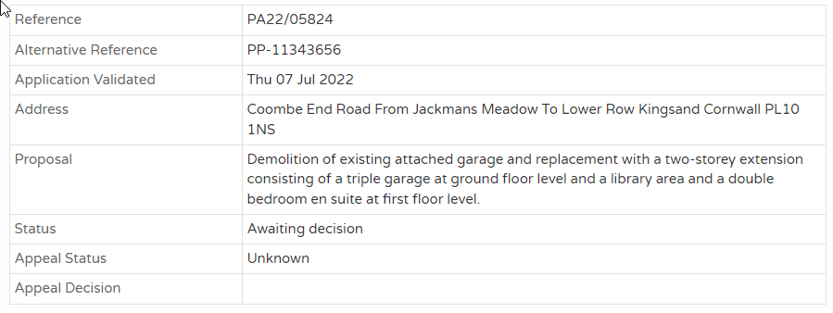
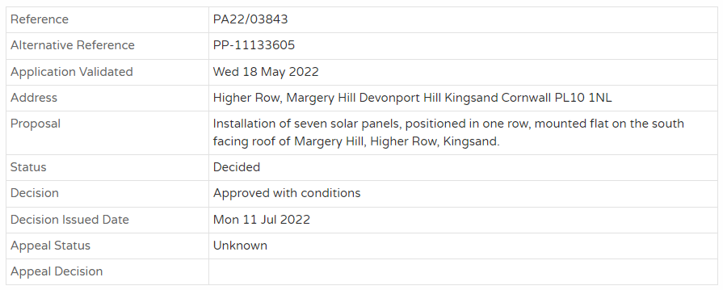
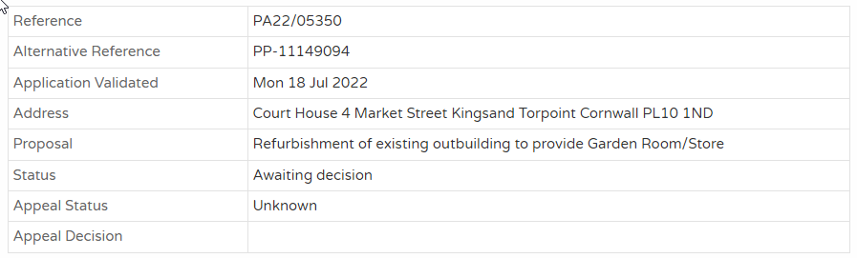

Appendix B - Planning Applications – reviewed - pending decision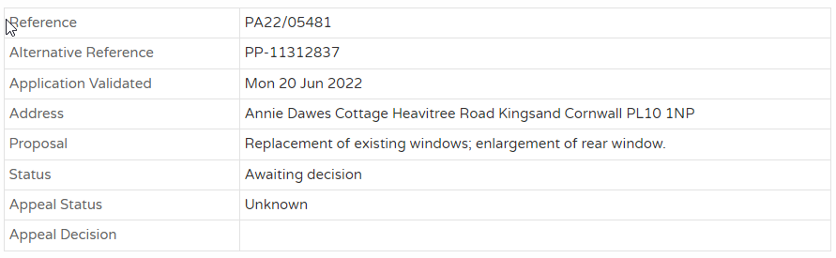

Appendix C - Planning Decisions – to note
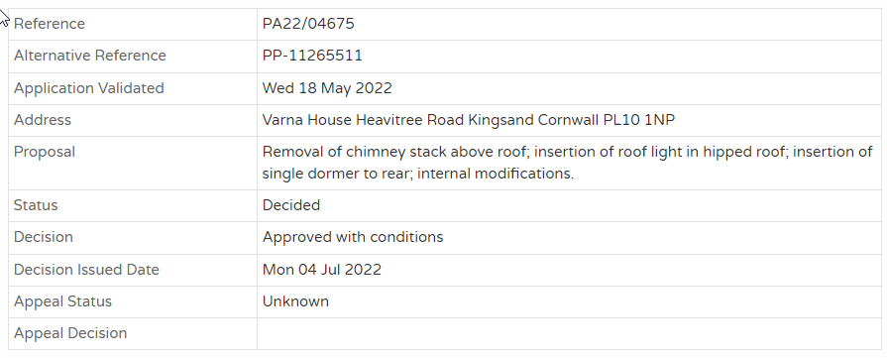
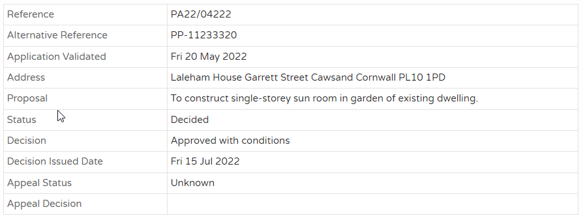

Planning item iii – 1 Porspoder Place, Green Park, Cawsand:

 | Comment
Site name and address | 1 Porspoder, Green Park, Cawsand, Torpoint PL10 1PP
UPRN | Housing
Property Description | A piece of land owned by Cornwall Council that was previously the site of a CHL-managed bungalow that was destroyed in a fire in 2015.  Planning approval has been received for the construction of 2 one and a half bedroom apartments, with associated parking and amenity.  The Council is unable to deliver an own-build scheme on the site due to viability constraints and is therefore intending to dispose of it to an alternative, community-led affordable housing provider.  There are 15 Households on the register for Maker with Rame, 7 of which are looking for a one bed property.
Planning position | Conditional permission: PA20/00061  decision date:19th March 2020  Planning permission will expire March 2023.
Plan  Insert or attach | 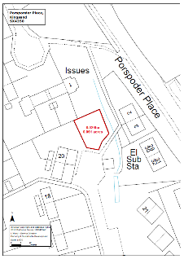
Photograph  Insert or attach | Bungalow prior to fire  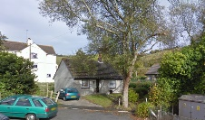
Recommendation | That the land is disposed of to the Rame Peninsular Trust.
Surveyor | Garry Becconsall
Date prepared | 1st June 2022

Consolidated Summary of Open Actions @30th June 2022:

# | Action | Who | When
22052301 | Committee ToRs to be reviewed for Jul PC mtg | Clerk | 25/07/22
22052302 | Receive an update on bus services from Cllr Ewert. | Clerk | 25/07/22
22052303 | Review Asset Register | Chair | 25/07/22
22052304 | Report quarterly forecast against budget | Clerk | Complete
22052305 | Review annual objectives of Clerk | All | 25/07/22
22052306 | Investigate cost for xfer of mail delivery to Clerk’s address | JK | Complete
22052307 | Investigate cost of Community Orchard sign | CG | Complete
22062701 | Community Event 2023 on the agenda for the October meeting to commence planning and budgeting. | Clerk | 20/10/22
22062702 | On the wider issue of the Mt Edgcumbe Country Park zero budget and what the plans were to make this possible, Cllr Weale request Chris Burton to attend a future meeting to present the overall strategy and plans. | JW | 25/07/22
22062703 | Cllr Weale noted that as Dog control was not on the main agenda, it should be brought back to the July meeting as an agenda item and encourage members of the Community to attend and share their opinions on the matter. | Clerk | 25/07/22
22062704 | Forward Pier Lane Residents email to Cornwall Council and request an update. | Clerk | 01/07/22
22062705 | Review Ian Turpitt email and respond on behalf of the Clerk. | JK | 01/07/22
22062706 | Reconcile the outstanding payments due for the Boat Park and send out reminders as required. | JK  Clerk | 25/07/22
22062706 | Confirm whether Precept has been received and report back at July meeting. | Clerk | 25/07/22
22062707 | Investigate rate of Post Office spend to date and report back at July meeting. | Clerk | 25/07/22
22062708 | Find out how to submit the Parish Council input to these Planning Applications and do so as soon as practicable. | JK | 08/07/22
22062709 | Reply to Chris Worrall email of 21 June acknowledging the above and the ongoing concerns of the Council until such repairs had been completed satisfactorily. | JK | 01/07/22
22062710 | Contact SWW re concerns over lifted drain covers on Footpath 2. | Clerk | 25/07/22
22062711 | Add agenda item of traffic consultation for September meeting. | Clerk | 25/07/22
22062712 | Follow up with formal note to Kate Ewert and Cornwall Council re the Parish Council concerns re the sea wall at Garrett Tops. | JW | 08/07/22
22062713 | Confirm defib training dates with Steve Matthews and promote on FB page etc. | JK | 01/07/22
22062714 | Provide update on discussions with Jane Mutch at next meeting. | JK | 25/07/22
22062715 | Update all on availability of Jubilee photos, link to website | JF | 08/07/22
22062716 | Feedback the concerns of the Council to PK and to request regular cutting of the paths is completed. | CG | 08/07/22
22062717 | Come back to the Full Council meeting in July for a further discussion on the Welcome Sign. | CG | 25/07/22
22062718 | Review and feed back on ToRs by July meeting | ALL | 25/07/22
22062719 | Add agenda item for the ToRs Endorse and sign-off at July meeting | Clerk | 25/07/22
22062720 | Arrange for a meeting with members of the MwRCH Committee to discuss our various roles and responsibilities, the potential transfer of assets we currently hold, and future ways of working. | JK | 25/07/22
22062721 | Review assets and approach to depreciation | JW  Clerk | 25/07/22
22062722 | Invite CA and others to a future Community event. | WF | 25/07/22
22062723 | Finalise any changes to the wording of the Clerk’s objectives and issue. | JW  WF | 08/07/22
22062724 | Contact Chris Burton or MtECP for a discussion on opportunities to work together on grasscutting and path clearance. | JW | 01/07/22
22062725 | Refine the tender document in the light of the above discussion and circulate to all for final input. | Clerk  JK | 25/07/22
22062726 | Advise Clerk of any agenda items for the July meeting | All | 15/07/22

Note – further historic actions will be added in due course until we are up to date.

