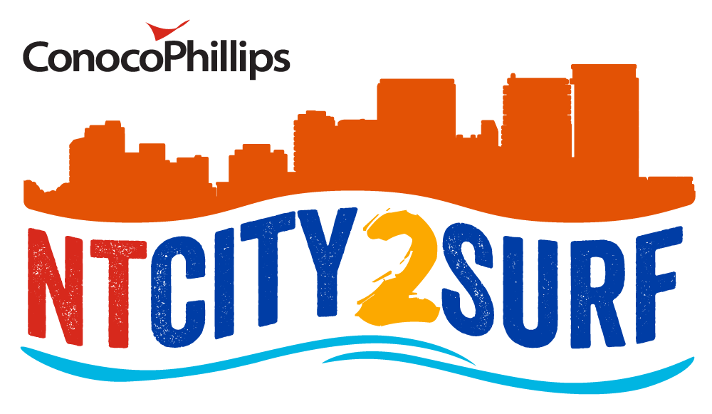

Honor Board

Year | 12km – City2 Surf |  | 4km - Mini Surfer
2021
2020 | Tim Hewitt – 00:42.05 | Pippa Featherston – 00:51.42 | Emerson Pomfret – 00:13.25 | Elisha Pettit – 00:15.56
2019 | Francisco Sanzana -00:40.53 | Vanessa Alvaro – 00:47.40 | Emerson Pomfret – 00:13.09 | Hayley Schoenmaker – 00:14.32
2018 | Jon Beck 42.54 | Audrey Hall 48.23 | William Harding 13.18 | Hayley Schoemaker 00:15.20
2017 | Darren Peacock 43.35 | Claire Johnson 50.16 | Joshua Cameron 12.55 | Amy Jones 16.47
2016 | Cody Williamson 44.41 | Pippa Featherston 51.25 | John Donnan 14.28 | Zoe Kopp 18.25
2015 | Darren Peacock 44.24 | Pippa Featherston 50.41 | John Donnan 13.13 | Andrea Foot 15.48
2014 | Darren Peacock 43.05 | Pippa Featherston 50.49 | Tiras Pie 13.34 | Joanne Stannard 17.48
2013 | Michael Marantelli 41.43 | Lucie Hardiman 49.24 | William McClay 14.28 | Sarah Lowden 16.50
2012 | Wondwosen Geleta 40.33 | Claire Johnson 48.47 | David Wood 13.57 | Andrea Foot 16.18
2011 | Darren Peacock  43.20 | Emma Kraft  51.45 | Ian Cameron | Imogen Teale
2010 | Ryan Cox 41.03 | Lucie Hardiman 48.54 | Edward Bourchier 13.51 | Ryoko Jones 16.53
2009 | Peter Eason 41.10 | Lucie Hardiman 49.37 | Edward Bourchier 13.33 | Hollie Goodall 16.33
2008 | Peter Eason 40.06 | Sophie Hawkens 47.04 | Alex Crossman 14.56 | Amy Terry 17.25
2007 | Peter Eason 40.43 | Lucie Hardiman 49.04 | Patrick Donohue & Theodore Bukka 15.57 | Hollie Goodall 17.48
2006 | Scott Brittain 41.51 | Eliza Mayger 47.39 | Garth Small 14.03 | Lauren Burrow 17.35
2005 | Ryan Cox 42.19 | Alison Kean 51.15 | Matt Brearly 13.22 | Hayley Barber 15.37
2004 | Steve Blake 42.44 | Jo Warden 49.16 | Ian Cameron 12.58 | Hayely Barber 15.57
2003 | Steve Blake 42.17 | Jo Warden 49.00 | Ian Cameron 13.05 | Simone Solomon16.57
2002 | Steve Blake 44.07 | Jo Warden 53.14 | Ian Cameron 13.18 | Amelia Hills 17.57
2001 | Steve Blake 44.04 | Jo Warden 53.21
2000 | Steve Blake | Jo Warden
1999 | Steve Blake 44.40 | Lucie Flanagan 48.16
1998 | Steve Blake | Lucie Flanagan
1997 | Steve Blake | Lucie Flanagan
1996 | Steve Blake | Lucie Flanagan
1995 | Steve Blake | Lucie Flanagan
1994 | Steve Blake | Cathy Gabel
1993 | Steve Blake | Helen Summers
1992 | Murray Wood | Lynn Clayton
1991 | Steve Blake | Helen Summers
1990 | Steve Blake | Anita Schaller
1989 | Steve Blake
1988 | Steve Blake
1987 | Steve Blake

1987 | Steve Blake
1986 | Steve Blake
1984 | Adrian Wellington
1983 | Steve Blake
1982 | Roger Hollis
1981 | Rob Lange
1980 | Rod Ellis
1979 | Nick Helms
1978 | Danny Boltz
1977 | Marcus Hirsiger
1976 | Marcus Hirsiger
1975 | Geoff Samuels
1974 | Rod Lyons

