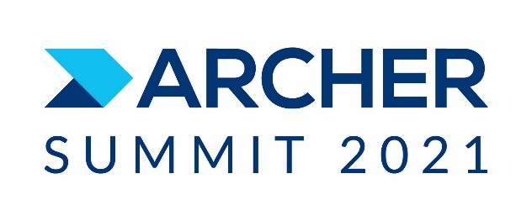

Re: Invitation to Archer Summit 2021
Duration:

Event to occur on: Monday, September 13, 2021 – Wednesday, September 15, 2021
Customer:

Dear Sir or Madam,

Archer is pleased to invite the following people from your organization to our user conference, Archer Summit 2021 taking place at Walt Disney Swan and Dolphin Resort, 1500 Epcot Resorts Blvd, Lake Buena Vista, FL 32830

Name Passport ID No. Date of Birth Title

This invitation letter is issued to facilitate the obtaining of a Visa from the US Embassy in {Country}. If you have any questions in this regard, please contact the undersigned at +1 571-277-1055

Sincerely yours,

Stacy Sakellariou
Archer Marketing
(email) stacy.sakellariou@rsa.com

Archer, a RSA Business
174 Middlesex Turnpike
Bedford, MA 01730

