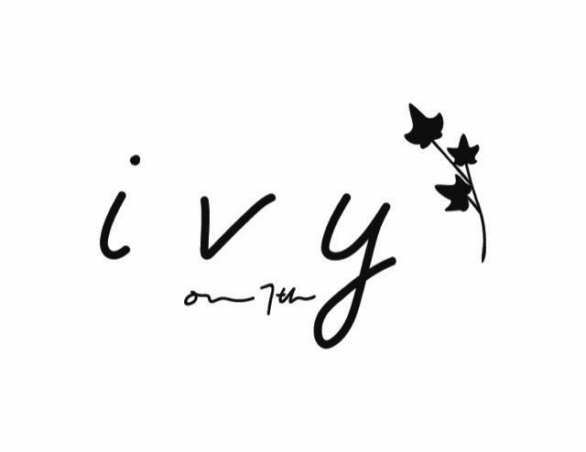

Dinner Option #1 $55 per person

Appetizers
(Choose 2)
FRIED FETA roasted tomato & oregano sauce GF
MINI CRISPY EGGPLANT & BURRATA tomato-basil pesto sauce GF
SICILIAN- STYLE MEATBALLS mozzarella, currants, pine nuts, tomato conserva GF
SPICY GARLIC SHRIMP CROSTINI calabrian chile, toasted garlic, olive oil (GF AVAILABLE )
ARTICHOKE & RICOTTA CROSTINI black truffle, lemon (GF AVAILABLE) vegan option
WARM MUSHROOM CROSTINI fontina fondue, parsley (GF AVAILABLE)

SALADS

( Choose 2)
CHOPPED GREEK-ISH” SALAD
baby romaine leaves, cucumber, hot pickled peppers, cherry tomatoes, cured black olives,
falafel- spice roasted chickpeas, feta, lemon-oregano dressing

BABY KALE & ROMAINE “CAESAR”- (v)
roasted garlic- lemon dressing, parmesan, parsley, ciabatta croutons

BABY ARUGULA & RADICCHIO
black figs, gorgonzola, hazelnuts, balsamic

ENTREES

(Choose 2)
PAN ROASTED CHiCKEN BREAST - GF
charred tomatoes, spring leeks, olives, fingerling potatoes, herbs de provence, white wine jus

WOOD GRILLED PETITE FILET & HAND CUT FRIES- GF
house- pickled red onions, demi glace

PAN SEARED SALMON GF
charred escarole, gigante beans, oven dried tomatoes, lemon-caper aioli,

RIGATONI MEZZE
tomato basil parmesan cream (vegetarian) GFO

BRAISED LAMB CANNELLONI
hand made pasta, colorado lamb bolognese, fontina fonduta, tomato-rosemary sugo

PAN ROASTED MEDITERRANEAN SEA BASS- GF
crushed red potatoes, feta, celery, capers, olives, herb vinaigrette

DESSERTS
Choose 1
ESPRESSO CREME BRULEE
chocolate covered espresso beans

FLOURLESS CHOCOLATE CAKE
vanilla whipped cream, amarena cherries

RASPBERRY PANNA COTTA
fresh berries, honey

Dinner Option #2 $65 per person

Appetizers
(Choose 3)
FRIED FETA roasted tomato & oregano sauce GF
MINI CRISPY EGGPLANT & BURRATA tomato-basil pesto sauce GF
SICILIAN- STYLE MEATBALLS mozzarella, currants, pine nuts, tomato conserva GF
SPICY GARLIC SHRIMP CROSTINI calabrian chile, toasted garlic, olive oil (GF AVAILABLE )
ARTICHOKE & RICOTTA CROSTINI black truffle, lemon (GF AVAILABLE) vegan option
WARM MUSHROOM CROSTINI fontina fondue, parsley (GF AVAILABLE)

SALADS

(Choose 2)
CHOPPED GREEK-ISH” SALAD
baby romaine leaves, cucumber, hot pickled peppers, cherry tomatoes, cured black olives,
falafel- spice roasted chickpeas, feta, lemon-oregano dressing

BABY KALE & ROMAINE “CAESAR”- (v)
roasted garlic- lemon dressing, parmesan, parsley, ciabatta croutons

BABY ARUGULA & RADICCHIO
black figs, gorgonzola, hazelnuts, balsamic

ENTREES

Choose 3
PAN ROASTED CHiCKEN BREAST - GF
charred tomatoes, spring leeks, olives, fingerling potatoes, herbs de provence, white wine jus

WOOD GRILLED PETITE FILET & HAND CUT FRIES- GF
house- pickled red onions, demi glace

PAN SEARED SALMON GF
charred escarole, gigante beans, oven dried tomatoes, lemon-caper aioli,

RIGATONI MEZZE- tomato basil parmesan cream (vegetarian) GFO

BRAISED LAMB CANNELLONI
hand made pasta, colorado lamb bolognese, fontina fonduta, tomato-rosemary sugo

PAN ROASTED MEDITERRANEAN SEA BASS- GF
crushed red potatoes, feta, celery, capers, olives, herb vinaigrette

DESSERTS
Choose 2
ESPRESSO CREME BRULEE
chocolate covered espresso beans

FLOURLESS CHOCOLATE CAKE
vanilla whipped cream, amarena cherries

RASPBERRY PANNA COTTA
fresh berries, honey

