Co-Production Collective Allies Group
Meeting notes: 8 November 2021

Members
Present: Niccola Hutchinson-Pascal, Lizzie Cain, Graham Hart (chair), Mandy Rudczenko, Cristina Serrao, Rob Horne, Karen Groot, Laura Crane, Laura Cream
Apologies: Ian Needleman, Simon Denegri, Sarah Welsher

Actions
Agreed approach | Person taking this on | Deadline
- Develop document(s) which clearly sets out Co-Production Collective’s offer and can be shared with potential partners and contacts | Nicc/Lizzie | Feb 2022
- Develop guide for UCL staff and funders which sets out how Co-Production Collective can be costed into research funding applications | Nicc/Lizzie | Feb 2022
- Share UCL Strategy Consultation link and background information with Allies | Laura Cream | Share with meeting notes
- Explore NHS examples of internal service provision, funding and governance | Team with support from Cristina | Feb 2022
- Introduce relevant contacts to Co-Production Collective | All Allies | Ongoing
- Explore potential to develop Co-Production Collective’s relationship with OVPH (Office Vice Provost Health) | Graham, Laura Cream | ASAP
- Set up meetings (or join existing meetings with Office of the UCL Vice Provost (Research, Innovation & Global Engagement) with new Dean of Population Health, and faculty Vice Deans of Research, Health and Impact | Graham, Laura Cream | ASAP

Updates
Lizzie provided updates on recent Co-Production Collective activity, including
- Our First Anniversary (read more in our recap blog)
- Plans to develop a ‘Halfway there’ report and web page for Our Direction 2020-2022, building on the slides shared at the birthday celebrations. Intend to use this to support marketing as well as reflection, check and challenge.
- Our current delivery projects, which include:
  - Co-Production partner on NHS England and Improvement Hearing Checks project
  - Learning partner for National Voices/Health Foundation Voices for Improvement project
  - Facilitating UCLH Biomedical Research Centre co-production of principles governing the use of patient data in research
  - Co-evaluating Camden Council’s Family Changemakers Project
  - Training for: UCL Mental Health Science PhD programme; Policy Impact Unit in UCL’s department of Science, Technology, Engineering and Public Policy; and London School of Hygiene and Tropical Medicine.
Mandy asked how co-producers are able to get involved in this work and highlighted the importance of transparency in this process. Lizzie agreed that it was not currently as good as it could be (we approach co-producers based on their relevant skills/experience), but we hope to make it fully transparent with the development of our new online community area.
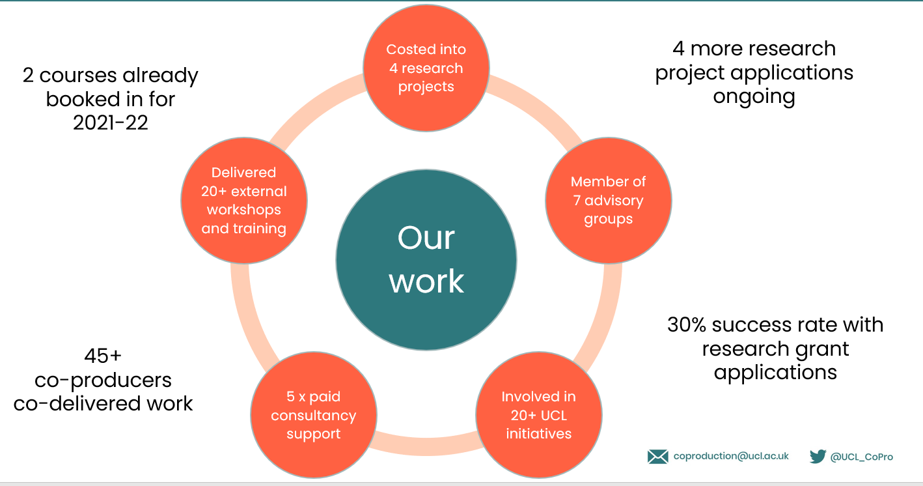

Funding
Niccola led a conversation about our current funding position. The discussion highlighted that:
- Most of our approaches for commissioned work come via word-of-mouth and reputation
- Relatively few of these are from inside UCL – a key concern.
- Our current model needs sustained funding support to continue beyond September 2022, ideally from internal UCL funding.
- Cristina highlighted the risk of losing staff given the current financial uncertainties.
This led into a conversation about how we could develop our offer internally within UCL:
- Graham emphasised the need for visibility and influence at a strategic level – Vice Deans and funders – not just researchers, and the responsibilities of Allies to be highlighting the value of co-production more broadly
- Karen echoed this, stating that Research Facilitators only see a fraction of research funding applications, and suggested a faculty-based approach
The discussion moved to focus on the need to clarify our ‘model’, offer and ‘sales pitch’.
- Rob and Mandy emphasised the need for a very clear, short and snappy offer document that can be shared with external contacts too – we could consider co-producing our marketing
Laura Cream updated the group about UCL’s internal strategic and leadership changes, and how they may affect Co-Production Collective’s position in the next few months. She and Graham agreed to set up meetings with various internal stakeholders, as well as highlighting the opportunity to respond to UCL’s Strategy Consultation by championing the value of engagement and co-production.
Our offer to UCL
Lizzie asked the Allies to provide feedback on a proposed model setting out which services we do and don’t charge for internally (when providing them to UCL staff). The discussion recognised that we our technically funded by UCL at the moment, so have to provide some free services, but we can look into what and how much we do this.
- Offering initial consultations for free can lead to funding once the relationship develops
- Laura Crane suggested that we could offer to provide services for free but explain our current funding position and request that, if there is budget, we are paid if possible
- Laura also highlighted the confusion around our position as UCL staff but needing to be costed in to research grants, and working to make this clearer.
- Recognition that there is no ‘one size fits all’ approach, as sitting on advisory groups for free may have benefits in terms of new connections/raising our profile, but for other projects, may not bring any benefits – need to assess on a case-by-case basis.
Everyone agreed that any involvement from co-producers in our community should always be paid.

Governance approach
Lizzie and Nicc presented some ideas to begin the process of co-creating a new governance structure for Co-Production Collective.
First and foremost, we believe Co-Production Collective’s governance should align with our core values – human, inclusive, transparent and challenging. This means balancing risk-holding and accountability with shared power and decision-making.
More specifically, our governance structures/practices need to:
- Hold strategic oversight over our work
- Provide accountability – financial and compliance but also to the wider Co-Production Collective community
- Provide support with our development, long-term sustainability and growth
- Provide ‘check and challenge’ at strategic and operational levels
- Involve the Co-Production Collective community at all levels
One suggestion involved distributing power and responsibility across three interconnected groups:
- Our Allies Group – oversight
- Our Co-production Check and Challenge Group
- Our Priority Setting Group
This was presented as a potential starting point, although it was emphasised that the approach and detail would be fully co-created with the Co-Production Collective community. There was also a suggestion of convening a working group to oversee and advise on any co-creation process.
Discussion
There was wide ranging discussion about the potential hierarchies and distinctions between groups:
- Laura Crane noted that if all the groups fed into the Allies, then this still created a hierarchy, which has both pros and cons; it was noted that this was a key issue for co-creation.
- Rob noted that the ‘tried and tested’ board model works, but Laura Cream pointed out that we exist to do things differently and that this way of working is potentially becoming outdated.
- Concerns were highlighted around the blurring of roles between different groups, and the need to be really clear about roles and responsibilities, particularly the distinction between decision-making and advice and guidance.
- Risk and accountability, plus the burden of administering three groups, were also raised as key concerns.
- It was suggested that two groups might be more appropriate, but Cristina noted that this creates an ‘us and them’ situation, whereas three groups distributes power more evenly. She suggested considering a stakeholder, a delivery and a strategic group.
- Cristina also noted that the three groups don’t have to be formal or traditional in set-up, and could be ad hoc, managed over email, etc.
There was agreement that, however we move forward with co-creating this, then we need to model our values and be innovative in our approach. We also need to prioritise equity, access and representation.
- Mandy noted that the reflective learning from the process of co-creation will be crucial, and something which others would be interested in – we should be keeping a record of our process to share and support others to do similarly.

Developing impactful relationships
Nicc defined ‘impactful’ relationships as one which supported our vision, mission and the co-production movement, as well as presented some funding opportunities. These relationships are worth more effort if they are likely to generate substantial impact.
The discussions included reference to:
- The tension between targeting high level, strategic individuals or organisations who can help us achieve real change, and targeting potential income sources
- Training the next generation of researchers
Questions about how far to move beyond the health sector.
Allies were asked to support Co-Production Collective by making connections with their relevant contacts and potentially attending meetings with us to support relationship development.

Date of next meeting: Tuesday 25 January 2022, 14:00-16:00.

