Payment Co-creation Sessions Summary

We came together on Friday 7 May and Tuesday 18 May to explore four key issues in relation to our payment policy:
- Eligibility for payment
- Non-financial recognition and reward
- What counts as ‘work’?
- A co-producer’s payment journey
We started from the position that in an ideal world, we’d offer to pay everyone for co-producing with us. But we don’t have unlimited funding – how can we take an approach which upholds our values but is also realistic?

Below are the headline ideas which emerged from the session, information about what next, and a detailed recap of the discussions around each issue.

Headlines
This section summarises the broad consensus we reached together for each issue (although, of course, there was considerable nuance for each issue).

Eligibility
- Co-Production Collective benefits from having a diverse community of co-producers with different circumstances, backgrounds and experiences.
- We should approach payment from the perspective of who isn’t eligible to be offered payment rather than who is. Ultimately, this means offering payment to anyone who isn’t participating as part of their job (i.e. they’re already being paid to be there), with the understanding that not everyone will accept it (i.e. if they don’t feel they need it).
- We should explore payment with individuals on a case-by-case basis, recognising that everyone’s circumstances are different and may change. It’s not our place to ask or make judgements about people’s needs or lives – we start from a place of inclusivity.

Non-financial reward and recognition
- There are many additional benefits which co-producers gain from being part of Co-Production Collective – and more that we can work towards offering, e.g. peer support, training opportunities, recognition of achievements.

What counts as work?
As a group, we established that activities count as ‘work’ are those which:
- Require significant time and commitment
- Make use of people’s experience and expertise
- Involve everyone working together as one team
We agreed that activities which are more social and informal, or primarily involve Co-Production Collective staff giving information rather than everyone collaborating, do not count as work and therefore payment should not be offered.

A co-producer’s payment journey
The breakout groups identified similar stages which should be present on the ideal co-producer’s payment journey, including:
- An introduction to Co-Production Collective in general, including our values
- Individual conversations to explore their needs, preferences and what might work for them
- Easily available and accessible information in a range of formats
- Regular and proactive communication from the team throughout the payment process

What next?

There’s still a lot of work for us to do to bring this all together, but the ideas from the co-creation sessions will feed into a new draft, which we hope to have ready for July. This will then be shared for another round of co-creation via a document (online or offline), before we do a final revision. We hope to have the policy in place by September/October, test and learn as we implement it, then review after six months.
It will always be a work in progress!
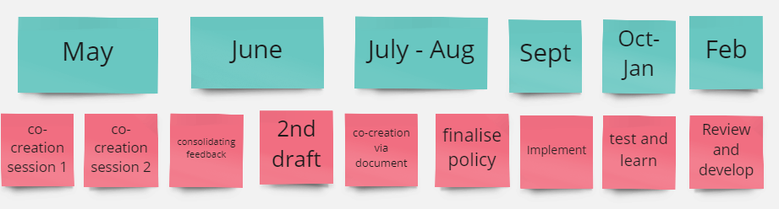

The issues in more detail

Eligibility
Below are the imaginary co-producers, some information about them, and the group’s general conclusion about whether they should be offered payment or not. Shaun and Ben were the easiest to agree on – Lauren and Ayisha were less clear cut and not everyone agreed on the best way forward.

Shaun
Shaun is an Uber driver, so he has flexible hours but uncertain and low income.
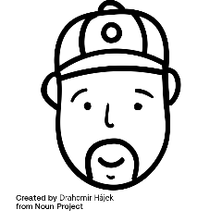
Shaun is a carer for his wife and heard about co-production through talking to other patients and carers at his local hospital.

Shaun has to choose between co-producing with us or working.

Verdict: eligible for payment
Why? This was a clear decision for the group. Shaun would be experiencing a financial loss if he co-produced with us without receiving payment – a barrier which may stop him joining in the first place. He is interested from a personal perspective and doesn’t work in a related area, so is less likely to gain any career benefits either.

Lauren
Lauren is a lawyer with a well-paid part-time job. She chooses to work part time so she can spend two days a week with her children.

Lauren is interested in Co-Production Collective because she chairs her local maternity voices partnership. They take a co-production approach to improving maternity services based on their personal experiences.

Lauren co-produces with us on the days she’s with her children, not in work.

Verdict: eligible for payment
Why? This was harder, as Lauren is financially secure so it felt harder for some in the group to justify paying her in the context of Co-Production Collective’s limited resources. However, she is joining us from a personal perspective and may miss out on time with her children, so she should be considered eligible for payment. Given her circumstances, she may well choose not to accept.

Ayisha
Ayisha is a university researcher with job security.
Ayisha is trying to encourage her department to do more co-production – at the moment it is very limited and she’s struggling to get backing from senior leaders.

Ayisha can co-produce with us as part of her job but it means taking time away from her research, so she has to make this up in the evening or at the weekend.

Verdict: probably not eligible for payment
Why? This was the trickiest situation, with some feeling that she should be offered payment as she has to catch-up on the work she misses. However, she is attending from the perspective of her paid job and will gain direct benefits in this area. The group suggested that we could support Ayisha to demonstrate the benefits of her involvement to her employer, supporting her participation as part of her role.

Ben
Ben has a full-time role at an NHS trust on a short-term contract.
Ben’s job involves supporting others to co-produce, running workshops and training with patients, clinicians and researchers.

Ben can take as much time as he likes to co-produce with Co-Production Collective as part of his job.

Verdict: not eligible for payment
Why? This was also relatively straightforward for the group – Ben can attend in the capacity of his paid role, so doesn’t need additional financial support or recognition from us.

What else could Co-Production Collective offer as part of a ‘package’ for co-producers?
First we explored why people get involved in co-production activities (with us or elsewhere) and what they gain from it. Answers included:
- To make a difference – challenge the system
- Feeling valued and valuable – belonging, connection, community
- Personal development – skills, learning, knowledge, confidence
- Supports wellbeing
- It’s interesting and enjoyable
Then we moved on to consider how Co-Production Collective could build on this. Themes included:
- Peer support, e.g. buddies, mentoring, reflective spaces
- Recognition, appreciation and celebration
- Access to additional opportunities and support – learning, employment, skills

What counts as work?
We used four Co-Production Collective examples to explore the type of activities which count as work and so should be paid (for those who are eligible).
Co-creation session
A workshop where we come together to actively co-create an aspect of Co-Production Collective such as our payment policy. What we do has a direct influence on the Collective’s work or approach.
Verdict: Counts as work
Everyone agreed that this should be paid as it is fundamental to the work of Co-Production Collective and co-production itself. In these sessions, everyone is working together as one team so all contributions should be valued.

Blog
Writing or contributing to a blog which is published on our website.
Verdict: Counts as work
Again, there was widespread agreement that this should count as work due to the time and effort involved, as well as the value of the contribution to Co-Production Collective’s work. Payment also enables co-producers who may not otherwise have a platform to share their experiences.

Cuppa
An informal get together with no agenda – a chance to meet and chat with others interested in co-production, make new connections, etc.
Verdict: Does not count as work
It was agreed that those who choose to attend (rather than facilitate) a Co-Pro Cuppa were doing so for the social and other personal benefits they may gain. This was seen as more of an offering from Co-Production Collective, rather than work on its behalf.
Intro meeting with one of the team
A chat with Niccola, Lizzie or Rory to find out more about Co-Production Collective, what we do and whether you might want to get involved.
Verdict: Does not count as work
This was the most difficult decision and in an ideal world, perhaps we would be able to offer a nominal amount to enable a co-producer to come to a meeting in the first place. However, there were concerns about the practicalities of offering payment (and the personal information required) at so early a stage, as well as recognition that this meeting is more similar to the process of applying for a job than actually doing the work. It could be seen as the start of an ongoing relationship with Co-Production Collective which will enable further opportunities for payment through other activities.

A co-producer’s payment journey
We took imaginary first-time co-producer Shaun (who it had already been decided was eligible for payment) on his payment journey, asking what information he needed to know, when and how he should find this out.
Broadly, access to all the information as early as possible was the general consensus, but with concerns that this could be overwhelming. Providing the key information up front, with links to access more detail in his own time, was therefore seen as important.
Everyone agreed that an individual conversation with the team would be valuable, not only to introduce Shaun to the Collective, but also talk him through our processes and understand his needs and preferences.
Regular and ongoing communication at all stages of the journey was a key message from all groups, as was the need for the Collective to be proactive in offering payment – this would help remove stigma and uncertainty for Shaun.
Other key points included the need for flexibility, as well as providing information in multiple formats.
The information Shaun needed to know included:
- Eligibility criteria
- Alternatives to financial payment if needed/wanted (e.g. donation to charity, vouchers, other support)
- Rates of payment
- Clarity around what activities are and aren’t paid
- How to claim and methods of payment
- Expected payment timeline
- Tax/benefit implications and his personal responsibility in this area, including signposting where he can access additional support

