

Our Co-production Pilot Projects  
2018-2020

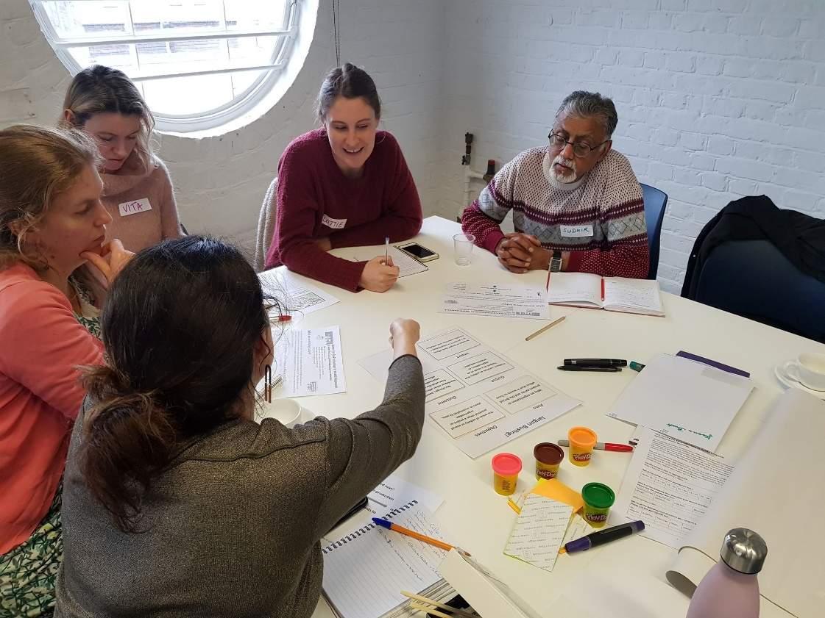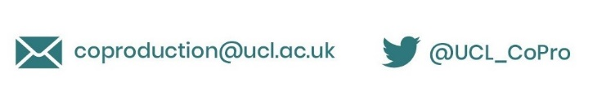

## Introduction

As part of our work as UCL Centre for Co-Production, we funded two phases of co-production pilots to co-produce a health research or innovation project. The aim of this work was to test and learn about co-production by supporting teams to co-produce in practice.

Applications were open to any group, as long as they included people with lived experience working alongside researchers and/or practitioners. We didn’t want to be traditional research funders – applications could be sent by video, funding decisions were made by a mixed panel from our co-production community, and we co-created our learning and evaluation approach together.

In Phase 1 we funded five projects up to £5K each over four months. We soon learnt that this wasn’t enough time and not much money! So in Phase 2 we allocated up to £15K per pilot over seven months. We funded one pilot in both rounds.

Almost all of the projects have continued to grow beyond our funding, and remain part of our co-production community. The learning we generated together has been embedded across all of our work, from the training sessions we run to the co-production of Co-Production Collective itself.

We will be sharing much more about what we learnt over the next few months. In the meantime, you can find out about all the pilot projects below.

# **Co-producing the Real Talk Intervention and Prevention Programme** Action Youth Boxing Intervention (AYBI) and HERON (Health Inequalities Research Network)

AYBI’s Real Talk programme is based on Cognitive Behavioural Therapy, Rational Behaviour Therapy, social life skills, motivational teamwork activities and goal setting to help young people in Camden and Somers Town who are experiencing challenges with learning, behaviour, and emotional issues. They use non-contact boxing as a medium to reach out to young people in need of help.

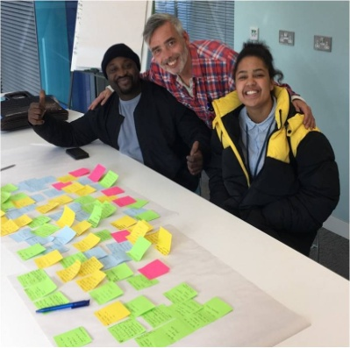AYBI’s founder Albert was keen to evaluate the impact of their work on young people, in order to grow and strengthen their activity. Together with UCL researcher Charlotte (who he met through a UCL Creating Connections event), they worked with young people to co-produce an organisational theory of change, a research plan and new aspects of their programme, including yoga and mindfulness.

They also tested out different evaluation approaches and ways to share their evaluation findings.

*“If the project had been designed/delivered just by researchers, the nuances of the programme and context would have been missed, and the outcomes developed would not have necessarily reflected those important to young people or those identified by schools”*

#### The AYBI team pose ready for boxing (c. AYBI

#### What happened next?

The evidence base they co-produced has helped to demonstrate the impact of their work, enabling them to successfully apply for further funding and develop partnerships with more schools. AYBI also now have a stronger relationship with their neighbours UCL and even won a UCL Public Engagement Award!

## Find out more

Watch [AYBI’s Public Engagement award video](https://www.youtube.com/watch?v=1TUsffl6D00&list=PLmR-JZVheI8roMuf_gHxYLne9gSGO8GVC)  
Visit the [HERON website](https://heronnetwork.com/)  
Visit the [AYBI website](http://aybi.co.uk/)

An uncommon cancer diagnosis: understanding lived experiencesRoyal Marsden Uncommon Cancer working group  
  
Members of the Royal Marsden hospital’s Uncommon Cancer working group (Alison and Margaret, patient representatives, and Peta and Jamie, clinical nurse specialists) developed their idea for this pilot based on their own experiences of the difficult pathway to diagnosis with an uncommon cancer. They particularly wanted to find out more about the problems encountered, unmet patient needs and the impact of a diagnosis on those close to the patient.

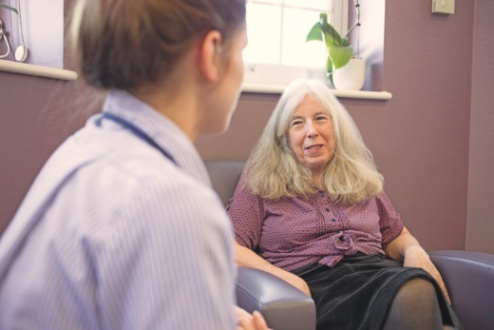

*“The involvement of two nurses with face-to face-contact in clinics with patients with melanomas was critical in recruiting the patients for the focus group. The project could not have happened without this co-productive approach as the PPI reps were not employed by the hospital and had no patient contact”*

Together they co-produced a focus group for patients, analysed the findings and wrote a report identifying key themes. Participating in the project had a positive impact on the patients themselves, as well as providing important learning and insight into their different perspectives for the nurses.

*“I found the analysis difficult reading it on my own, however I found the co-production meeting very helpful in analysing the data… I learnt about the process of designing the study from the ground up...and about the patient experience.”*

#### What happened next?

Their findings contributed to the Uncommon Cancers research theme for the NIHR Biomedical Research Centre at The Royal Marsden NHS Foundation Trust and Institute of Cancer Research. They were also the first project involving patient experience to be featured in the organisation’s annual report, and the team presented their work at a national conference for community research.

#### Find out more

Explore the project in more detail on the [BRC Royal Marsden website](https://www.cancerbrc.org/patient-and-public-involvement-and-engagement/brc-patient-representatives-our-experiences/understanding-lived-experience)

## Who cares if bleeding gums worsen diabetes and heart disease?

UCL Eastman Dental Institute

Research has shown that intensive gum disease treatment improves outcomes for patients with diabetes. However, there is a gap with how this is translated to real life.

Ian and Francesco, clinical specialists in gum disease, connected with Brian and Heather, patient representatives interested in type 2 diabetes and oral health. They wanted to work together to strengthen their understanding of this issue before co-producing a grant application to the National Institute of Health Research (NIHR) for a large-scale research project.

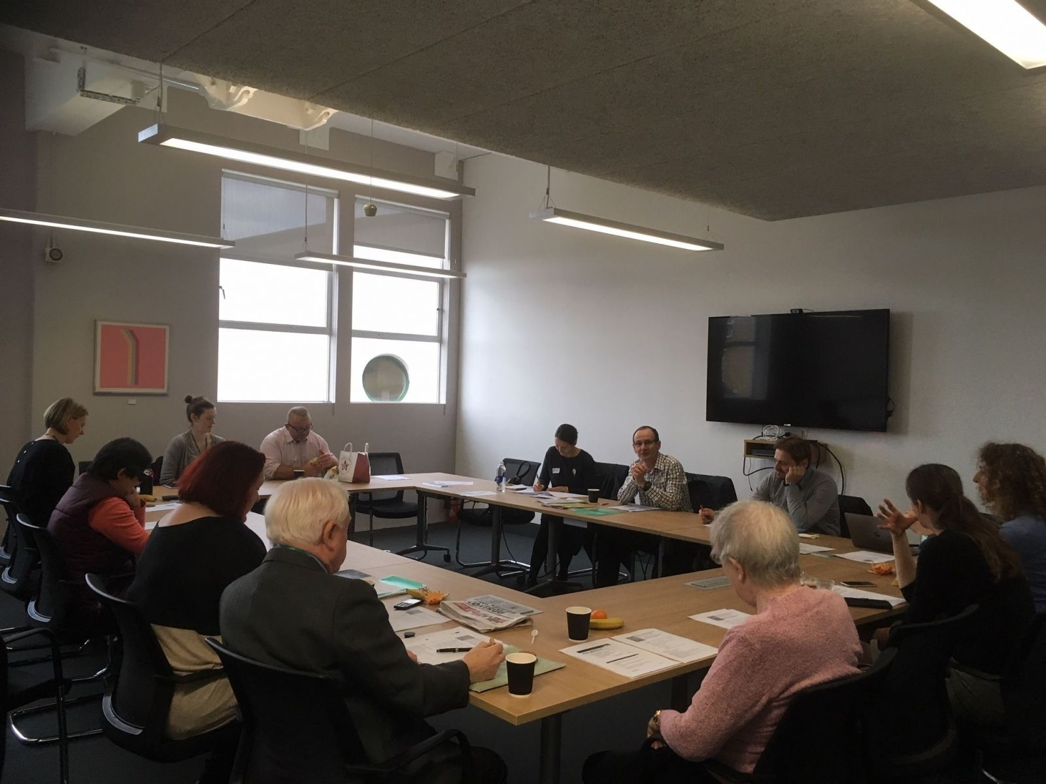

*“It is striking that many participants independently commented on how much they value what they have learned during the pilot. The learning has helped to empower their own health management and interest in participating in projects.”*

Through community engagement activities, they explored people’s knowledge, understanding and concern about oral health and diabetes. A key finding was the lack of awareness among health professionals, as well as patients, and the need for greater education to support this. Community pharmacists were identified as a particularly valuable group to work with in future.

*“In the very short timescale of the project, I have learnt just how powerful co-production can be to improve research, develop strong community engagement, change minds and empower people. The potential value for healthcare research is obvious”*

#### What happened next?

The team (including Heather and Brian) are now leading a national consortium applying for funding for a research project on oral health and diabetes. Co-production has been embedded across this work and will continue to be central to the activity if it is funded (Co-Production Collective are now part of the team too!).

They’ve also been asked by the Department of Health to contribute to their Patient Group advising on national pathways for this issue.

#### Find out more

You can read more about the project in [this news article](https://www.uclhospitals.brc.nihr.ac.uk/news/public-patients-and-researchers-co-produce-research-gum-disease-and-diabetes) and hear more about Ian’s perspectives on co-production [in this video](https://www.youtube.com/watch?v=avI2S2OJau4&list=PL1vtHOjD7gN0zv69hASCuk6wfgHC4yrSq&index=3).

## We Ci2i

This was project was funded in partnership with NIHR Moorfields BRC’s Challenge Fund for vision research

Jacq is a children’s research nurse at Moorfields Eye Hospital, working on a PhD which aims to improve children and young people’s experiences of taking part in eye and vision research. Partnering with Sarah, whose child is a patient at Moorfields, they aimed to bring together a group of children, young people, parents and researchers, to feed in perspectives as a ‘design team’ for the Ci2i Project.

*“Originally, we had imagined that we would use this funding to set up a co-production style advisory/steering group and then get quickly on with co-designing the Ci2i Project. However, it didn’t take us long to realise that you can’t bring a new group together and, for example, expect to reach a co-produced set of ground rules in the first meeting! Developing those relationships and orientating the group to their purpose with education, takes time and investment in the individuals.”*

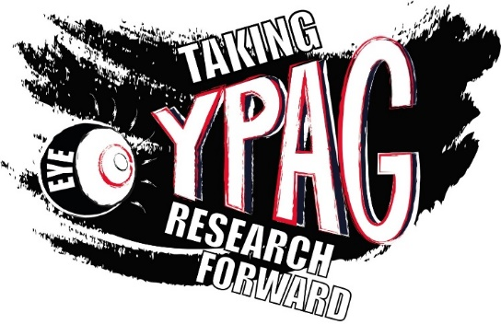They ran creative sessions to recruit and engage a wide age range of members (8-16 years) and spent the next few months building relationships. During the first year, as well as advising eye and vision researchers, the group also spent time developing their shared identity, working with artist Sofie Layton and culminating in the co-design of a group logo and new name – EyeYPAG ‘Young Person’s Advisory Group’.

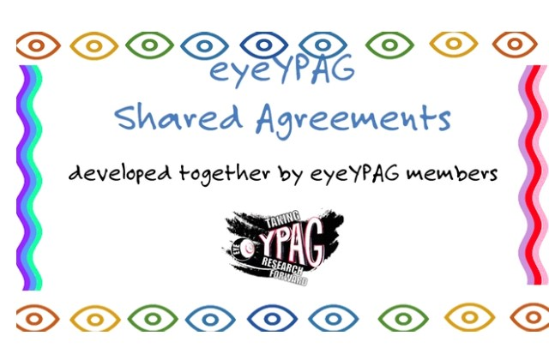

Moving into their second year, to continue developing themselves, the group ran a peer-interview workshop, followed by multiple group discussions, to arrive at their ‘Shared Agreements’: their commitment to a way of working together with a ‘co-production’ ethos.

#### What happened next?

As well as developing themselves as a group, EyeYPAG and their parents have now significantly contributed to the design of Jacq’s Ci2i project. For example, using a filming workshop to think through the ethical considerations of data sharing and using process maps to plan the overall design. One member, Lily, has also put her artistic skills to great use by creating illustrations to make the project information more accessible to younger children.

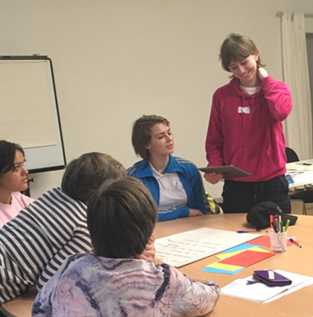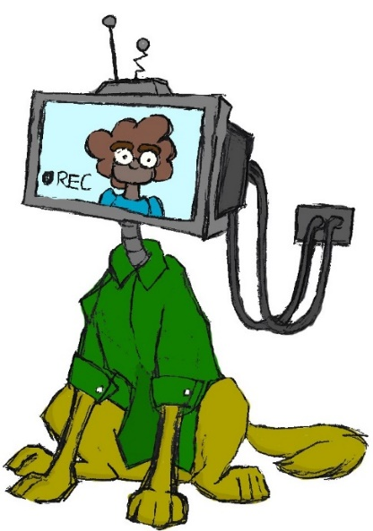

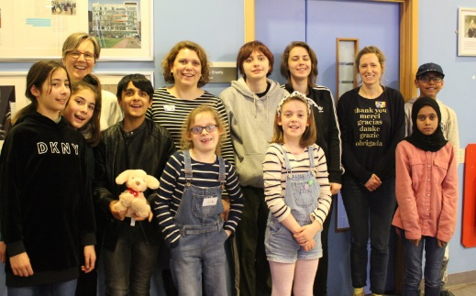The group has gone from strength to strength run by Louca-Mai, Annegret and Jacq. They have not only contributed to Jacq’s Ci2i Project but have also worked very successfully with many eye and vison researchers over the past two years. In 2020, they won the Increasing Patient and Public Involvement and Engagement (PPIE) Award at Moorfields.

#### Find out more

Meet Eye-YPAG [via their video](https://vimeo.com/433706680) and catch-up with their meetings [on their website](https://generationr.org.uk/eye-ypag/). Watch their Shared Agreements video and find out more about their journey [here](https://generationr.org.uk/eyeypag_shared-agreements/). You can also watch Jacq talking about her learning [in this video clip](https://www.youtube.com/watch?v=TNs8RtMfiTo&list=PL1vtHOjD7gN0zv69hASCuk6wfgHC4yrSq&index=4).

## Hearing Birdsong – raising awareness of hearing loss in under-represented groups

Kennedy Woods, Imperial Institute of Global Health Innovation and partners

This project was funded in both rounds of pilot funding, first as ‘Making care safer through innovation’. This project evolved into ‘Hearing Birdsong’, involving members of the same team and newcomers in the second phase of co-production.

The project began with questions around how to improve communication between people with hearing loss and health/social care professionals in North West London. Anna, Rachel and Jean were the initial members of the project team and drew together a diverse steering group to co-produce a sandpit innovation workshop. This workshop brought together people with hearing loss, researchers, healthcare professionals and designers to develop novel research ideas. They also secured a further £5000 from the NIHR Imperial Patient Safety Translational Research Centre to award to the winning idea.

The two-day event took place in January 2019 and sparked several new collaborations. The award was ultimately won by Hearing Birdsong, an idea generated by a team led by product designer Tom from Kennedy Woods Architecture.

Ideas include - immerse staff training, birdsong, conveying your message, hear ear clip nad sticker, screening in memory clinics and rehab unit screenings. 

The ideas are illustrated with little doodles*“Although decisions took longer, we had a final product that was a non-clinical, enjoyable way to start a conversation around hearing loss. It could very nearly have become an App on a smart phone, which wouldn’t have reached the seldom heard groups in Hackney.”*

Hearing Birdsong was inspired by Angela, a member of the team who was motivated to get her hearing checked when she realised that she could no longer hear the birds on her morning walk. Fusing together art and technology, the Hearing Birdsong bird boxes play birdsongs at different frequencies to raise awareness of hearing loss in a non-threatening way.

In the second phase of their project, the Hearing Birdsong team co-produced a series of events, taking the installation out into the community to engage with groups who are more likely to have undiagnosed hearing loss. They also continued to co-produce the Hearing Birdsong installation itself with members of those communities, including the Hackney Brocals.

Team members and volunteers show visitors around the Hearing Birdsong installation in Dalston Curve Garden (c. Hearing Birdsong)

#### What happened next?

Hearing Birdsong is still going strong! They were highly commended for ‘Environmental Awareness’ at the Advancing Healthcare Awards and have recently been awarded a World Hearing Day small grant from the World Health Organisation. They have presented at international conferences and their learning has been incorporated into teaching and research at Imperial.

#### Find out more

Experience Hearing Birdsong for yourself [via their website](https://www.hearingbirdsong.com/), explore the background to the idea in [this BMJ blog](https://blogs.bmj.com/bmj/2019/03/03/jean-straus-could-birdsong-help-boost-engagement-with-hearing-tests/) and follow them [on Twitter](https://twitter.com/hearingbirdsong).

## BAME Voices in Maternity Care (2019-2020)

Maternity Voices Matter, UCLH Maternity Services, Manor Gardens Community Centre, North Central London Commissioning Support Unit (NEL CSU)

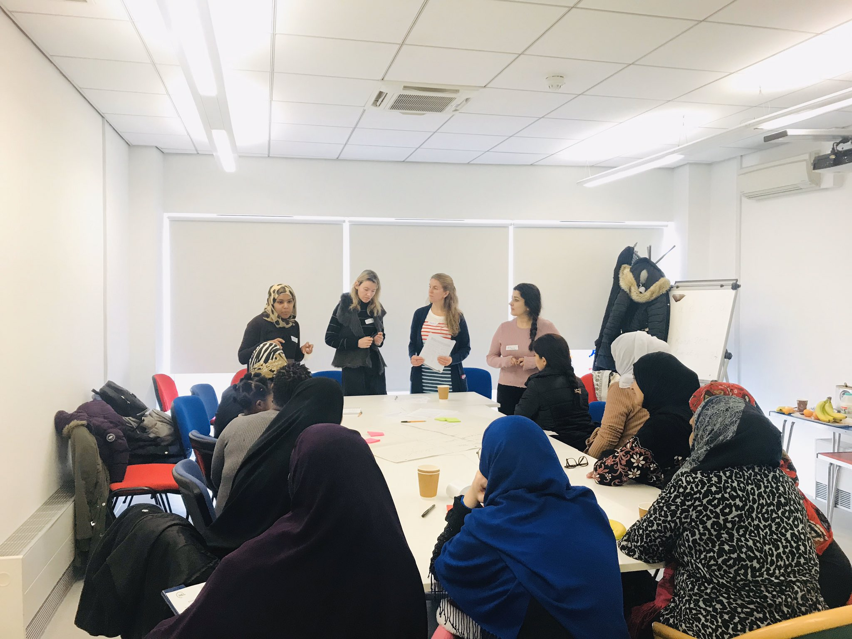Maternity Voices Matter - Aygul, Emily, Abuk, Vita, and Anna - are trained maternity service users using a peer-led approach to community research to include the voices of families in co-producing and improving maternity services. Their aims are to listen to service users, give feedback to health professionals, and ensure that service users’ experiences are at the heart of service provision. They worked with NHS partners and a bilingual family support service at Manor Gardens Community Centre to co-produce a participatory research project into BAME and ‘seldom-heard’ women’s experiences of maternity care.

Together, they designed, facilitated and analysed the research, building trust with families and gathering personal testimonies. These were brought to life by actors at a powerful event attended by frontline health workers, midwives, and representatives from a wide range of specialist services and charities, as well as the families themselves. Their work has fed into the UCLH Maternity Voices Partnership, encouraged Manor Gardens to do more co-production, and ensured services listened to those whose experiences had previously gone unheard.

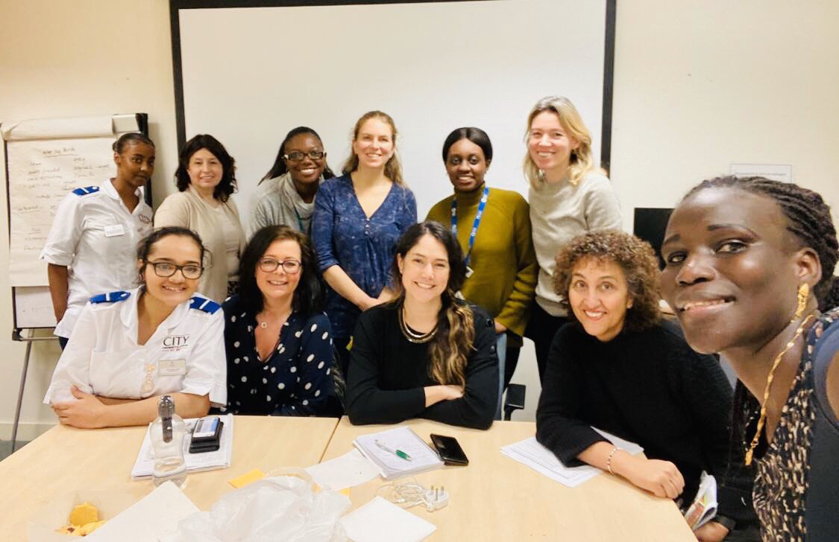

*“We couldn’t have done what we’ve done without those organisations we coproduced with, and there’s no way they would have even thought about doing it, let alone been able to. Together we are stronger, alone there is only so much we can do.”*

#### What happened next?

The group have now formed Maternity Voices Matter, their own social enterprise, to continue this work and are inspiring others around the country.

#### Find out more

Follow Maternity Voices Matter [on Twitter](https://twitter.com/MaternityVoice) and read more about [their co-production journey here](https://blogs.ucl.ac.uk/public-engagement/2020/05/15/co-production-and-compassion/)

## Authentistic: Co-production with autistic adults

Authentistic Research Collective

Rates of anxiety and depression are much higher among autistic than non-autistic people, but there is limited evidence about how to adapt treatments such as Cognitive Behavioural Therapy (CBT) to be accessible and supportive to autistic people. Similarly, group-working processes (such as those used in co-production) can also be inaccessible for autistic people.

*“Research can ultimately meet the needs of the autistic population better if autistic voices are part of the process. The goal is for research to both benefit the individuals who participate, empowering them within the process, and also to provide research to benefit the many through rigorous and thoughtful scientific practice.”*

The Authentistic Research collective – Eloise, Dorota, Annalise, Naomi, Sophia, Keith, Nick and Richard – came together to tackle both of these issues. They wanted to investigate how psychological therapies can be adapted for autistic people, whilst at the same time exploring the process of co-production. The team compromised autistic and non-autistic members with diverse experiences in psychology, neuroscience, media and mental health, and were recruited via word of mouth and local groups.

Their collaboration was co-produced from the beginning, giving the group the safety and freedom to be their ‘authentic’ selves. Through a series of online and offline meetings and activities they co-produced an accessible report ‘*Adapting Psychological Therapies for Autistic Adults: A Curious Approach to Making Adaptations,* aimed at therapists, researchers, autistic adults and other interested parties. They highlighted suggestions for adaptations that can be made to CBT, alongside gaps in existing knowledge, based on research and their experiences.

The process of co-producing also helped them to understand what worked and what could be done differently to support autistic adults to co-produce. This generated a set of reflective guidelines to guide and encourage future co-production initiatives between autistic and non-autistic team members.

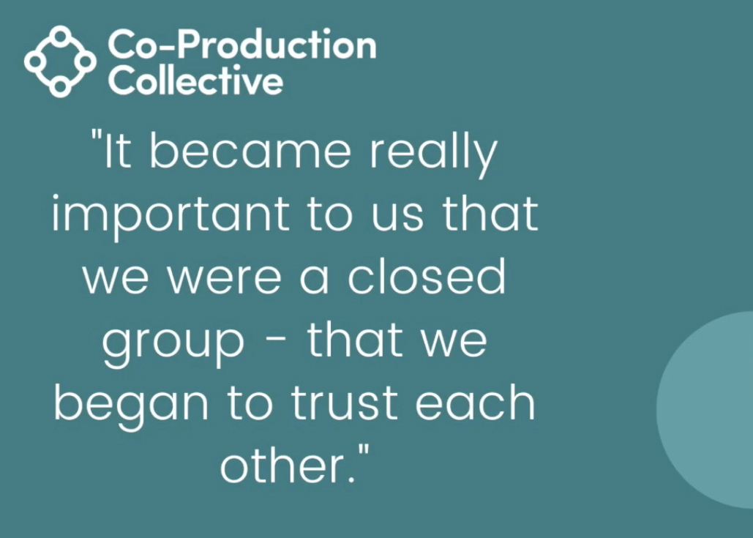

What happened next?   
Their guidelines have been turned into an article, *Coproduction with Autistic Adults: Reflections from the Authentistic Research Collective*, and published by the journal Autism in Adulthood.

#### Find out more

You can find out more about Authentistic and access [their publication here](https://www.authentistic.uk/) and [their journal article here](https://www.liebertpub.com/doi/10.1089/aut.2020.0050). You can also hear more about Keith’s perspectives on co-production in these clips: [Video 1](https://www.youtube.com/watch?v=9OUepdbY3yI&list=PL1vtHOjD7gN0zv69hASCuk6wfgHC4yrSq&index=14) and [Video 2](https://www.youtube.com/watch?v=DY7_Ys_l0so&list=PL1vtHOjD7gN0zv69hASCuk6wfgHC4yrSq&index=5)

## Bridging Gaps

*University of Bristol, One25*

Bridging Gaps is a team dedicated to improving access to primary care (GP services) for women with complex needs.

Lucy, a GP and researcher, was running a weekly drop-in clinic at One25, a charity which supports women with complex needs, when she became aware that the women didn’t feel safe or supported to access mainstream GP services. Together with other researchers from the University of Bristol, Lucy and a group of the women have been collaborating to tackle this issue. Through storytelling workshops and planning meetings, the group built the skills and confidence to deliver education sessions for GP surgeries, with the women sharing their personal stories. They’ve also produced a video addressing the stigma and challenges they face, which will be used in healthcare education settings.

*“After the educational session with the GP trainees, one of the GPs present approached one of the women with lived experience and personally thanked her for her bravery in sharing her experiences with the group. This GP and many others were obviously moved by the stories shared by women in the education sessions.”*

The project has been very well received, gaining backing from a local NHS commissioner and securing further NIHR funding to pilot potential solutions and increase their impact. Further recognition came when the team won two Golden Key Great Practice Awards in 2019, for ‘Independent Futures’ and ‘Inspiring Learning’. The women involved have also experienced significant personal benefits from being part of the co-production team.

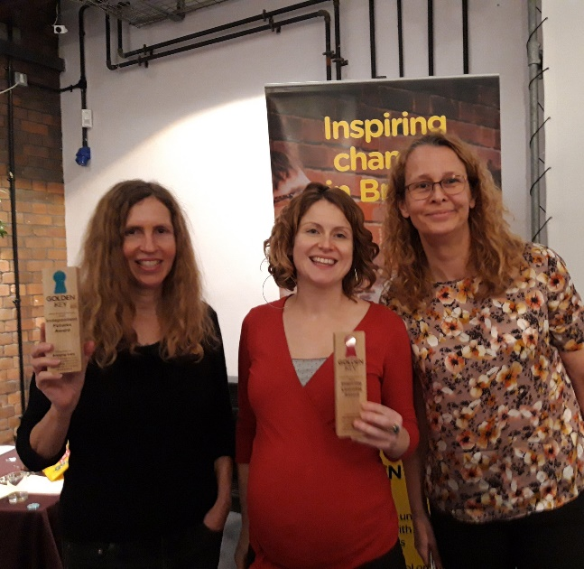

*“It has… fostered greater understanding and trust between the women with lived experience, academics and clinicians in the group. Some women have shared how this has also had a positive impact on them as they go forward, in terms of their interactions with other professionals. Likewise, the clinicians and researchers in the group have had their practice informed by valuable learning shared by the women with lived experience.”*

#### What happened next?

The Bridging Gaps team are still co-producing together and were able to continue to do so during lockdown, funding IT equipment so all members participate. They have recently been successful in securing Q Exchange funding and support to roll out the project.

#### Find out more

Read the latest update from the team [on the Q Exchange](https://q.health.org.uk/idea/2020/making-primary-care-accessible-to-women-with-experience-of-trauma/) and watch Michelle talking about the importance of relationships [in this video](https://www.youtube.com/watch?v=o16tpEXUNKU&list=PL1vtHOjD7gN0zv69hASCuk6wfgHC4yrSq&index=7).

## Learning and developing – what’s next?

As you can imagine, these 8 projects have generated so much learning about co-production as a process, as well as the value it can bring for individuals, teams, organisations and sectors.

All of this evidence has contributed to Co-Production Collective’s work so far, helping us to co-create ourselves, design support and training for others co-producing, and champion co-production far and wide. Equally, the Co-Production Collective community contributed to the progress of these pilot projects, mainly through our face-to-face sessions between 2018 and 2020. We learnt about communication, making decisions, sharing power, evaluation, and much more, exploring challenges and ideas together.

We’re so proud of all of these projects and the amazing things they’ve achieved, none of which could have happened without a diverse and committed group of co-producers.

*“I was part of the team who chose the co-produced Pilot projects to fund. Not only did I learn a lot from this involvement but also it has been a great experience to see the projects grow and develop.”* Katherine, co-producer

We therefore want to say a huge **THANK YOU** to everyone involved in these pilots, from the teams themselves to the panels who assessed the applications, and all those who contributed their thoughts and support along the way.

We plan to share much more of this learning over the coming months so watch this space!

#### Stay in touch

Visit [our website](http://www.coproductioncollective.co.uk)

Follow us on Twitter: [@UCL_CoPro](https://twitter.com/UCL_CoPro)

Drop us a line: [coproduction@ucl.ac.uk](mailto:coproduction@ucl.ac.uk)