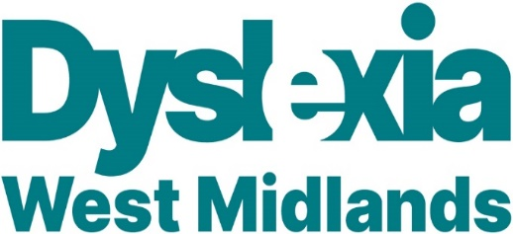

EHCP Overview for parents
The Education Health and Care Plan (E.H.C.P.) or E.H.C plan, is an exciting new system that puts you and your child at the very centre of the assessment and planning process. It is designed to make sure that your views are not only heard but also understood.
This is called 'person centred planning' because it increases your choice and control. This new process focuses on what is important for children and young people. That’s because you know what you and your child want to achieve now and in the future. Young people and families have helped to design the plan.
The E.H.C.P. is designed to create a real change in the way that education, health and social care professionals work with families and young people.

Who is an EHCP for?
The educational health and care plan is for children and young people who have special educational needs (SENs) and/or disabilities. Your child’s needs will be assessed by education, health and social care professionals to see if you should have a EHC plan. You can talk to your child’s school, college or nursery about eligibility for an assessment. For example, your school’s special educational needs coordinator (SENco) will be able to help.
At the start of the assessment, you and your child will get the chance to say what’s working, what’s not working and what you think needs to change. Your school and LA will help you with this because a great plan can theoretically mean great change for your child!
At the same time information will be gathered from the other people working with your child and a meeting will be arranged. At this meeting you can figure out outcomes and how you think they can best be met.
Remember that this is all about a partnership between you and the professionals involved to make the right decisions for you as a family.
Near the end of the assessment time, the multi-agency group will meet again to confirm the EHCP. They will decide what support you might be eligible for to meet your agreed outcomes. The plan will be clear about how much things cost and will have agreed timescales. This will make sure that your child's plan is updated and reviewed regularly. That's really important so that any changes in their condition or development can be supported. The plan will then go with your child or the young person as they change services, change schools and also when they leave school and go on to college, training or employment.
The EHCP is designed to create a real change in the way that education, health and social care professionals work with families and young people.

How might this affect the support my child gets?
The EHCP assessment and planning is designed to focus on agreeing individual outcomes and the support needed to achieve these. The plan will be tailored to each child's needs. This could include helping families to make best use of support available. These might include services available in the local offer, from the local community, or provided by statutory services.

