

***Early Intervention***

***PARENT MANUAL***

***2020 - 2021***



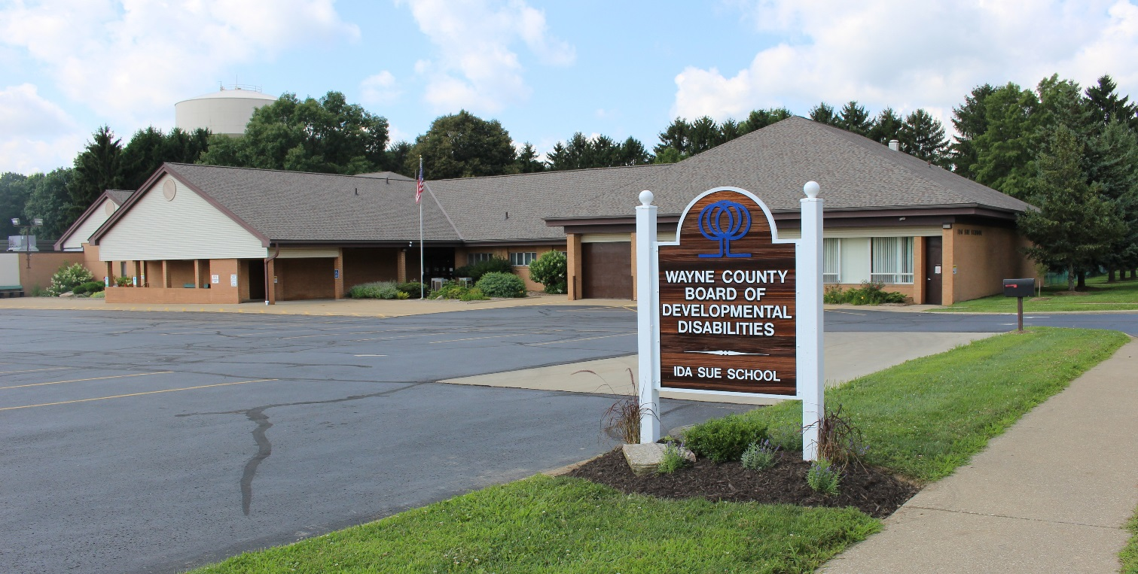

**Purpose of Early Intervention**

We want to welcome you and your family to our Early Intervention Program (EIP). This handbook is designed to help parents understand Early Intervention and the services offered to families by our facility. Early Intervention is a system of services and supports designed to meet the developmental needs of infants and toddlers birth through age two and to meet the needs of the family related to enhancing the child’s development. Early Intervention services are built on the child’s strengths as well as the family’s concerns and resources related to their child. The Early Intervention Program works in collaboration with other community agencies, as well as with the Wayne County Help Me Grow. An Individual Family Service Plan (IFSP) is developed to reflect goals and outcomes determined by the family. We recognize the unique and critical role that families play in the development of their child. You are **the most** important teacher.

The Wayne County Board of DD Early Intervention complies with the Ohio Department of DD Rule OAC 5123:2-1-04 and the Ohio Department of Health, Help Me Grow policies, Part C of IDEA.

**ELIGIBILITY:**

Eligibility shall be determined by at least two of the following procedures: standardized evaluation tools, observation, and descriptive data, in addition to informed clinical opinion.

Initial assessment will be done in all areas listed below. Eligibility shall be demonstrated by at least one developmental delay in an area.

Adaptive development,

Physical and sensory development, including vision

and hearing,

Cognitive development,

Communication,

Social or emotional development; or

an **established risk** related to a diagnosed physical or mental condition that has a high probability of resulting in developmental delay.

**Biological Risk:** history of prenatal, neonatal, and early developmental events suggestive of biological insult (s) to the developing nervous system.

**SERVICES OFFERED:**

Early Intervention Program Services follow a coaching model and may include: Physical, Occupational and Speech Therapy services which can address the following areas of development.

Language and Communication development;

Self-Help Skills and Adaptive development training;

Physical (fine and gross motor) development;

Social and Emotional development;

Cognitive development;

Sensory development;

Family support; and

Health services

Services offered by the Board are family-centered. Locations may include, but are not limited to, community based, home based, virtual or a combination of all depending on the needs, priorities, and interests of the family. The family and team determine timing and extent of participation.

The program is culturally committed to family empowerment and prevention of further development of disabilities. The Wayne County Early Intervention Program is a member of the Wayne County Family and Children First Council and Help Me Grow. Transition and linkage to agencies providing services to preschool children is an important part of our program. Each parent will receive information about preschool services when their child turns two and a half from their Service Coordinator.

**PROGRAM ACCESS:**

The Early Intervention program (EI) philosophy is that families should participate with their children in programming. Intervention is provided in the natural environment with the parent /caregiver engaged in the activities so that they learn how to provide strategies for the child on a daily basis to meet their developmental needs. This is the coaching model of services. The Primary Service Provider as identified by the IFSP team will work with the family in providing intervention during daily routines and activities. Support services may also be identified and scheduled as needed in order to address immediate concerns. Services are provided on a year-round basis as indicated in frequency and duration outlined in the IFSP.Parents spend time with their child during intervention so they may use the strategies throughout each day. Please call the program if you are unable to have a session. Please see the enclosed Enrollee Health Guide outlining when your child should not see a visitor. Therapists coming to your home follow the Ida Sue School calendar**. If the school is** **closed due to a calamity the therapist will not come to your home**. Closing information and school calendar is at the back of this book.

**EVALUATION:**

The preliminary evaluation data used to verify the eligibility of an infant or toddler for the EIP shall be current within ninety days of the eligibility determination. This evaluation shall be conducted by designated personnel of the county board or other appropriately licensed or certified specialists.

The evaluation will be completed within 45 days from your initial contact with Help Me Grow.

Upon initial contact by the parent or other referral source, the county board shall ensure that the family receives communication within two working days. This communication shall include at a minimum, informing the parent of the infant or toddler that an initial service coordinator and parent contacts are available, and explaining to families that they will develop an Individual Family Service Plan (IFSP). An evaluation to determine eligibility may also be arranged.

**Individual Family Service Plan:**

The Help Me Grow Service Coordinator will work with the family to complete the Individual Family Service Plan. An Individual Family Service Plan (IFSP) is a written plan that identifies the functional, meaningful and relevant outcomes for the family and child using the Six-Step Criteria. The plan must be updated every 180 days or more often if needed; families must sign each time the ISFP is revised or at each review. The IFSP can keep your child's doctors and Primary Service Provider (PSP) up to date on current goals and progress. The IFSP represents a process that is family-centered from beginning to end and the family receives a copy of the current IFSP. The focus of the IFSP and PSP is on enhancing development by using intervention based on best available research, support how children learn and communication style that supports adult learning. The evaluation that is done early in the IFSP process determines the child's eligibility and current status, not the child's need for placement into services. The assessment required for the IFSP is used to identify the child's strengths and needs as well as the family's resources and concerns related to their child. The PSP will provide updated developmental information to the EI Specialist for the IFSP reviews.

Within forty-five calendar days of the initial contact, the county board shall:

* assure the completion of the evaluation for eligibility and, if the child is eligible, complete the comprehensive assessment of the infant/toddler and family. All components of the comprehensive assessment shall be current within ninety days of the development of the initial IFSP,

* participate in the development of the IFSP,

* initiate services, as the family agrees.

When the parents give consent for services to begin, an interim IFSP may be developed and implemented. If there are attempts to complete the IFSP, but documented extenuating circumstances make it impossible to finalize the assessment process in forty-five days, the following may occur:

* If an interim IFSP is developed, the county board, with consent of the family, may commence Early Intervention services prior to the completion of the assessment process.

* An interim IFSP shall not be written solely to circumvent the forty-five day timeline.

* The IFSP shall be completed within forty-five days of the development of the interim IFSP. Provisions regarding timelines for finalization of the IFSP must be included in this interim IFSP

* The interim IFSP shall include the name of a service

coordinator.

Parents will be given Prior Written Notice upon any changes deemed necessary by the IFSP team two weeks prior to the change.

Weekly, the Early Intervention team and Help Me Grow team meet to discuss each plan’s progress of all the children who receive services. Parents are welcome to attend the portion of the team meeting to discuss their child’s plan and progress. When requested, parents will be informed of the schedule, and can attend the meeting in person, or by telephone or video conferencing.

**CHILD’S FILE:**

The following information shall be compiled and kept on file for each infant and toddler enrolled in the Early Intervention Program (EIP):

* Application for enrollment,

* Verification of eligibility determination,

* Written consents and releases

* A comprehensive assessment which shall include a health assessment dated within ninety days prior to enrollment and updated at least annually, or as specified in the IFSP or

required by the child’s physician or the Ohio Department

of Health,

* A health record which shall include ongoing pertinent health information, authorization for emergency medical treatment, updated immunization record, or the exemption or waiver where an immunization is medically contraindicated, a list of medications, and a list of any allergies and treatments,

* Accident or unusual incident forms,

* Attendance and home visitation records and related

correspondence, (electronic and/or paper)

* IFSP and related correspondence with the family, service coordinator, and other agency / service providers,

* Annual review of IFSP goals and objectives.

* Annual review of parental Rights and Due Process

* A Transition plan (only when county board provides service

coordination).

**IFSP DEVELOPMENT:**

The EI staff shall cooperate with the Help Me Grow Service Coordinator and family in developing the Individual Family Service Plan. **The IFSP outcomes will follow a six step criteria assuring that they are functional, meaningful and relevant to the family.** The staff may attend the meeting in person or provide written information regarding progress or by phone conversation.

An annual review shall be conducted prior to the IFSP meeting with the purpose to provide current information of strengths and needs. This meeting shall:

* Be scheduled at a place and time that is convenient for the

family

* Be preceded by written notices to the parents and other participants, sent early enough to ensure that they can attend, regarding meeting times, dates, and place, copies of which are kept in the child’s permanent record; and

* Be in the native language of the family or other mode of communication used by the family unless it is clearly not

feasible.

Each initial meeting and annual meeting to evaluate the IFSP shall include, at a minimum, the following participants:

* The parents of the child, and other family members as requested by the parents;

* An advocate or person outside of the family, at the parent's

request

* The service coordinator, or who has been working with the family since the initial contact;

* Persons directly involved in conducting the evaluations and assessments;

* Representatives of other agencies or persons who will be

providing services to the child or family.

If any of the persons listed in the above paragraph of this rule are unable to attend the initial annual review, arrangements shall be made for that person's involvement through other means, which may include:

* Participating in a telephone conference call,

* Having a knowledgeable authorized representative attend the meeting or,

* Making pertinent information available in writing.

**IFSP CONTENTS:**

Contents of the IFSP shall include:

1. The child's present level of development based on an assessment that includes professionally acceptable objective criteria.

2. With the concurrence of the family, a statement of the family's strengths and needs related to enhancing the development of the child.

3. A statement of the major outcomes expected to be achieved for the child and family.

4. The criteria, procedures, and timelines used to determine progress toward achieving the outcomes and whether modifications or revisions of the outcomes or service are necessary.

5. The specific Early Intervention services necessary to meet the unique needs of the child and family to achieve the outcomes including, but not limited to, transportation needs and medical issues.

6. The frequency, intensity, location, method, and dates of service delivery.

The frequency and location of participation in early intervention services for each child and family shall be individually determined and shall be based on the child’s age and developmental needs, emotional needs, physical stamina, and the wishes of the family.

7. The payment arrangements, if any.

8. Other services that the child needs as determined by the IFSP interdisciplinary team.

9. The name of the Service Coordinator from the profession most immediately relevant to the child's or family's needs, or as chosen by the family. The role of the Service Coordinator will be to work with the family to schedule assessments, help identify family resources concerns and priorities, make referrals, coordinate services, advocate for the child and family, and monitor the services identified in the IFSP.

10. The steps to be taken to support the family and child during the transition of the child upon reaching age three, to other appropriate services or to preschool services. Transition programming shall begin at least six months prior to the child turning three years old and shall include but not be limited to:

Discussions with parents regarding future placements and other matters related to the child's transition;

Procedures to prepare the child for changes in service delivery including steps to help the child adjust to and function in a new setting; and

With parental consent, the transmission of information about the child to the receiving agency, to ensure continuity of services, including evaluation and assessment information, copies of IFSP's that have been developed and implemented, and other relevant data.

A transition planning conference will be held at least 90 days before the child turns three, the transition plan will be written and incorporated into the IFSP. This meeting will include the parents, service coordinator, LEA (with parent permission), and other service providers or individuals requested by the family.

**DUE PROCESS:**

Due process is an orderly procedure, which allows a person to be heard, and protects their individual freedoms. The Wayne County Early Intervention Program ensures that an individual or the parent of a minor, or guardian has the opportunity to resolve a disagreement of the Superintendent’s decision regarding identification, enrollment, transfer from within, evaluation, eligibility, and denial of an individual’s initial or continued enrollment.

If an individual, parent, or legal guardian is not in agreement with decisions pertaining to the above-mentioned actions, they have the right to request an appeal to the Superintendent’s decision. For children enrolled in the Early Intervention Program, the procedures for Due Process as described by Rule 3301-51-02 of the administrative code shall be followed**. Families who file a grievance with the County Board will be assured that the grievance will be settled in 30 days to comply with the Help Me Grow Procedural Safeguards. Families can utilize the County Board Safeguards and/or Help Me grow Procedural Safeguards.**

**Due Process procedures follow this sequence**:

1. A request is made to the Superintendent to appeal a decision.
2. An administrative review of the decision is held with the Superintendent.

3. If the appellant is not satisfied, they may appeal to the Wayne County Board of Developmental Disabilities.

4. If the appellant continued to disagree, they may appeal the Board’s decision to the Ohio Department of Developmental Disabilities.

If an individual, parent, guardian wishes to appeal a decision of the Superintendent and the Board, they may request a copy of the procedural process from the Superintendent.

PARENTS’ RIGHTS OF CHILDREN WITH A DEVELOPMENTAL DELAY OR DISABILITY:

Parents of a child with a developmental delay or disability have special rights stated in the federal law called Individuals with Disabilities Education Act (IDEA). If your child has a delay or disability, your rights include:

* *Developmental evaluation to determine eligibility;*
* *The right to have an advocate, friend or interpreter present at any or all contacts with service providers;*
* *The right to receive written notice before there is a change in services. The written notice should include what and why the change is being proposed or denied.*
* *Help with transition planning before your child turns the age of three.*

# PARENTS’ RIGHTS IN HELP ME GROW:

When you and your child become involved in the Help Me Grow program you have certain rights that are granted to you. Your rights include:

*\* The right to accept or decline some or all services from the Help Me Grow*

*\* The right to be informed of your rights.*

*\* The right to provide informed written consent before any information about your child or your family is shared between service providers and before evaluation and service begin.*

*\* All information about you and your records are kept confidential.*

*\* The right to review and make changes to records about your child and family at any time.*

*\* The right to request, be present at and take part in meetings about your child*  *and family.*

*\* The right to make a formal complaint about services for your child.*

* The right to know to whom to make a written complaint and then get an

answer to that complaint within 30 days.

*\* Assessment of the strengths and needs of your family.*

*\* The right to Service Coordination*

* Help with writing and updating the Individualized Family Service Plan

(IFSP)

If you have any questions or concerns about services, first ask your Service Coordinator. If your question or concern remains, then contact Amber Carther, Project Director, Wayne County Help Me Grow. If your question is in regards to Wayne County Board DD services, contact Aaron Bernstein, Director of Educational Services or Ramona Stoner, Early Intervention Supervisor.

*Jan Higgins, Contract Manager Aaron Bernstein, Director of Educational Services*

*Wayne Co. Help Me Grow Wayne County Board of DD*

*144 N. Market St 266 Oldman Rd.*

*Wooster, OH 44691. Wooster, OH 44691*

*330-988-1302 330-345-7251 ext 235*

**David Ashley**

**Wayne County Board of DD Superintendent**

**266 Oldman Road**

**Wooster OH 44691**

**330-345-6016**