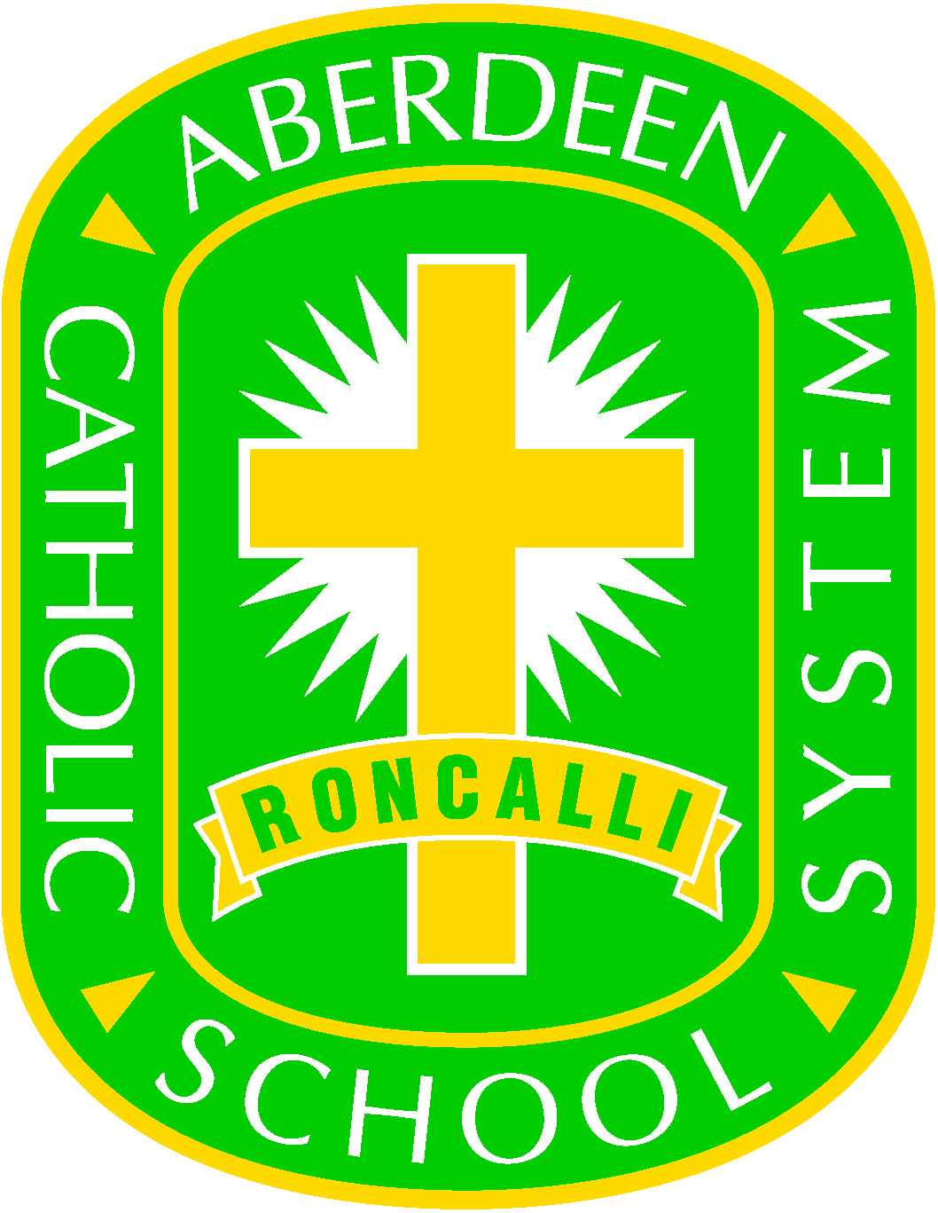
ABERDEEN CATHOLIC SCHOOL SYSTEM
Financial Aid Application Due to Special Circumstances
2022-2023

Financial Aid Due to Special Circumstances is designed for families that have experienced an emergency situation,
such as loss of job or illness, which has affected their finances.

Parent/Guardian

Address

Day Phone Home Phone

Student Name(s) |  | Grade |  | School 2021-2022 |  | Tuition Amount
_________________________ |  | _______ |  | ____________________ |  | ___________________
_________________________ |  | _______ |  | ____________________ |  | ___________________
_________________________ |  | _______ |  | ____________________ |  | ___________________
_________________________ |  | _______ |  | ____________________ |  | ___________________
_________________________ |  | _______ |  | ____________________ |  | ___________________
_________________________ |  | _______ |  | ____________________ |  | ___________________

Total Tuition: $__________________

Have you received financial aid in the past? No_____ Yes______

If yes, Dollar Amount $_________________ Dates ______________________

Anticipated length of time assistance will be needed?

Please describe any critical circumstances, which have recently occurred, that have affect your financial situation and ability to pay tuition, and attach relevant documentation if available. (If more is needed, please attach additional sheets)

Please return to the Aberdeen Catholic School System Business Office
1400 North Dakota Street, Aberdeen, SD 57401

