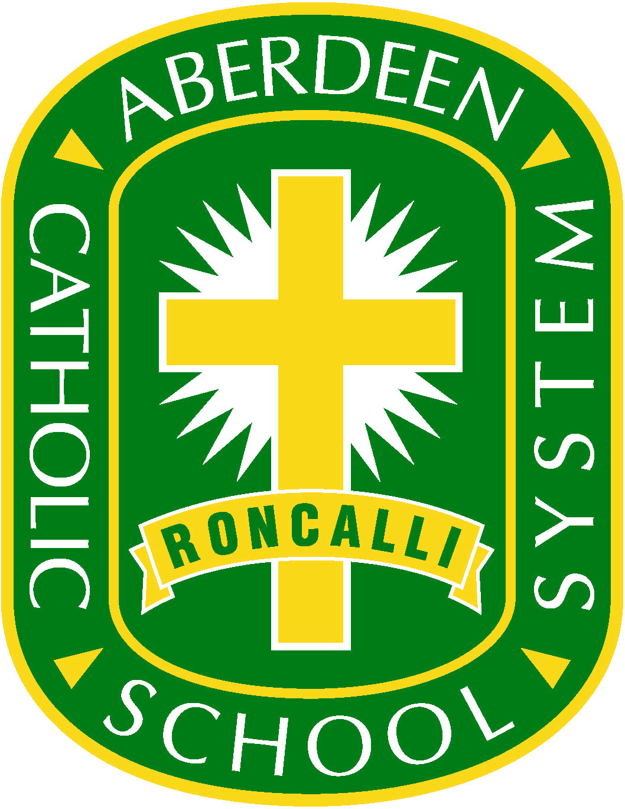 | Aberdeen Catholic School System
 | Educational Assistant Job Description

Educational Assistant

EMPLOYMENT TERM: School year only - 9 months

REPORTS TO: Building Principal

REQUIREMENTS:

A. Education Level: Degree or 48 credit hours at the post high school level required or must demonstrate through a formal academic assessment knowledge of and the ability to assist in instructing reading, writing and mathematics.

B. Experience Desired: Prior service work or training with child care or youth activities. Some background in preparation of instructional materials.

C. Other Requirements: Commitment to the mission of the Aberdeen Catholic School System.Demonstrated interest and commitment toward the welfare of young people. Positive human relations skills toward both adults and children. Ability to supervise students in a variety of situations. Skills in word processing, operating office machines and audio-visual equipment. Skills in grammar, creative writing, and editing necessary.

D. Physical Requirements: This position requires eye-hand, mind-eye coordination, physical
dexterity, the ability to frequently walk, stand, bend, stoop, and
talk.

ESSENTIAL FUNCTIONS AND DUTIES:
• Provide direct instruction to groups as students.
• Work with small groups of students to reinforce information given by teacher.
• Assist children in need of individual attention.
• Assist with non-instructional activities suggested by teacher.
• Support classroom activities determined by the teacher.
• Perform routine supervisory duties such as lunchroom, playground, halls, and classroom.
• Perform other duties as assigned by the Building Principal.

