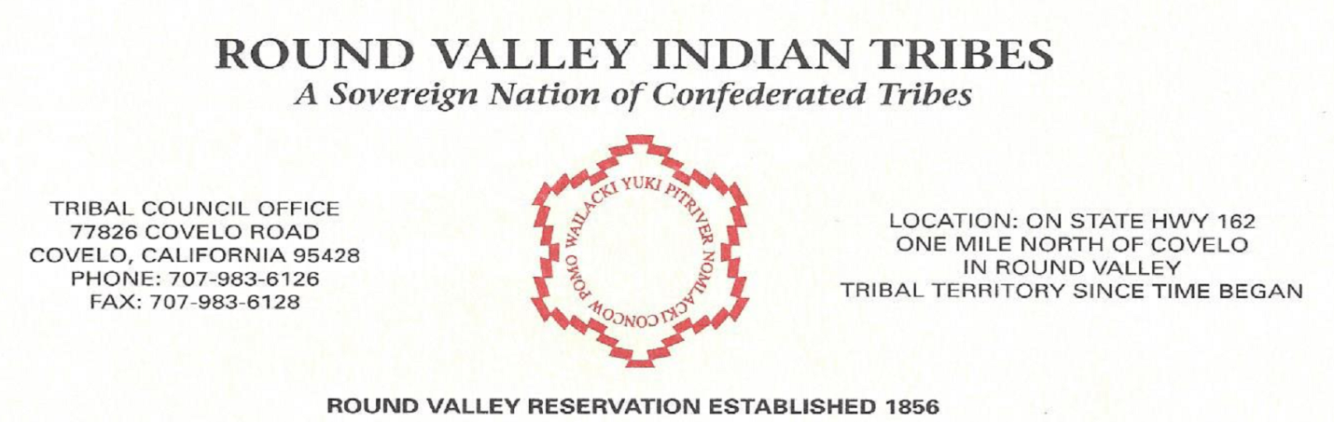
NOTICE: DEADLINE
Welfare Relief Fund Checks
What to do if you did not receive a check:
If you have not received a check from RVIT please follow the steps below:

1.) Please e‐mail the Tribalreceptionist@rvit.org the following information:
Your Name: Tribal enrollment #
Your address: (street, city, state & zip code)
Contact phone number, where we can reach you between the hours of 8am and 5pm.

2.) If you do not have access to e‐mail, please phone the RVIT-Enrollment Clerk @ (707)983‐6126 ext. 104
Please provide the following information:
Your Name: Tribal enrollment #
Your address (street, city, state & zip code)
Contact phone number, where we can reach you between the hours of 8am and 5pm.

PLEASE NOTE THAT APRIL 14th, 2021 AT 5:00PM WILL BE THE FINAL DATE TO INQUIRE OR SUBMIT UPDATED INFORMATION FOR REISSUING OF A CARES STIMULUS CHECKS TO RVIT MEMBERS. AFTER THIS DATE, NO ADDITIONAL STIMULUS CHECKS WILL BE PROCESSED. ALL CHECKS ARE VALID FOR 30 DAYS FROM ISSUING DATE.
THE REISSUED CHECKS WILL BE RUN ON APRIL 15th, 2021

