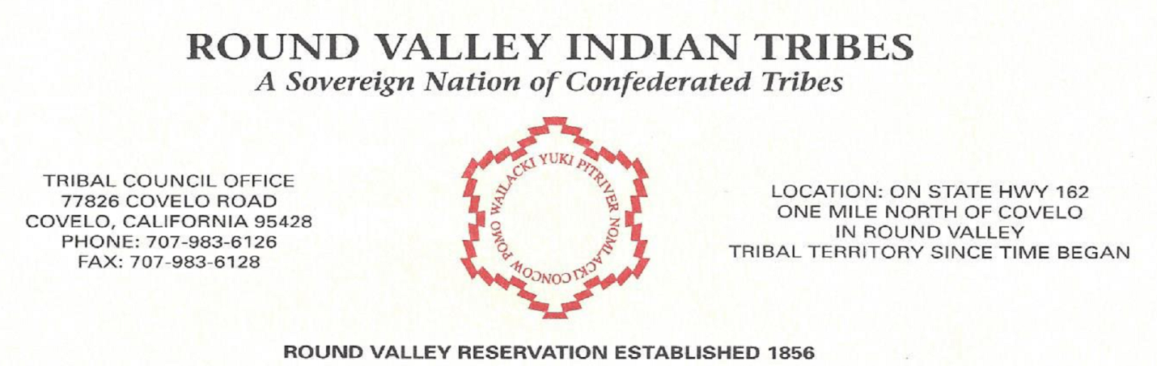
JOB ANOUNCMENT
POSITION: Maintenance Worker
Salary: DOE
Reports to: Tribal Business Administrator
Classification: Full time position.

OPEN UNTIL FILLED
Description: The Maintenance Worker will be responsible to assist with a wide variety of facilities and property maintenance/custodial duties for the Business Park, Mercantile Building Big Oak Ranch, and other properties. The maintenance worker will assist in performing the maintenance, repair, and replacement of the buildings and related, equipment, as well as mechanical, electrical, water supply and plumbing systems. The incumbent also provides technical assistance regarding the quality and performance of interior and exterior machinery, buildings, and other facilities.
KNOWLEDGE, SKILLS AND ABILITIES: Knowledge of HVAC plumbing, electrical and water systems; Competency using hand tools, power tools, etc.; Ability to read technical repair manuals, blueprints, parts catalogs, etc.; Strong communication and negotiation skills; Ability to complete all the tasks efficiently/effectively; Ability to adapt to change and unforeseen circumstances; Basic computer skills; Performs carpentry, flooring, painting, exterior building work, plumbing, electrical work.
ADDITIONAL REQUIRMENTS:
- High school diploma or GED required.
- Must pass drug screening test and background check.
- Requires a valid California Driver’s License, a dependable automobile and approved insurance.

INDIAN PREFERENCE: Preference in filling vacancies with the Round Valley Indian Tribes will be given to qualified Indian candidates in accordance with the Indian Preference Act (Title 25 USC 472,473). In other than the above the Round Valley Indian Tribes is an equal opportunity employer.

