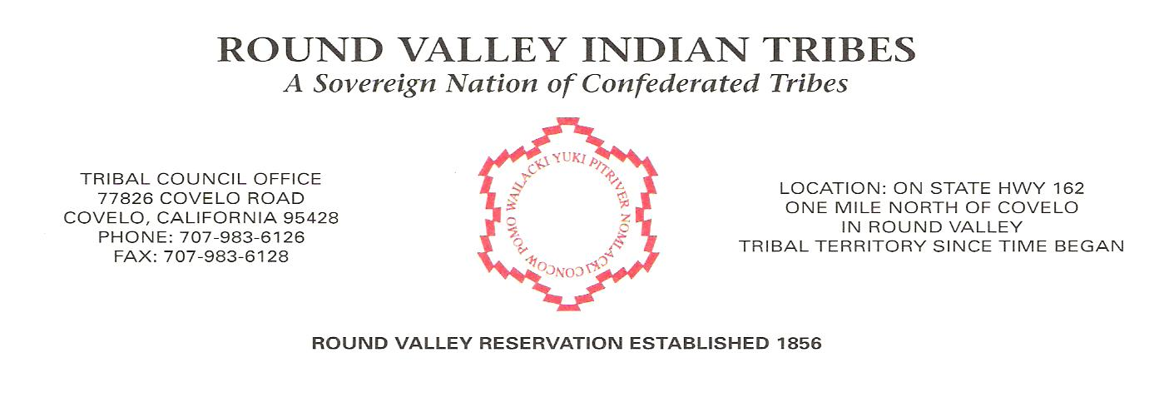
Date: February 26th, 2021
To: Tribal Programs & Entities
From: Tribal Council
Subject: Schedule Change – Funeral Notice

PLEASED BE ADVISED
IN RESPECT FOR THE FAMILY AND FRIENDS OF:
Zechariah DeCent
Wake:
Friday, February 26th, 2021 – 5pm
Methodist Church, Covelo, Ca.

Funeral & Graveside Services:
Saturday, February 27th, 2021 – 12noon
Methodist Church, Covelo, Ca
Graveside following at Head Quarters Cemetery

Administration and Programs Closure
Friday, January 26th @ 1pm.

All essential businesses will remain open.

