Time to Move On from Cheeverstown Campus,
Information Share
April 2023

Dear all

This information share tells you about Cheeverstown’s progress in moving towards full community integration in line with national policy that people with disabilities should be supported to move from congregated settings to their own homes in the community.
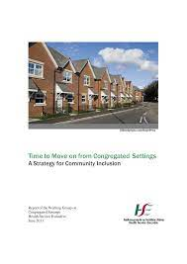
Time to Move on from Congregated Settings: The national policy is detailed in the report “Time to Move on from Congregated Settings – A strategy for Community Inclusion”. The report was published in 2011 and adopted as national policy in 2012 The full report is available on Cheeverstown’s Website:
Cheeverstown - Time to Move on from Congregated Settings

The policy recommends a person-centred approach where every person is enabled and supported to lead the life they want. This is line with international evidence, with new models of residential services now being developed so that people with disabilities will be supported to live “ordinary lives in ordinary places”. Under the policy, people living in congregated settings now have the opportunity and the right to move to a home of their choice in the community.

With the support of the HSE, people supported on Cheeverstown campus (a congregate setting) will have the opportunity to transition to community based homes over the coming years.

Progress to date: In 2021 Cheeverstown supported 4 people to move into move into homes in the community. In 2022 Cheeverstown purchased a further 3 homes to support people to move from Cheeverstown campus to new homes in the community. In 2023 10 people will moved from Cheeverstown campus to homes in the community.

How are moves to community planned?
Supporting a person to move from a congregated setting to a new home in the community is not something that happens overnight. Time is taken with each person to support them to discover what they want, at a pace that suits them and allows them to be fully involved. Taking time in this way is important, as it can be a challenge for the person with a disability to make decisions, particularly when their own experiences, which will influence their choices, may have been limited.

When a community home is on the horizon for an individual, the manager and multidisciplinary team begin an assessment that guides the journey. Families are very important in this journey and are of course included at a very early stage.

Cheeverstown stays with the person as their support service. Cheeverstown will ensure people moving to their next home will receive the support they require to be safe and live a life of their choice. Staff who have supported people on campus will have the opportunity to now support people in their community homes. This is a journey for us all, and there is a lot of planning and communication with every transition. It will be a number of years before Cheeverstown has community living options for all our residents.

You can see videos about people who have moved on www.hse.ie/timetomoveon and www.genio.ie/videos. Regular updates are also provided on Cheeverstown’s website www.cheeverstown.ie. Attached to this letter is ‘Philip’s story’ which he wrote for Cheeverstown’s 2021 Annual Report.

We look forward to your continued support for this important strategy. Please don’t hesitate to contact your local manager if you have questions or wish to discuss further.

Yours sincerely,

TJ Duggan
Chief Executive Officer

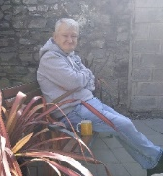 | Philip’s story - supported living  Hi, my name is Philip and I moved into my new home.
 | The house is very big and I tell everyone it is a nice house. I have a lot of room in my new home. I have a back garden and a front garden.
 | My new home is close to a lot of things, the shop, the church and the bus stop. My favorite thing is to do is to get the bus into the city centre. I love going on the DART and I always decide which direction I want to go.
 | I love walking around the village and the park. It is nice and quiet. On Sunday morning I walk to church and then I go to McDonald’s to have a coffee. There is a café close to my home and I like to go there also.
 | During the week I like to go to the parish hall and meet people for a chat and have a cup of tea. There is music on Tuesday night in the local pub and I love going. Music is one of my favourite things.
 | I have lots of neighbours and sometimes I meet up with one of my neighbours for an ice cream and a chat.
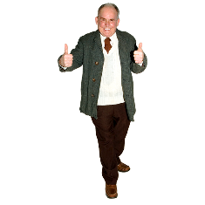 | I like living in this house.

