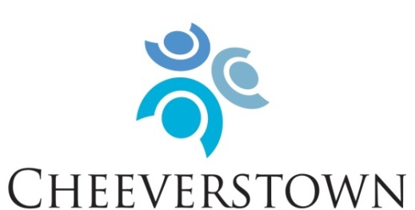

To enable people with intellectual disabilities to have full and meaningful lives through person centered services in partnership with their circle of support.

Our Values:
- Rights
Promote, protect and ensure the full and equal enjoyment of all human rights and fundamental freedoms by all persons with disabilities, and to promote respect for their inherent dignity.
- Person Centred
Placing the service user at the centre of our supports, services and decision making.
- Inclusion
To support full inclusion in all educational, employment, consumer, recreational and domestic activities that are typical in everyday society.
- Partnership
Partner with people who use our services, their families, funders, government agencies, housing agencies, local community members and local authorities.

Cheeverstown are now inviting applicants who share in our mission and values to apply for the following posts:

Community Inclusion Coach
New Directions (Day Supports)

1 x Permanent, Full Time Contract
1 x Specific Purpose, Full Time Contract

Role Description:

The Community Inclusion Coach will provide supports within the framework of New Directions, an outcomes-based individualised approach to services for people with intellectual disabilities. The purpose of the role is to support people to access a wide-range of community-based services and opportunities to meet their needs, interests and desires.

The role of the Community Inclusion Coach is:
- To work on a one-to-one and group basis in the community with people we support, providing supports in areas including employment, travel, education and training, health and wellbeing, social roles, recreational activities, volunteering and money management.
- To maximise opportunities for people to be included and active in their own communities
- To empower people to live full and meaningful lives

Locations of work include Nutgrove, Templeogue and Tallaght. However, this role involves considerable travel within the wider community, and the post-holder must possess a full clean driver’s licence and have access to a car to fulfil the role.

Essential:
- A relevant professional qualification e.g. Social Care, Supported Employment, Training and/or Education.
- Experience of working with people with intellectual disabilities.
- Values that correspond with Cheeverstown’s values.
- Excellent verbal and written communication skills, including good listening skills.
- Demonstrated ability in relationship building, networking and promoting inclusion.
- Flexibility and ability to respond to changing needs and situations.
- Proven ability to work autonomously and on own initiative.
- Ability to collaborate and work as a member of a team.
- Be proactive, with high degree of motivation and drive.
- Strong organisational and time management skills.
- Good IT and administrative skills.
- Possess a full clean drivers licence and access to car.

Desirable:
- Knowledge and understanding of New Directions standards.
- Experience in supported employment.

The role of Community Inclusion Coach is significant in a person’s life. A key element of the work is building confidence in people, helping to change their expectations of themselves and promoting peoples’ own autonomy. The work is rewarding, varied and interesting. Salary will be paid at Senior Supervisor/Instructor (Specialist Agencies) scale, HSE Consolidated Salary Scales. Benefits include access to appropriate Pension Scheme; Health Services Staff Credit Union and Health Insurance Group Discount Scheme.

A detailed job description is available via email from hr@cheeverstown.ie

For informal enquiries:
Please contact April Balmer, Team Manager, New Directions at abalmer@cheeverstown.ie

To apply:
Please submit cover letter and detailed CV to Human Resources, Cheeverstown, Templeogue, Dublin 6W, or email hr@cheeverstown.ie.

The closing date for receipt of applications is Friday 10th March 2023

CHEEVERSTOWN HOUSE LTD IS AN EQUAL OPPORTUNITIES EMPLOYER

