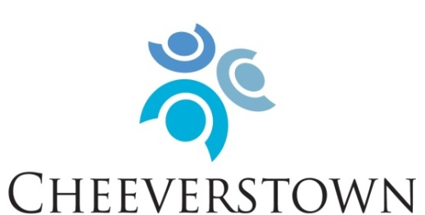

To enable people with intellectual disabilities to have full and meaningful lives through person centered services in partnership with their circle of support.

Our Mission: To enable people with intellectual disabilities to have full and meaningful lives through person centred services in partnership with their circle of support.

Our Values:
- Rights
Promote, protect and ensure the full and equal enjoyment of all human rights and fundamental freedoms by all persons with disabilities, and to promote respect for their inherent dignity.
- Person Centred
Placing the service user at the centre of our supports, services and decision-making.
- Inclusion
To support full inclusion in all educational, employment, consumer, recreational and domestic activities that are typical in everyday society.
- Partnership
Partner with people who use our services, their families, funders, government agencies, housing agencies, local community members and local authorities.

Cheeverstown are now inviting applicants who share in our mission and values to apply for the following posts:

Psychology Project Workers
New Directions (Day Supports)

Permanent, full-time (39 hours per week)

Role Description:
Working as a member of the direct support team, the Psychology Project Worker will provide supports to individuals with intellectual disabilities, within the framework of New Directions, an outcomes-based individualised approach to day services and supports.

In collaboration with colleagues and the clinical team, the Psychology Project Worker will support people attending the service to:
- identify goals in line with the twelve New Directions supports
- appropriately assess the support needs required to achieve these
- develop individualised support plans, specifying pattern and types of support needed
- take the lead in implementing, monitoring progress and evaluating plans, supported by line manager and Psychology Department

The Psychology Project Worker will support people in a community based, day service location, within the Dublin South West catchment area including Crumlin, Templeogue, Tallaght and Rathfarnham. Flexibility to move between locations is required, as the need arises.

Person Specification:

Essential:
- Honours Degree in Psychology or equivalent (e.g. H Dip conversion)
- Experience working with people with intellectual and neurodevelopmental disabilities
- Values that correspond with Cheeverstown’s values.
- Excellent verbal and written communication skills, including good listening skills.
- Strong commitment to increasing opportunities for people to become valued members of their local community and to live their best life.
- Belief in a person-centred approach and the empowerment of people supported
- Ability to collaborate and work as a member of a team.
- Possess a proven ability to work on own initiative
- Flexibility and ability to respond to changing needs, situations and locations.

Desirable:
- Knowledge and understanding of New Directions standards.
- Possess a full clean drivers licence and access to car.
- Be proactive, with high degree of motivation and drive.
- Strong organisational and time management skills.
- Good IT and administrative skills.

Salary will be paid at Social Care Worker salary scale on the HSE Consolidated Salary Scales, depending on qualifications and experience. Benefits include access to appropriate Pension Scheme; Health Services Staff Credit Union and Health Insurance Group Discount Scheme.

A detailed job description is available via email from hr@cheeverstown.ie

For informal enquiries, please contact:
Colette McLoughlin, Area Manager, New Directions on cmcloughlin@cheeverstown.ie

To apply, please submit cover letter and detailed CV to:
Human Resources, Cheeverstown, Templeogue, Dublin 6W, or email hr@cheeverstown.ie

The closing date for receipt of applications is: Friday 3rd March 2023

CHEEVERSTOWN HOUSE LTD IS AN EQUAL OPPORTUNITIES EMPLOYER

