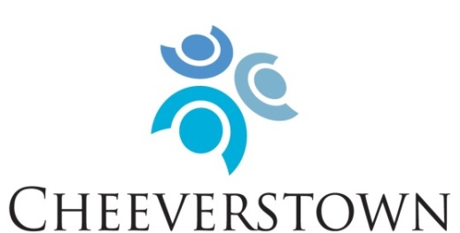

“Enabling people with an intellectual disability to have full and meaningful lives through quality person centred services in partnership with families”

Our Mission: To enable people with intellectual disabilities to have full and meaningful lives through person centered services in partnership with their circle of support.

Our Values:
- Rights
Promote, protect and ensure the full and equal enjoyment of all human rights and fundamental freedoms by all persons with disabilities, and to promote respect for their inherent dignity.
- Person Centred
Placing the service user at the centre of our supports, services and decision making.
- Inclusion
To support full inclusion in all educational, employment, consumer, recreational and domestic activities that are typical in everyday society.
- Partnership
Partner with people who use our services, their families, funders, government agencies, housing agencies, local community members and local authorities.

Cheeverstown are now inviting applicants who share in our mission and values to apply for the following post:

Support Worker
New Directions (Day Supports)

A number of Permanent and Specified Purpose Contracts are available
at full-time and part-time hours (39/19.5 hours per week)

Role Description:
The Support Worker will provide supports within the framework of New Directions, an outcomes-based individualised approach to services for people with intellectual disabilities and autism. The Support Worker will:

- Plan and deliver supports that are person-centred, which will enable people to have full and meaningful lives.

- Respond to individual needs, interests and desires in planning and delivering supports.

- Support people to access community-based services and opportunities, enabling people to develop relationships and roles to ensure people are included and valued in their own communities.

- Work to maximise opportunities for people to meet their potential.

The Support Worker will support people in one of our community based, day service locations, within the Dublin South West catchment area including Tallaght and Templeogue.

Person specification:
Essential:
- Values that correspond with Cheeverstown’s values.
- A person-centred approach to the provision of supports, including an understanding of the individual needs and abilities of each person.
- A QQI qualification in a relevant area e.g. health, community, care. At least level 5 (Major Award/8 modules)
- Excellent verbal and written communication skills, including good listening skills.
- Flexibility and ability to respond to changing needs and situations.
- Openness to providing supports across a variety of activities.
- Commitment and dedication to enhancing the lives of people with intellectual disability and autism.
- Ability to work as a member of a team.
- Good IT and administrative skills.

Desirable:
- Experience supporting people with intellectual disabilities.
- Experience supporting people with autism.
- Knowledge and understanding of the New Directions standards.
- Possess a full clean drivers licence and willingness to drive.

The role of Support Worker is significant in a person’s life. The work is rewarding, varied and interesting. Salary will be paid at Care Assistant grade on the HSE Consolidated Salary Scales, depending on qualifications and experience. Benefits include access to appropriate Pension Scheme; Health Services Staff Credit Union and Health Insurance Group Discount Scheme.

A detailed job description is available via email from hr@cheeverstown.ie

For informal enquiries, please contact:
Colette McLoughlin, Area Manager, New Directions on cmcloughlin@cheeverstown.ie

To apply, please submit cover letter and detailed CV to:
Human Resources, Cheeverstown, Templeogue, Dublin 6W, or email hr@cheeverstown.ie

The closing date for receipt of applications is: Wednesday 9th November 2022

CHEEVERSTOWN HOUSE LTD IS AN EQUAL OPPORTUNITIES EMPLOYER

