Advocacy Meeting
Date: 03rd of May, 2022
Time: 4-5pm
Attendees: Deirdre Troy, Joe Feehily, Eddie Kelly, Sharon Murphy, John O’ Reilly, Patricia Halihan, Elaine Doran, Hazel Larkin, Mary Dowds, Martina Curran, Grace Andrews

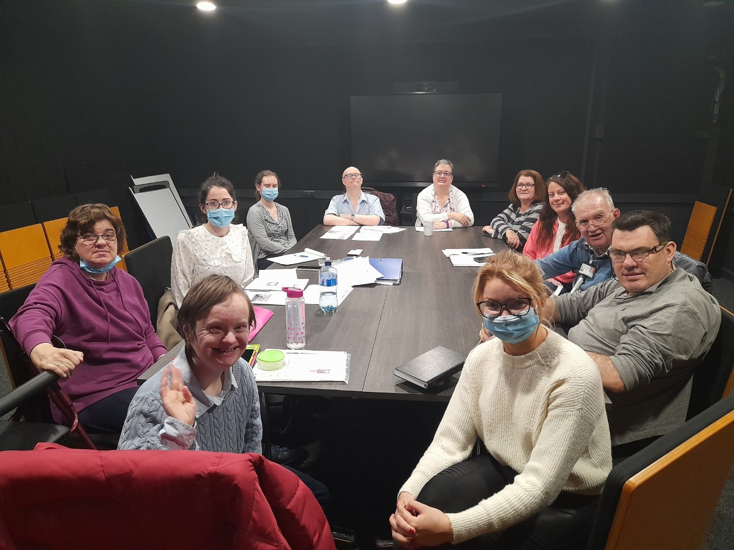

- Main points
Pictures and biographies for the website
The pictures and biographies have been sent to Susan Wilson to go onto the Cheeverstown website. Joe put together a video for the Facebook page to tell people about advocacy. Eddie thought this was “lovely”.

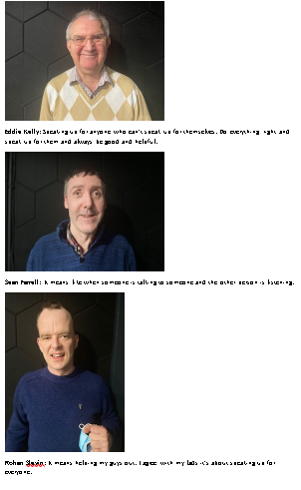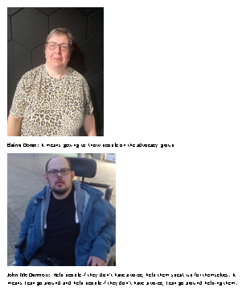
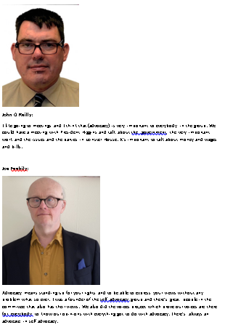

Footpaths
This is an ongoing issue:

Stuart and Sean were going to bring photos and a map of where there are breakdowns in the path but they were not at advocacy today. Deirdre thought it was a good idea to bring the photos and a map “It’s bad, one of the girls lives down there and it’s pretty bad”.

Mary OT is happy to help support advocacy members to contact the council.

John Mc Dermott will give an update of his meeting with Mike Redmond at the next advocacy meeting.

“The path outside our place so many cars are outside our place. The neighbours are giving out” Deirdre Troy talking about motorists parking near her home.

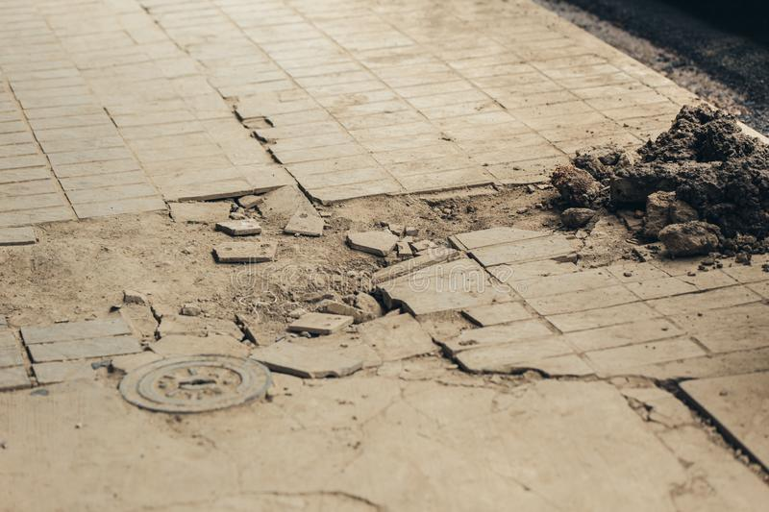

300k- have your say (whole community)

Eilís explained what the 300k- ‘have your say’ is about. Eilís read out past winning ideas such as sensory gardens and parks.

Everyone was asked about what ideas they had “paint my house” Joanne, “go on a holiday together” Patricia, “cars for transport” Martina, ‘drinks… champagne!’ (anonymous!) but then we had to think again about the community and how the money would impact on our whole community. This might be an issue we are having or that other people we know are having.
Deirdre agreed benches would be good to have along the paths so that she could take a break when on her rollator.

“I’ve been asking for this for so long… There’s not that many benches.. today when we were out with staff not many benches where staff could sit. Paul, our driver, brought us out and he said it was ridiculous brining us out and there no benches” Deirdre Troy

However, Eddie felt “there are a lot of benches in parks”.

“Maybe from Tallaght to Airton there could be benches” Sharon suggested.

Joe suggested we quote article 19 to highlight people with disabilities should be part of their community.

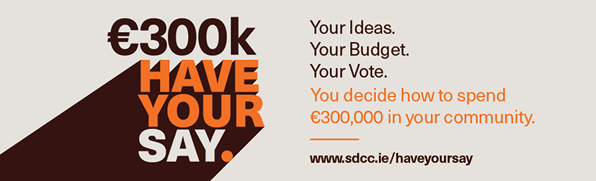

Chairperson
Rohan, John and Joe had said they wanted to be chairperson. They all put forward their reasons for wanting to be chairperson. Today a chairperson was elected, unfortunately Rohan was not at the meeting today. Joe was voted to be chairperson.
Patricia introduced what the Ceann Comhairle does in the Dail meetings:
‘Saw a chairperson on the news, different people trying to talk in the Dail and all talk about the issues and they would tell the Ceann Comhairle what the next person was going to say’
Joe
‘I founded the lovely committee with help, I will be able to help people, inviting to the meetings. I will become chairperson our voices will be heard, issues that we want to be heard will not only be in Cheeverstown but also in Dail Eireann’
John
‘I like the job and I would like to have a think about it. Only one person can talk at a time, can’t have everyone talking at the same time. Have to be able to speak and stand up for yourself and not to be scared to say anything.’
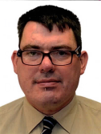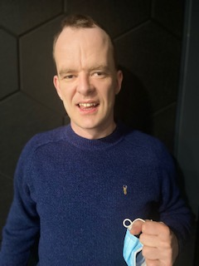

Minutes online
We need to get the main points from our minutes filmed at the next meeting for the facebook page.
We talked about who gets to see the minutes from our meeting. The mailing list is too big. Only the people who have replied saying they want the emails will stay on the mailing list. Everyone named their key worker that they would do their advocacy actions with. The key workers will be added to the mailing list. Paul Caggis for Eddie, Leona Feeman for Elaine, Charlotte Grey for Joe, Elizabeth for Deirdre, Jenny Feehily for Patricia and April Balmer for John.

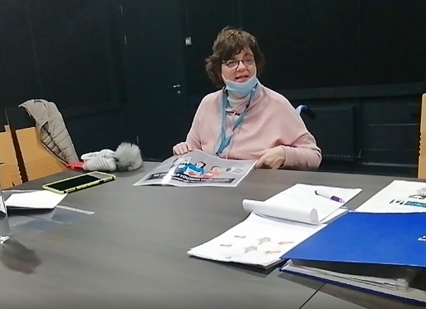

UNCRPD
We want to know what are the government doing to make sure Ireland are following the UNCRPD:
We invited Anne Rabbitte for a meeting. Anne Rabbitte’s secetary saw our invitation and will get back to us. Martina to follow up. TJ said he will be able to help if we do not get a response.
Since the meeting Anne Rabbitte has said she can come! She will be with us on the 28th of June at 4pm. We need to do an agenda and an attendance list for that meeting.
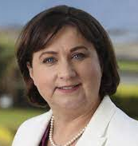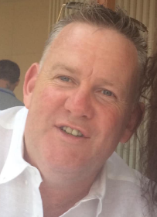

Video for the UNCRPD
We are contacting different videographers to price how much it would be to do our video.
The treasurer Eddie Kelly will talk about the different prices at the next meeting.

ACTIONS

- Decide what we are going to talk about and who will come for Minister Rabbittes meeting

- Film the minutes from each meeting

- Eddie to talk about the videographer invoices and their costs to do the rights video

- Everyone to have an understanding of their article and an example.

- Stuart and Sean to bring the photographs of the path breakdowns to the meeting
- Everyone to bring their tablet to the next meeting
- Eilís to bring new news items from twitter e.g. ILMI, DFI, WCA etc.

