Advocacy Meeting
Date: 22nd of February, 2022
Time: 4-5pm
Attendees: Rohan Slevin, Rose Ngegwe, Deirdre Troy, Joe Feehily, Eddie Kelly, Chris Haughton, Jenny, Patricia, Sean and Eilís
- Main points

Footpaths
Deirdre, Joe and Rohan were to talk to South Dublin County Council. However, they need help with this email.

John Mc Dermott also asked for help with paths. The Brentwood coffee shop is difficult to get to because the paths are too high.

“Same issue with this one” Deirdre Troy

ACTION: Group to send an email at the next meeting to roadmaintenance@dublincity.ie.

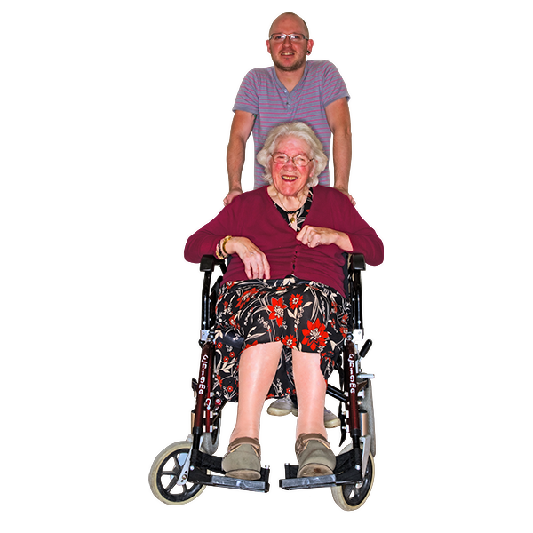
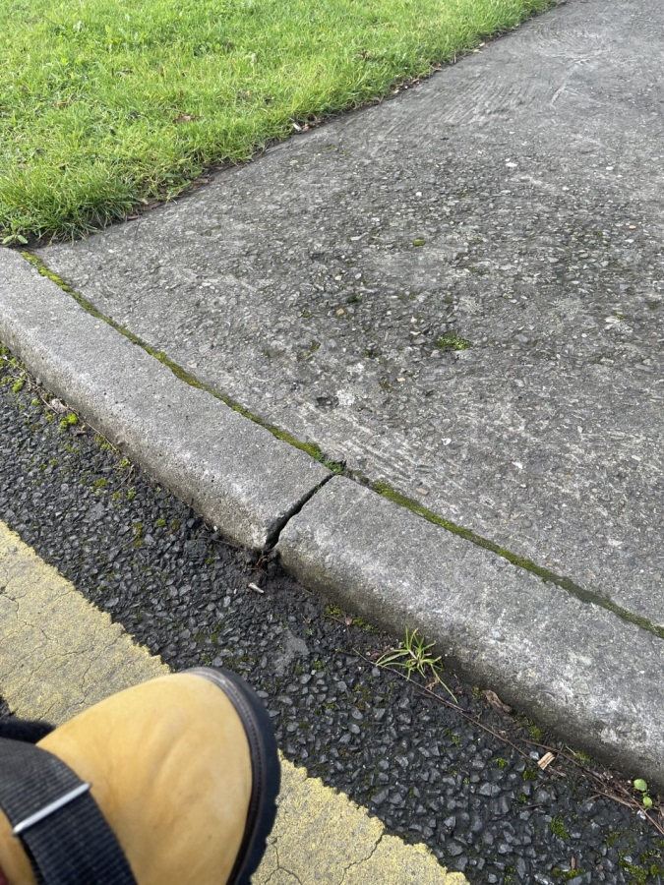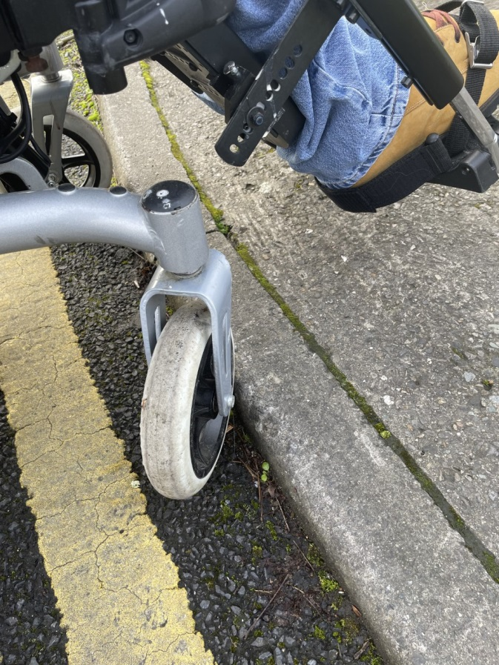
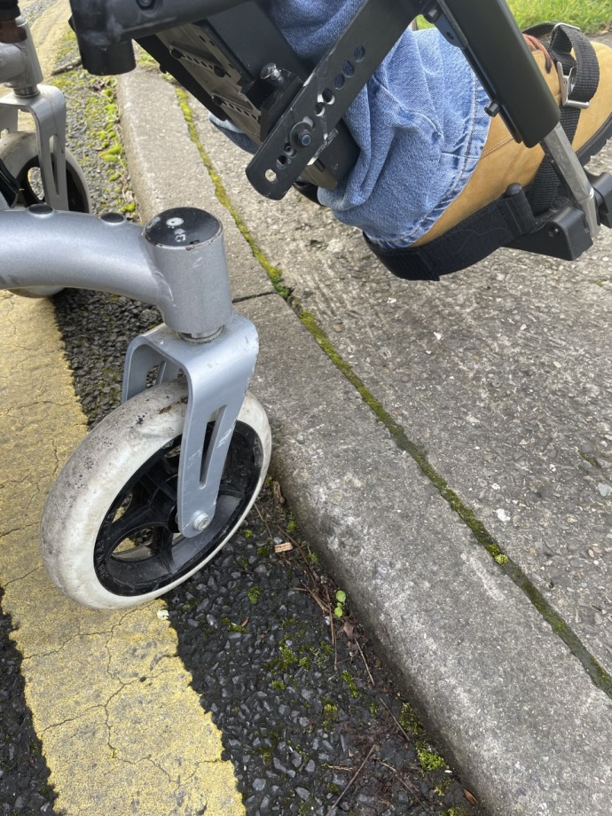

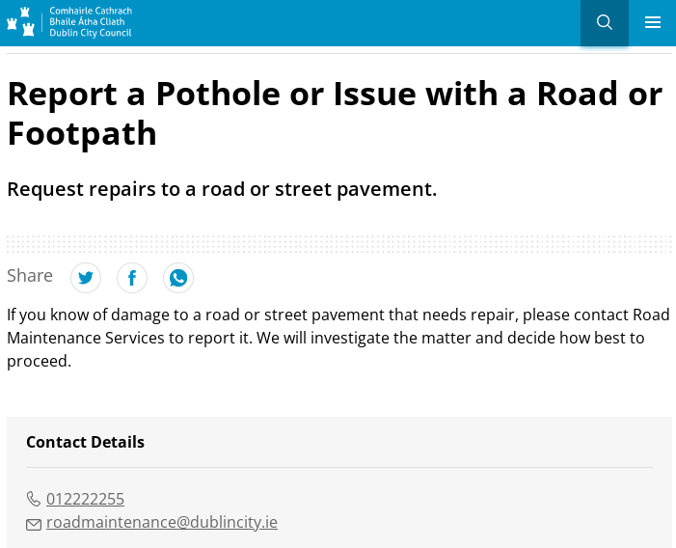

Microsoft Teams

We did not use Microsoft teams today.

Action: Everyone to bring their tablet to the next meeting

The new meeting room

We all met in the Edge in our new Advocacy meeting room. It’s class!

‘Beautiful’ Eddie Kelly

‘It looks like one of the rooms in the most upper chamber of the Dail’ Joe Feehily

‘Easy to get to’ Deirdre Troy

*Photo pending*

DFI

Joe said he might not be able to go to the meetings but Deirdre can go instead. Deirdre said yes to this.

Minutes online

Everyone has a consent form for being filmed. Not everyone has sent theirs back.

Action: Everyone to send their consent forms to Eilís. Choose who will say the minutes first.

Bus needs a grab rail

The referral has been sent to OT.

Website
Susan Wilson said she would be happy to have the advocacy members on the website.
Action: Everyone to send their consent forms to Eilís
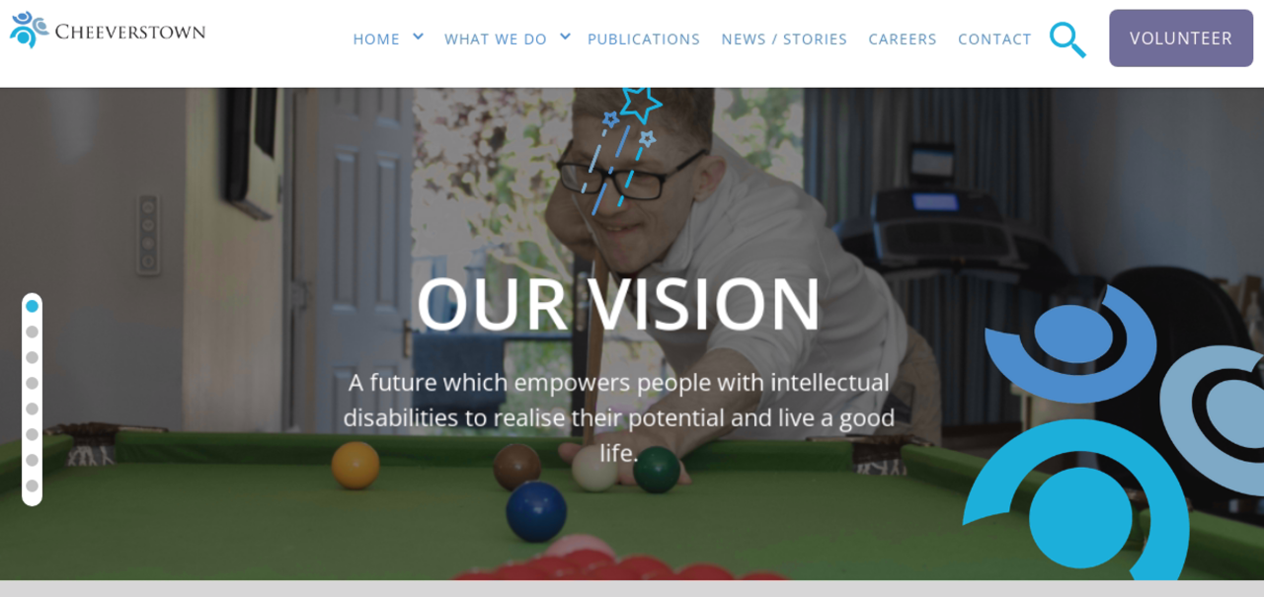

Roles
Chairperson to be elected at the next meeting. We would like to congratulate Eddie on being treasurer. He jokingly said his role was to “take the money” and Rohan replied “he’s hilarious”.

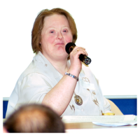

UNCRPD
Joe presented the UNCRPD to the advocacy group. It was excellent.
Main points were discussed:
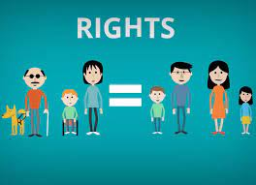
Equal: What would you think if someone talked over you or didn’t talk to you “Strange” Sean
Decisions: “Everyone can make their own decisions” Deirdre Troy
Money: “I put it in the post office and get it out when I want to” Eddie Kelly on his payment from Tesco.

Information in a way that you understand: “If you watch the right programmes” Joe Feehily
Choose where you live: “During lockdown I lived with my parents and I was very upset at that time. I couldn’t hug my family.” Patricia
Rights are respected: “Cheeverstown always respects my rights” Eddie Kelly, “Sometimes” Sean, “I feel respected” Patricia

Work: “Cheeverstown helped me get a job in Tesco” Eddie, “Cheeverstown helped me get a job in Griffith college and the radio” Joe
Discrimination: We talked about what discrimination means and Eddie said it meant “Ignorant”
Deirdre read out the strategic plan after this.
Actions: Each person is going to take a part of the UNCRPD and say it to camera and give real life examples so that other people can know more about what it means. Joe is going to match the UNCRPD to the strategic plan.

Minutes
Deirdre and Eilís are doing the minutes together. Rohan said he will help with the minutes next time.
“I’ll help you Eilís” Rohan Slevin
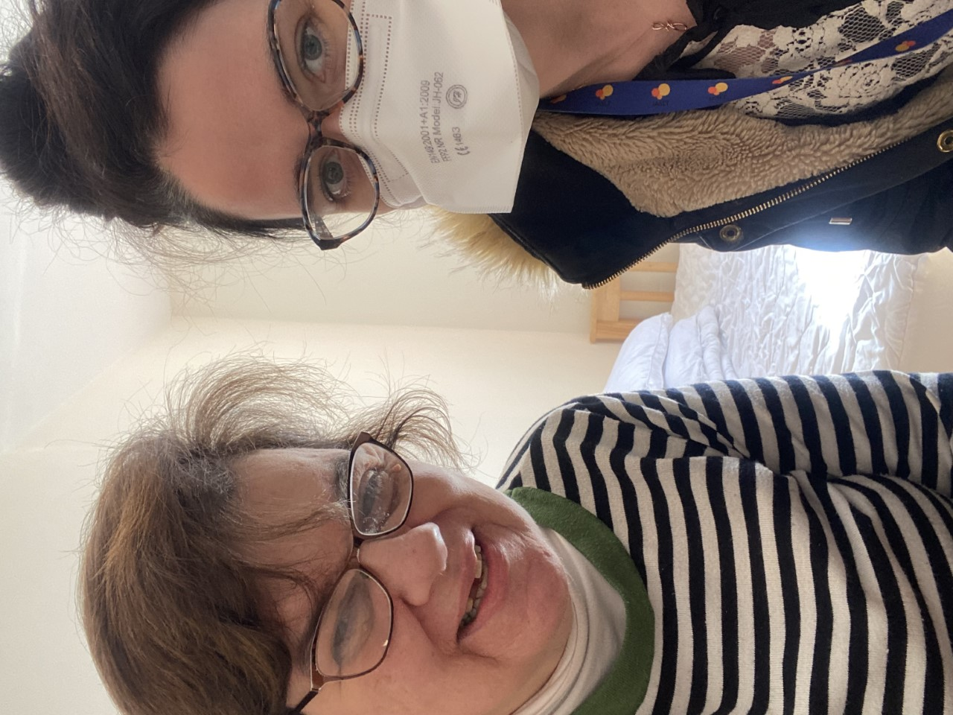

Referral to the advocacy group
Eibhe thanked the advocacy group. The councilor that Deirdre and Ursula told her to get in touch with is going to sort out the path problem!
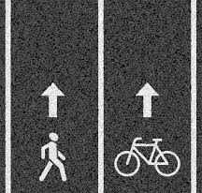

RIP
Patricia told the advocacy committee about her brother. He died in hospital from COVID. We were all very sorry to hear this. Different members helped support Patricia.

ACTIONS

- Group to send an email at the next meeting to roadmaintenance@dublincity.ie

- Deirdre to take pictures of where the paths are broken down. Also say where the locations of these bad paths are.

- Joe to look at the strategic plan to the UNCRPD and see if they match.
- Everyone to send consent forms back to Eilís.
- Joe and or Deirdre go to DFI meetings
- Organise who will say the minutes online
- Everyone to bring their tablet to the next meeting
- Each person is going to take a part of the UNCRPD and say it to camera and give real life examples so that other people can know more about what it means. Joe wants to take parts 18 and 19.
- Eilís to bring new news items from twitter e.g. ILMI, DFI, WCA etc. https://www.iwa.ie/get-involved/advocacy-campaigns/our-campaigns/think-housing-build-accessible/

