Advocacy Meeting
Date: 11th of January 2022
Time: 3-4pm
Attendees: Deirdre Troy, Eddie Kelly, Martina Curran & Eilís Rojack

- Talking points 
What does advocacy mean to you?

‘It means to have something to say. To go ahead and say it like if you have a complaint say it out straight instead of holding it all up in your head like in your mind like if you’ve something to say.. say it.’



Why is this group important?

‘Very important… People who can’t speak up for themselves I want to help them’

‘Because it gets all the anger out straight and not at another person. Speak up for other people if other people can’t speak.’



What is important to you?

‘I like to see them’ (the people on the advocacy committee)

‘Because like what I have been going through all the years starting on this. It took me a while to get zoom. Because it’s good to continue to speak up’

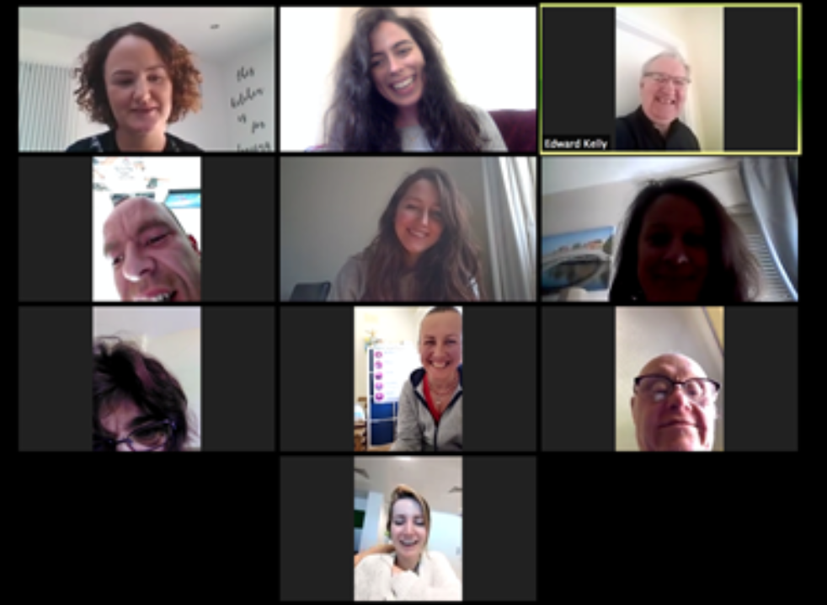

What is important to any of your friends that go to any of the Cheeverstown services?

‘There’s just at the moment only 3/4 of us in the room. Strange to be back. Yesterday was the first day so we’re just settling back in’



Who runs the advocacy twitter page?

Martina Curran


How can we tell more people about the work in the advocacy group?

Agreed that flyers have not worked and the poster alone has not made people more aware. Eddie felt word of mouth and talking to people about advocacy does work. Eddie and Deirdre said it could be a good idea to put it on social media. We talked about different types of social media like twitter, Instagram and Facebook. Voice overs on the minutes by Caroline.



- Twitter and social media
Martina runs the twitter account. If anyone is interested in tweeting let Martina know. OR if anyone has something to tweet about let her know. To talk further about using other social media.

- Website
Attendees agreed the website looked good. Would it be an idea to have the advocacy committee on the website?

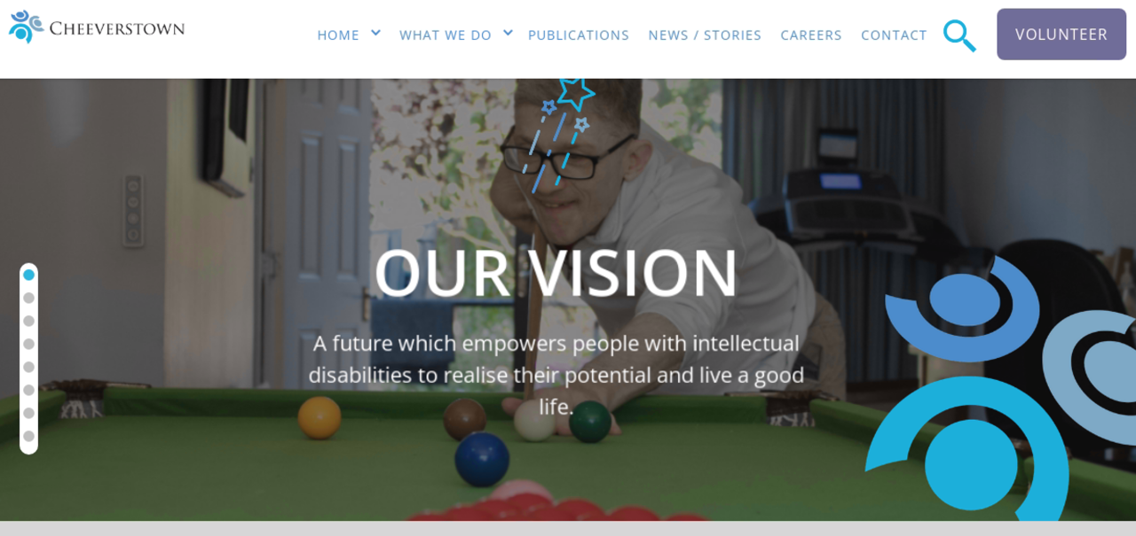

- Roles
There is a role of chairperson, time keeper and treasurer. These roles have not been filled. It was decided this should be done by a vote if more than a person wants a job.
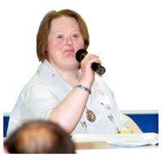

- Referral to the advocacy group:
Eibhe, OT, has requested support to make a complaint to improve path ways that are used by a lady who uses a wheelchair. Deirdre Troy has taken this as her action. She will follow up and report back to the group. She will let the group know if she needs more support.


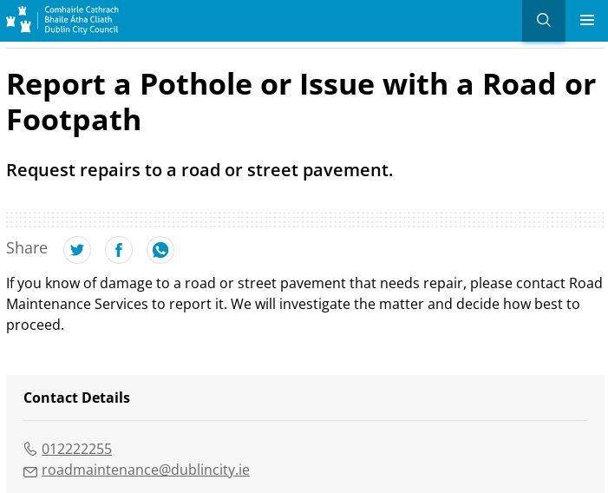

ACTIONS

- Deirdre to update the group on her work with Eibhe

- Decide who is treasurer, chairperson and timekeeper

- Whoever did not attend last weeks meeting to share their answers (sent out in the emails 2 weeks ago, if you need a copy let me know)

- Choose what social media platform we will use for example: twitter, Instagram, facebook

- Decide if we want the minutes with voice over / person

- Decide what to say to people to tell them more about advocacy

- Look at the Cheeverstown strategic plan

- Do members want to be on the website

