NZPork Reserves Policy

Introduction
The NZPork Reserves policy outlines how the NZPork Board will maintain a level of equity that allows for reserves to be held as a contingency fund to assist NZPork’s response to a major crisis including guidelines on use of the reserves.

This policy and guidelines replaces:
- NZ Pork Reserves Policy, April 2015

Responsibilities
- NZPork Directors are responsible for maintaining a reserves policy;
- NZPork Directors are responsible for consulting farmers before changing or setting the reserves policy;
- NZPork Directors are responsible for consulting farmers before allocating funds for industry-good projects;
- NZPork Chief Executive is responsible for making the policy available to farmers on request;
- NZPork Directors are responsible for ensuring the policy is complied with;
- NZPork Chief Executive is responsible for the reporting of the reserves via the Financial Statements and reports which are presented to the NZPork Directors at the Board Meetings; and
- NZPork Directors are responsible for the disclosure of reserves within the full financial statements in accordance with the Generally Accepted Accounting Practice in New Zealand (NZ GAAP).

Legislation
The Pork Industry Board Act 1997 Section 6 (8) Board Functions provides that the NZPork Board ‘In the exercise of its functions, the Board must have regard to the need for it to have adequate financial reserves’.

The Pork Industry Board Act does not provide any further requirements but some inferences can be made based on what the Act states regarding to assets- Section 4 (4) The Board's assets belong ultimately to pig farmers, and are for the time being held and administered for the benefit of pig farmers.)

There is also requirements regarding future income and assets in Section 7 Board to prepare and maintain statement of strategic and consultative intent and Section 11 (3). The Board must not exercise any of its rights, powers, or privileges, except for the purpose of:
- (c) entering into any financial transaction or financial obligation intended to—
  - (i) avoid or lessen any present or possible future risk to the Board's current or future income or assets; or
  - (ii) lessen any liability of the Board; or
  - (iii) avoid or lessen any possible future liability of the Board; or
  - (iv) maximise the Board's current or future income (whether net or gross).

Reserves Policy
The interest generated from investments is currently used for NZPork operational activities. This contributes, albeit in a small way, to reducing the levy.

NZPork maintains a current cash reserve level of $4 million. This level will be reviewed from time-to-time to ensure that cash reserves are sufficient to cover at least 12 months operational expenditure.

In the event reserves are called on for unforeseen emergencies, such as a disease incursion, NZPork will ensure that, with industry agreement, a suitable levy that is over and above operational requirements, is set for as long as is required in order to return cash reserves to their original amount.

In the event that an industry crisis is likely to require funds over and above NZPork’s cash reserves, NZPork will consider borrowing funds, secured on fixed assets and cash reserves before the cash reserves are exhausted. Should this occur, NZPork will, with industry agreement, set a suitable levy that is over and above operational requirements in order to repay the loan over the agreed term. NZPork may also, with industry agreement, set a suitable levy that is over and above operational requirements for as long as is required in order to return cash reserves to their original amount. This process may occur at the same time the loan is being repaid.

The Board has collected an additional levy since 2005/2006 to replenish the PMWS Reserve Fund. Due to hardships in the pork industry, the industry decided not to replenish the PMWS reserve fund during the 2008/2009 financial year. The PMWS reserve levy was reinstated for the 2009/2010 financial year. At the 2010 AGM, the meeting decided not to continue replenishing the PMWS reserve fund starting 1 October 2010.

Funds Under Administration

Regional Funds

NZPork also continues to administer the Ward Funds, which total $32,045 (as at 30 September 2019). Ward Funds are currently invested on six monthly terms with 2 September 2020 being the next maturity date.

Total Ward Funds as at 30 September 2019 are analysed by Region as follows:

Region 1 $ 19,413
Region 2 $ 12,632
TOTAL $ 32,045

NZ Pig Breeders 75th Jubilee Fund

The New Zealand Pork Industry Board took over the administration of the NZ Pig Breeders 75th Jubilee Fund during April 2008. The fund totalling $28,344 (as at 30 September 2019) has been invested for a term of 6 months and matures on 2 September 2020. The fund comprises the principal amount of $19,300 with the balance being accumulated interest earnings. The intention of the fund is to only distribute the interest earnt.

The New Zealand Pig Breeders Association 75th Jubilee Trust Fund was established in 1990. The purpose of the fund is to provide assistance for the training and education of people who have chosen a career in the pig industry.

The interest generated by the fund’s capital investment is available for an approved applicant. The allocation of grants is made by two Trustees; The New Zealand Pig Breeders Association and the New Zealand Pork Industry Board. The Trustees will assess the merit of an application and make a grant taking into consideration the original intent of the fund and the available money in the interest pool at the time the application is made.

Investment Summary
Below is a summary of the investments for the previous financial year taken from the audited statements as reported in the annual report.

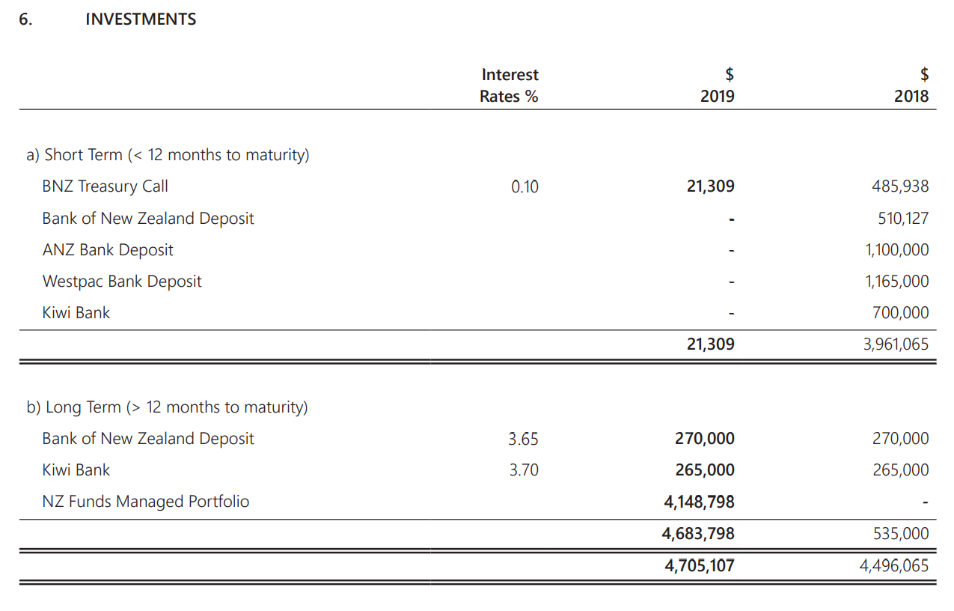

Use of the Reserves
The reserves may be utilised on activities including, but not limited to, the following:
- Coordination of crisis activities and communications;
- Provision of specialist advice and support to levy payers and agencies leading any response to the sector crisis;
- Advocacy on behalf of the pork industry during a crisis;
- Market research/public relations;
- Consumer promotion including advertising;
- Establishment and audit of quality control/food safety programmes;
- Research to gain further understanding of the nature of the event; and
- Legal expenses incurred in defending the interests of the sector.

Appendix A: Investment Background and History
This information was provided in early versions of this policy and has been retained as historical information.

Establishment
The New Zealand Pork Industry Board’s (NZPork) reserves, as with all other producer boards, were established by one-off payments received from the Government following the sale of meat to the United Kingdom during the 1951/52 season. With particular respect to NZPIB’s reserves, two payments were received in 1953 and 1954 following the sale of pig meat.

The first payment of £108,520 is clearly recorded in the New Zealand Pig Producers’ Council’s 1953 Annual Report, with the Chairman, I.B. Julian, reporting that;

“It has been decided to invest these funds over a fairly long period and this should give a great deal of stability to the industry in the future.”

The Chairman also commented that he was “confident that the United Kingdom is prepared to pay a price in keeping with the class and quality of pig meat most acceptable to her market, but will not continue paying for these classes that have, up to the present, served as ration stop-gaps. It is quite likely that pig meats will be the first meats to be released from the rationing in the United Kingdom and while the sale of pig meat is, along with other meat, covered by the bulk purchase agreement to September, 1955, it is possible that export sales after that date will revert to trader to trader basis.”

As a result, the second and final payment of £110,000 was made in 1954.

Consolidation
Whilst part of these reserves (originally known as the development fund) was used to establish the National Pig Breeding Station in the late 1950s, they were consolidated over the years and as at 31 August 1974, the day the Pork Industry Council became a statutory producer board, reserves totalled $359,414.

Further consolidation occurred via the:
- Establishment of a marketing reserve in 1969/70
- Establishment of a research and development reserve in 1983/84 and part funded directly by the Government up to 1987.
- The strategic move at the time to purchase the Board’s premises in 1992
- Realising a respectable profit on the sale of the Board’s shareholding in FarmPro Systems Ltd in 2002.
- Establishment of the PMWS Reserve Fund in 2005/2006 to help replenish the reserves used during the PMWS disease incursion.
- The marketing reserve and research and development reserve established in 1969/70 and 1983/84 respectively have been consolidated into the Accumulated Funds in 2010/11.

The 1981 Annual Report of the Pork Industry Council highlights that reserves totalled $697,252 and by 1991 NZPork and its subsidiaries had reserves totalling $2,606,498.
By 1995 NZPork’s reserves and accumulated funds totalled $4,496,817, represented by:

Marketing Reserve | $1,500,161.00
Research Reserve | $183,459.00
Land & Building Revaluation | $50,343.00
M.R.C Stabilisation | $30,000.00
Reserves Total | $1,763,963.00
Accumulated Funds | $2,732,854.00
Total Equity | $4,496,817.00

Total equity was represented by:

Net Working Capital | $312,658.00
Investments (other than Autocall) | $2,618,334.00
Investments - NPBC | $1,100,000.00
Fixed Assets | $465,825.00
Total Equity | $4,496,817.00

An additional $29,439.00 was also held in joint Ward Funds.

Policy Review

In February 2008 the Board added Kiwi Bank to the list of potential investment listees and if any term deposits made (with all any bank), not to exceed a term of 2 years.

During October 2008 the Board decided that as the economy is still volatile it was agreed to leave the term deposits as they are and reassess when they are due to mature.

During August 2009 the Board amended the investment policy to move outside the current length of term of its investing policy whilst interest rates are low and will change back when rates increase.

At the August 2010 Board meeting, the Board noted it would continue investing for short term periods and would continue to invest only with trading banks.

At the October 2012 Board meeting, the Board resolved that the final decision for length of the term investment is to be decided at time of reinvestment with the intention to vary term length (6 months to one year) for cash flow stability.

At the April 2015 Board meeting, the Board confirmed its Investment Policy is still applicable with the current economic climate. The Board will continue to invest with the four major banks (BNZ, ANZ, Westpac and Kiwi Bank) and any final decision for the length of the term investment would be decided at time of reinvestment with the intention to vary term length for cash flow stability (6 months to two years).

At the June 2017 Board meeting, the Board confirmed the amended reserves policy content to include more detail on Responsibilities, Legislation and Use of the Reserves. The Board confirmed that it will continue to invest with the four major banks (BNZ, ANZ, Westpac and Kiwibank) and any final decision for the length of the term investment would be decided at time of reinvestment with the intention to vary term length for cash flow stability (6 months to two years).

On 14 February 2019 the NZ Pork Board adopted a Statement of Investment Policy and Objectives (SIPO), determined a satisfactory Investment Strategy and resolved to place $4,000,000 with NZ Funds under a Managed Portfolio Service Agreement. The initial funds placement was $3,000,000.

The Board resolved on 14 February 2019 to transfer upon maturity, the remaining $1,000,000 of funds currently on Term Deposit with BNZ, Kiwibank and Westpac to NZ Funds for investment under the Managed Portfolio Service Agreement.

As detailed in the Board’s Statement of Investment Policy and Objectives (SIPO), the Board will formally review the SIPO at least annually.

This policy was reviewed on 20 July 2020 by the NZPork Directors and the Chief Executive. This policy will be reviewed annually.

