PRESS RELEASE
Contact Julian Lee
Email social@ambiclimate.com
Website https://www.ambiclimate.com

AMBI CLIMATE MINI EMPHASISES STYLE AND COMFORT TO SUIT THE NEW NORMAL
SMALL, STYLISH AND SMART AC & HEAT PUMP CONTROL

Consumers wanting out with the old and in with the new for 2021 will be pleased to know tech and smart home producers are becoming more style, lifestyle and energy conscious. The all-new Ambi Climate Mini is one timely example.

Lifestyle became a key focus of 2020 as people adjusted to a new normal - one with increased time at home and therefore an increased need for home comfort. Whilst temperature control is a key element of home comfort, it’s also a key contributor to energy consumption, raising the need for more energy-efficient air conditioner and heat pump control.

There are roughly 1.9 billion air conditioning units in the world with the International Energy Agency (IEA) expecting an almost three-fold increase by 2050.¹ Despite this, only one-third of purchased air conditioners feature the best available energy-sparing technology.** Further most new air conditioners have continued to perform in the exact same way for several generations.

Another emerging trend is for consumers to be more open to IoT and 5G integrations with people creating smart homes that offer intuitive and automatic adjustments to things like music, lighting and climate.³

This makes smart AC and heat pump controller Ambi Climate Mini one of the most worthy lifestyle products for 2021. Produced by Hong Kong IoT startup Ambi Labs, the compact and stylish Ambi Climate Mini promises users comfort, convenience and efficiency like never before.

Ambi Climate Mini helps users effortlessly enhance their lifestyle

Julian Lee, Founder and CEO of Ambi Labs says Ambi Climate Mini gives people the convenience to enjoy more personal and social experiences at home without distraction.

Imagine the climate of your home yoga or workout session is tailored to your personal preferences so you can continue to exercise knowing you won't overheat or catch a cold from the mix of sweat and excess cooling.
Or, friends and family can visit your home without worrying about your environment not suiting them. In fact, they might even be jealous about how good your home feels compared to theirs!
Julian Lee adds: "Users today demand a great user experience as well. Our free and comprehensive companion app provides a powerful and easy way to control the AC and heat pump.”
Ambi Climate Mini works through the app as a remote controller for the home’s air conditioner or heat pump. Users can easily adjust and remotely monitor their home environment for their family and pets even when they’re not at home. Other features include, scheduling, GPS tracking, voice control and optional subscription for the Comfort AI Assistant, which learns every time you interact with it. If you like the temperature slightly lower on a hot afternoon, it takes that feedback seriously and works to ensure you experience nothing but brilliant comfort from that point on.
Furthermore, Ambi Climate Mini promises efficient smart cooling and smart heating to limit energy waste. Its intuitive design offers ease of use alongside sleek and minimalist style that discreetly levels up your home.
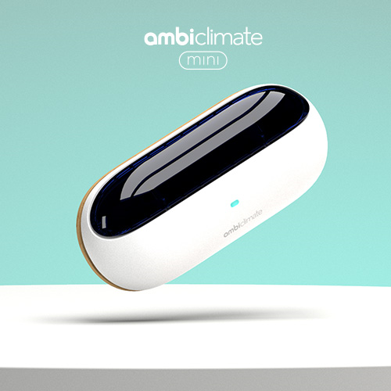
The smart lifestyle product to have for 2021
The beauty of smart AC controllers is in making things easier, more integrated and absent from users’ already busy schedules. It’s not just a more modern way to control AC or heat pumps. It’s about intuitive and effortless home comfort. Consumers chasing new lifestyle trends for 2021 would be wise to consider it.
Ambi Climate Mini promo video https://www.youtube.com/watch?v=WvZT0xOgfJc
Visit official website for product information
Further information
Main contact:
Julian Lee
social@ambiclimate.com

More images for this press release
https://www.dropbox.com/sh/vwd6qpirmtu67xi/AAB-kIOlD4gELkj14JPGFE4na?dl=0
Ambi Climate Press Kit
https://www.dropbox.com/sh/vyi16hlwxdvrekm/AABZW86KY6N5iRJBFWPhppRPa?dl=0

Ambi Climate - Website
https://www.ambiclimate.com/

Ambi Climate - Social medias #levelupyourhome
Instagram - Facebook - Twitter - YouTube

¹ Statista - Worldwide connected devices from 2015-2025
² IEA - The Future of cooling
³ Mobile Magazine - Smart home trends to watch in 2021

About Ambi Labs

At Ambi Labs, we believe both technology and design can help create a better future for everyone. This is why, since 2012, we’ve been focusing all our efforts on creating and providing the best products in Smart AC & heat pump Control.

The world is changing profoundly and new technologies enable us all to redefine the way we live our lives. Our community of innovators, designers and technologists are at the cutting edge of it all. We are inspired by the concept of “Ambient Intelligence” to make user-centric, smart home products that are so intuitive the technology simply fades into the background.

Our smart AC & heat pump controllers elevate existing home devices to save money, time, and energy while creating a perfect home environment all year round, allowing people to concentrate on the things they care about most.

