Safeguarding information for pupils
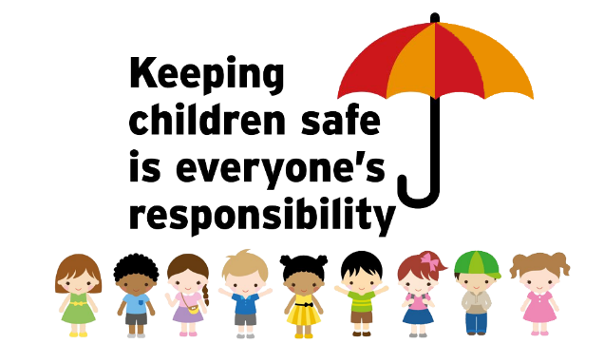
What is safeguarding?
Safeguarding means making sure Oratory pupils are safe, both in school and at home. It is everyone’s responsibility – teaching and non-teaching staff, parents AND most importantly you the pupils; we all have an important role to play. It is vital that we all look out for one another, and talk to someone whenever we suspect that something is not right.
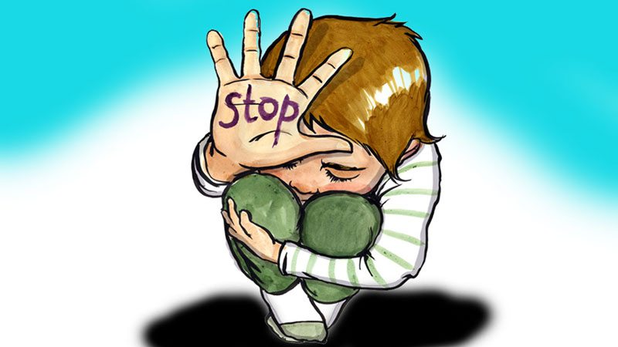
Safeguarding, a child (defined as anyone under the age of 18) means supporting the welfare of children. These are the key things we do when discussing safeguarding,
• protecting children from maltreatment;
• preventing damage of children’s mental and physical health or development;
• ensuring that children grow up safely and with effective care;
• taking action to ensure all children have the best outcomes.

What are our roles?
All staff should:
• be aware of the systems in our school which support safeguarding,
• receive appropriate safeguarding and child protection training (including online safety) which is regularly updated;
• know the identity of the Designated Safeguarding Lead or DSL (and any deputies) and how to contact them;
• know what to do if a child tells them they are being abused or neglected. They understand that they should never promise a child that they will not tell anyone else, as this is unlikely to be in the best interests of the child;
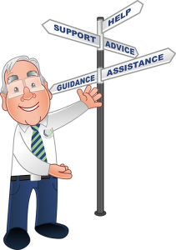
• Should be able to reassure all victims that they are being taken seriously and that they will be supported and kept safe. A victim should never be given the impression that they are creating a problem by reporting abuse, sexual violence or sexual harassment. Nor should a victim ever be made to feel ashamed for making a report.

Who are the safeguarding staff?
Junior House DSL – Mr Jeffery
Senior School DSL – Mr Mantio
6th Form DSL – Miss Carradine
Deputy DSLs - Housemasters and Senior Sixth Form tutors.

What school staff should look out for
Knowing what to look for is vital to stop abuse and neglect. All staff should be aware of signs of abuse and neglect, so that they can identify children who may need help or protection. Pupils can help too if they know that a friend or someone you know is suffering from abuse or neglect.

Forms of abuse and neglect
Abuse: means treating a child badly. Somebody may abuse or neglect a child by harming them or failing to act to prevent harm. Children may be abused by other children or adults, in a family or in a school, by those known to them or, more rarely, by strangers.
Physical abuse: a form of abuse such as hitting which causes physical harm to a child.
Emotional abuse: a form of abuse that makes a child feel worthless, unloved, inadequate, or not valued.
Sexual abuse: involves forcing or tempting a child to take part in unwanted sexual activities, that might be physical or non-physical (online).
Neglect: means persistently failing to look after the child adequately, which can affect a the child’s health or development. It may involve a parent or carer failing to provide adequate food, clothing, shelter and access to appropriate medical care or treatment.
Peer on peer abuse: This is abuse that is carried out by children on children. There are various types, including:
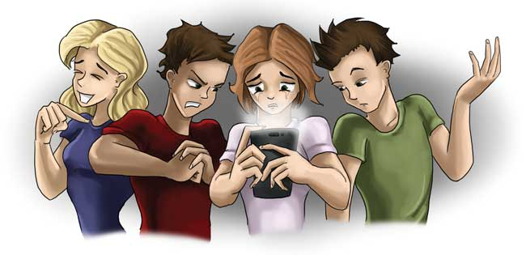
• Bullying, (including cyberbullying).
• Physical abuse, which can include hitting, kicking, shaking, biting, hair pulling and physical harm;
• Sexual harassment, such as sexual comments, remarks, jokes and online sexual harassment;
• Non-consensual (without permission) sharing of nude and semi-nude images and videos;
• up-skirting, which involves taking a picture under a person's clothing without their permission.
• initiation/hazing type violence and rituals.
We should all follow the 3R’s if we have any concerns about peer on peer abuse: Recognise – Respond – Report.
Recognise the signs a person is suffering from abuse
Respond by supporting the victim, it means a lot to them.

Report to any member of staff, a parent, the DSLs or deputy DSLs.

What should school staff and pupils do if they have concerns about another child
If staff have any concerns about a child’s welfare, they should act on them immediately. Staff will follow the school’s child protection policy and speak to the appropriate DSL (or deputy DSL).
The DSLs will generally lead on next steps, which may be informing and passing a concern to children’s social care and/or the police.
Why is all of this important?
It is important for children to receive the right help at the right time to lower the risks of abuse or neglect.

