**Malmo / Madrid/ Milano Chair Spec Sheet**

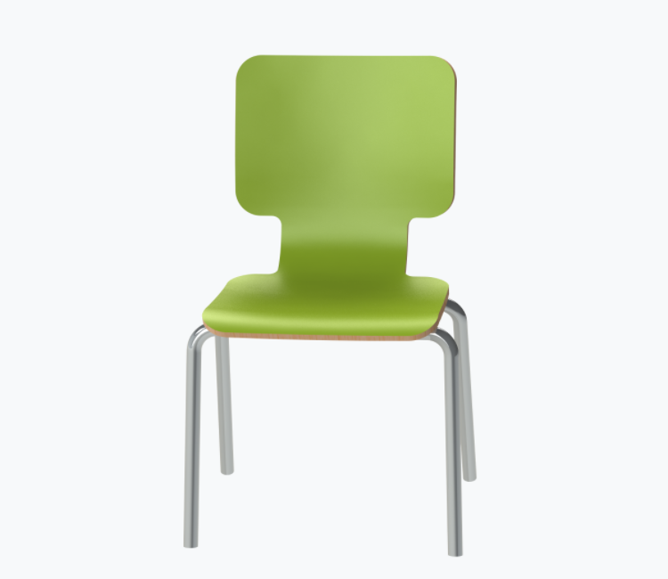

**Malmo Stack Chair**

Seat and Backrest

* Plywood seat and backrest in a laminate finish

Frame

* Chrome plated 13-gauge steel, 1” diameter
* Four Leg Frame
* Swivel Glides

Stacking

* Stacks 5 high

|  |  |  |  |  |  |  |  |
| --- | --- | --- | --- | --- | --- | --- | --- |
| Product | Part Number | Overall Product Dims  L x W x H | Seat Height | Seat Width | Seat  Depth | Product  Weight | Shipping  Weight |
| 12” 4 Leg Malmo | SP-MAL-12 | 14.5”x13.5”x24” | 12” | 11.5” | 11” | 7 lbs |  |
| 14” 4 Leg Malmo | SP-MAL-14 | 14.5”x13.5”x26” | 14” | 11.5” | 11” | 8 lbs |  |
| 16” 4 Leg Malmo | SP-MAL-16 | 21.9”x19”x31” | 16” | 16.5” | 15.5” | 11 lbs |  |
| 18” 4 Leg Malmo | SP-MAL-18 | 23.8”x19”x33” | 17.5” | 16.5” | 15.5” | 13.5 lbs |  |

**BIFMA tested**

**Milano Stack Chair**

Seat and Backrest

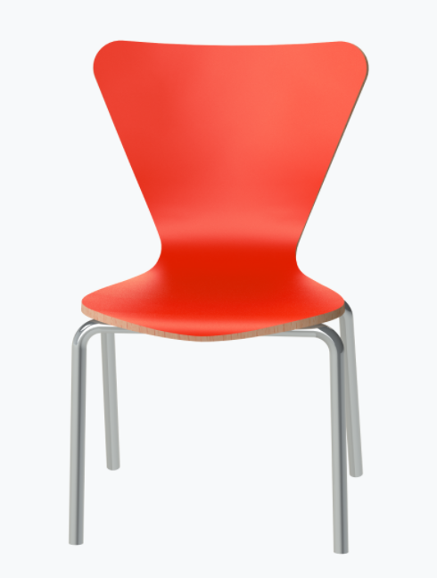

* Plywood seat and backrest in a laminate finish

Frame

* Chrome plated 13-gauge steel, 1” diameter
* Four Leg Frame
* Swivel Glides

Stacking

* Stacks 5 high

|  |  |  |  |  |  |  |  |
| --- | --- | --- | --- | --- | --- | --- | --- |
| Product | Part Number | Overall Product Dims  L x W x H | Seat Height | Seat Width | Seat Depth | Product Weight | Shipping  Weight |
| 12” 4 Leg Milano | SP-MIL-12 | 17.5” x 16.5” x 21.6” | 12” | 14.5” | 13.5” | 7 lbs |  |
| 14” 4 Leg Milano | SP-MIL-14 | 17.5” x 16.5” x 24” | 14” | 14.5” | 13.5” | 8 lbs |  |
| 16” 4 Leg Milano | SP-MIL-16 | 20” x 18.5” x 31.67” | 16” | 17.5” | 17.5” | 11 lbs |  |
| 18” 4 Leg Milano | SP-MIL-18 | 20” x 18.5” x 33.67” | 17.5” | 17.5” | 17.5” | 13.5 lbs |  |

**BIFMA tested**

**Madrid Chair**

Seat and Backrest

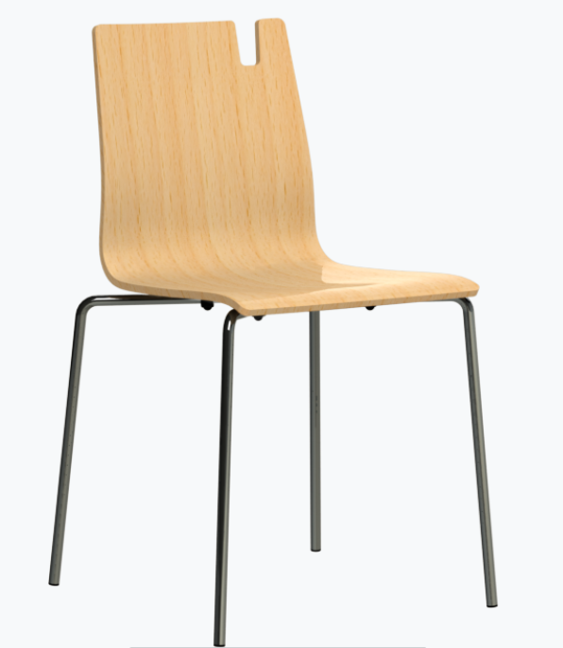

* Plywood seat and backrest in a laminate finish

Frame

* Chrome plated 13-gauge steel, 1” diameter
* Four Leg Frame
* Swivel Glides

Stacking

* Stacks 8 high

|  |  |  |  |  |  |  |  |
| --- | --- | --- | --- | --- | --- | --- | --- |
| Product | Part Number | Overall Product Dims  L x W x H | Seat Height | Seat Width | Seat Depth | Product Weight | Shipping  Weight |
| 12” 4 Leg Madrid | SP-MAD-12 | 16”x16”x22.5” | 12” | 14.25” | 13.5” | 7 lbs |  |
| 14” 4 Leg Madrid | SP-MAD-14 | 16”x16”x24” | 14” | 14.25” | 13.5” | 9 lbs |  |
| 16” 4 Leg Madrid | SP-MAD-16 | 19.6”x20.5x30.75” | 16” | 16.5” | 14.6” | 11 lbs |  |
| 18” 4 Leg Madrid | SP-MAD-18 | 19.6”x20.5”x32.75” | 17.5” | 16.5” | 14.6” | 12.5 lbs |  |

**BIFMA tested**

**Madrid Café Chair with Notch**

Seat and Backrest

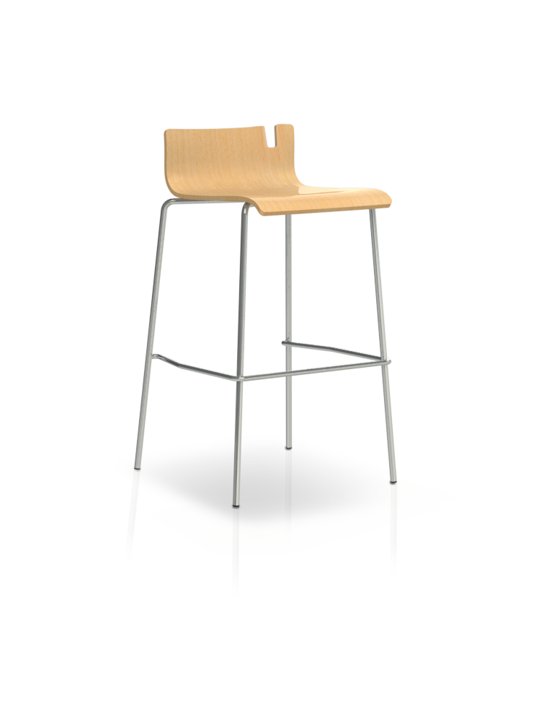

* Plywood seat and backrest in a laminate finish

Frame

* Chrome plated 13-gauge steel, 1” diameter
* Four Leg Frame
* Swivel Glides

Stacking

* No Stacking

|  |  |  |  |  |  |  |  |
| --- | --- | --- | --- | --- | --- | --- | --- |
| Product | Part Number | Overall Product Dims  L x W x H | Seat Height | Seat Width | Seat Depth | Product Weight | Shipping  Weight |
| 24” Low Back Madrid | SP-MAD-24L | 20”x20x35” | 24” | 16.5” | 15.5” | 13 lbs |  |
| 30” Low Back Madrid | SP-MAD-30L | 20”x20”x42.25” | 30” | 16.5” | 15.5” | 15 lbs |  |
| 24” High Back Madrid | SP-MAD-2  H | 20”x20”x40” | 24” | 16.5” | 15.5” | 15.5 lbs |  |
| 30” High Back Madrid | SP-MAD-30H | 20”x20”x 47” | 30” | 16.5” | 15.5” | 17.5 lbs |  |

**BIFMA tested**