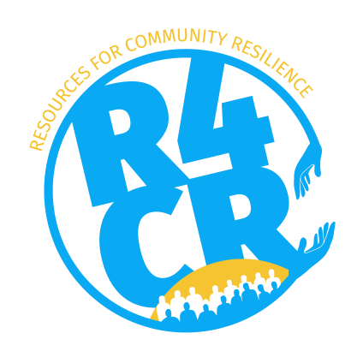
RESOURCES FOR COMMUNITY RESILIENCE

ANNEX 1: Template Technical Proposal

- Please fill out the general information of your organization and project in the tables below.

Legal name of the Organization
Full Official Address
Telephone Number
E-mail address
Website (if any)
Facebook (if any)
Name of your R4CR Project

 | Contact person/Coordinator | Board member
Name (first name, last name)
Position
Email address
Telephone

Type of Organization (Foundation, Association or other)
Registered with the Chamber of Commerce & Industry (COCI) | 0 Yes 0 No
Date of initial registration
Date of last updated registration
COCI registration number
CRIB Number

- What is the sector your project will be active in? You can thick of one or two that apply to your project.

- Community Councils/neighborhood initiatives and initiatives for relief;
- Day care centers/afternoon school programs and extracurricular activities;
- Sports and recreation activities/facilities;
- Nature and environment (re-/upcycling) and animal welfare activities;
- Art, cultural, archaeological and heritage activities;
- Psycho-social and emotional support;
- Poverty relief;
- Youth employment/entrepreneurship;
- Skills development
- Tackling gender based violence

- What is the main objective/goal of your project?

- What is the projected start and end date of your project? How long will your project be implemented?

Start Date (dd/mm/yyyy) | End Date (dd/mm/yyyy)

- What rehabilitation and/or reconstruction elements of your project are a direct result of hurricane Irma?

- What are the main intended results/outcomes of your project?
Use the SMART objectives (Specific, Measurable, Attainable, Relevant, Time-bound).

- How will you monitor and measure your results/outputs (SMART)?

- Which/who is the main target (group) expected to benefit from your project?

- Was your target group (if possible) consulted and/or involved during the design stage of the project? If so, please explain in what way.

- Who, and how many, will benefit directly from your project? In what way?

- Who, and how many, will benefit indirectly from the project? In what way?

- How many staff/employees of your organization will be involved during project implementation?
Please state the person’s name(s), function(s), whether he/she is a volunteer or employed (paid), and estimate the amount of time each person will spend on project activities (on a monthly basis).

Name (first name, last name) | Function(s) | Volunteer or Employed | # hours per month

- Are there currently comparable initiatives under implementation or have recently been completed? If so, in comparison, what unique selling point(s) does your project have ?

- Is your organization planning to implement the project independently or in collaboration with (an)other organization(s)? In case of a joint approach, please list the collaborating organization(s) and specify their role during project implementation and who will take on the lead.

- Give a clear description of your project taking into account the following elements (maximum 1,000 words). In other words share a detailed project plan.

- How are you going to achieve your project objective/goal?
- What are the specific project activities?
- Who is going to implement the activities (number of people and time spent), whom and how many will benefit?
- What is the time frame of the project?
- What is the expected end-result?
- How will you involve project beneficiaries, if applicable?
- How will you organize the communication and information on your project with the community, general public, and target group?

- Do you foresee any social and/or environmental project risks? If so, which ones and how will the risks be mitigated?

- What is the chance that your project result(s) will become sustainable. Are there follow up funds on which you can rely? Please explain in detail what you will do with the project results?

The following documents are included completing the total grant application package:
(please select those that will be submitted)

Scan/ copy of:
- ANNEX 1: Your technical proposal (this document)
- ANNEX 2: Your financial proposal (the budget)
- The extract of the latest COCI registration
- The establishment of your CSO as a legal entity (Notary deed – articles of incorporation)
- A copy of internal regulations known as the ‘Articles of Incorporation’ or ‘Statutes’ and by-laws associated with being a not for profit entity
- Two financial reports/audits of the last two years
- Two Social or Technical reports of the last two years
- Your annual budget plan for this year

Date
Approved by Board member: | Approved by Contact person / Coordinator:
Name: | Name:
Position: | Position:
Signature: | Signature:

FOR INTERNAL USE BY R4CR TEAM ONLY!

Date of receipt Grant application/Technical proposal
Organization
Round # (1-7)
Type of project | 0 Quick Win 0 Regular
Received by | 0 Email 0 hard copy 0 both
Email address
Signature Team Leader or Representative

To make sure the goal(s) you have identified in your project are clear and reachable, each one should be: specific (simple, clear and unambiguous), measurable (meaningful and motivating), achievable (agreed and attainable), relevant (reasonable, realistic and resource/result-based) and timely (time-based and time/cost limited).
Reference is made to section 2.4 (application assessment) of the Grant Manual. In case of a consortium, each consortium partner must submit a scan or copy version of these documents.

